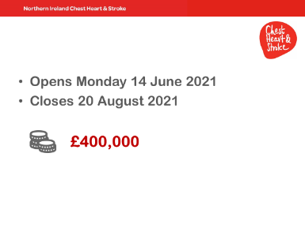
- This year, the window runs from Mon 14 June through to Fri 20 August. That gives you about 10 weeks to prepare & submit your application
- this year the pot is £400,000.
- We use a peer review process, based on 4 criteria, to identify suitable research. If the applications are not suitable, there’s no obligation to fund. Conversely, there has been a precedent set in previous years, where if an application is strong but just falls below the cut-off mark, we will recommend that study to our Governance Board who would decide whether to find additional funding for that study. But there are no guarantees that this will happen this year.
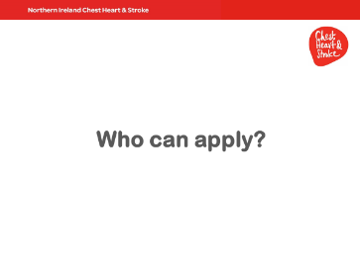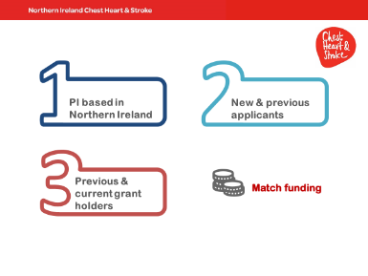
- All suitably experienced researchers with an interest in chest, heart and stroke issues can apply.
- The main requirement is that the PI must be based in Northern Ireland, as a researcher, working for a local institution (so, University, Trust, or organisation with research remit). The rest of your team can be drawn as appropriate. We recommend that your named alternate PI is also based in NI, but this is not a requirement.
- We welcome previous applicants, successful or otherwise, as well as new. Similarly, previous and current grantholders can apply.
- You can apply for 100% of your funding from us. We also are open to match funding, as outlined in our strategy, as long as the other funders are a fit with our goals and ethos.
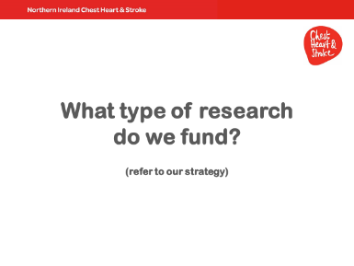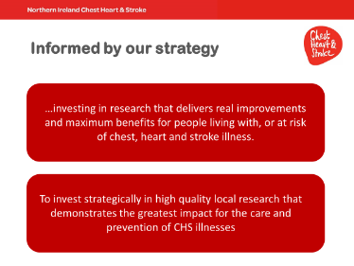
- First and foremost, as Fidelma indicated, the research we fund is informed by our strategy and in particular a focus on research that maximises potential real world benefit.
- Front and centre is the focus on “is this good science” and “how will it benefit those living with Chest, Heart, and Stroke conditions, and their loved ones?”
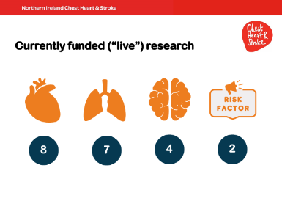
Currently we have 21 live studies – more detail on research webpages.
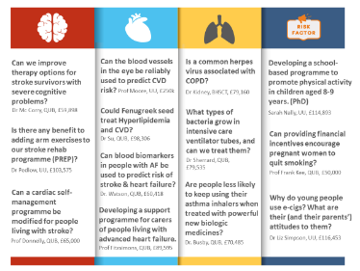
- Here are a selected few, described in lay terms.
- We fund a range of study types, across the range of issues that might be directly relevant to those living with CHS conditions, and with the potential for improving services, treatments, and quality of life.

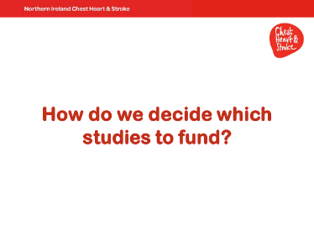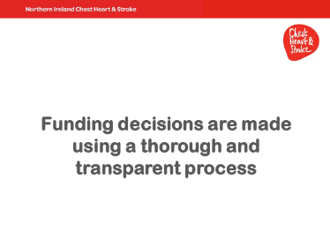
- As previously mentioned, we judge all applications on four criteria, using a peer review process. More on that in a moment
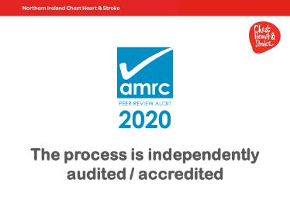
- The whole process is rigorous.
- It is also independently audited by the Association of Medical Research Charities to ensure transparency and fairness. We’re glad to say we were once again awarded this quality mark.
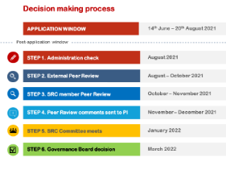
- So, there’s a 10 week window to prepare and submit an application.
- Post application window, the first checkpoint is an administration check to ensure all applications have followed guidance, provided necessary supporting materials and signatures.
- Step 2 – applications are prepared and sent for external peer review by two reviewers. As part of your application you are asked to identify potential peer reviewers. We will choose one of these. We will also identify a second peer reviewer ourselves.
- Step 3, we identify a member of our Scientific Research Committee – that’s the committee which reviews all applications – to act as a third peer reviewer.
- Step 4, once all peer review comments have been collated, we provide the PI an opportunity to comment on these.
- Step 5. Your application, the peer review, and your comments are circulated amongst all members of our SRC, who meet in January to discuss and score each application on the same four criteria as the peer reviewers.
- Just a few points about our committee. The committee is made up of 13 people, consisting of researchers, academics, clinicians and lay representation. We have representation from both local universities, as well as from Oxford University, London School of hygiene and tropical medicine, and we have representation from local health trusts. More about the committee on research webpages.
- Final step. The SRC send their recommendations for funding to the Gov Board, who make the final decision around which, if any, to fund.
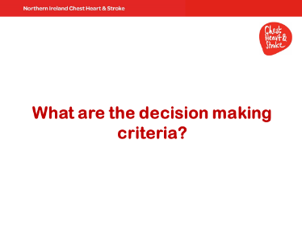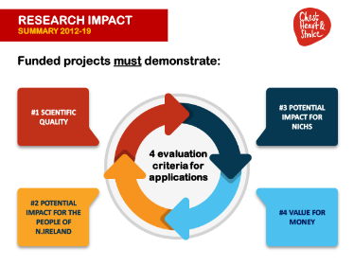
- As mentioned, we use four criteria to assess the suitability of every application. These are scientific quality, potential benefit for the people of NI, potential benefit for us as an organisation, and value for money.
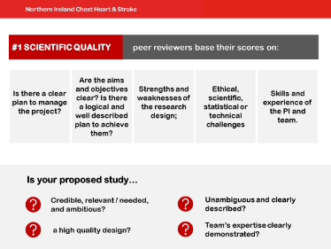
- whilst there is no formal weighting of criteria, scientific quality is of critical importance. An application that falls short on this criterion is going to be unsuccessful.
- Prof Clarke will explore this criterion a little further in his workshop session, but in summary, to give your application the best possible chance of succeeding, you must clearly show that you have meticulously planned it in terms of conceptualisation and design. And that you’re sufficiently experienced to carry out the research.
- The Peer reviewers and committee will consider whether
  - it is a well-designed research question?
  - did you demonstrate a clear understanding of current knowledge and gaps in the field?
  - are your aims, objectives, hypotheses clear and unambiguous?
  - Is your design appropriate to meeting these objectives?
  - And have you, where necessary, provided sufficient detail to independently verify your choices (i.e. design, analyses, sampling decisions)?
in summary – is your study
- relevant, and clearly described
- of sufficient quality
- and are you in a position to deliver?

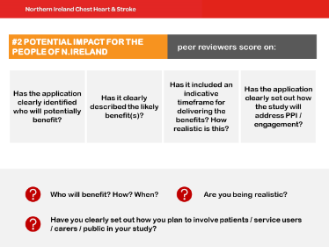 | the next criterion is potential benefit to the people of NI.  so, as we saw on an earlier slide, we favour research that maximises the benefit to those living with CHS conditions, and that will realise this benefit in a relatively short period of time (ideally 5 or so years)  Whilst we appreciate that all benefit is potential, and timeframes are indicative, In your application:  - be explicit and clear about the benefits and who are the intended beneficiaries.  - How will they benefit and within what timeframe? Are these timeframes realistic?  AS Fidelma indicated earlier, service user and carer involvement are central to our research strategy, and going forward we hope to see more patient / service user led and co-produced research.  in your application, be clear and realistic about how you plan to involve service users, patients, the wider public.  Will they be part of research planning and/or delivery? Will they be part of your dissemination plans? How do you plan to meaningfully involve and engage them, if at all?  from a practical perspective, if you envisage involving the people who use our services at chest Heart & stroke, you must try to provide as accurate as possible timeframes, numbers needed, and nature of their involvement, because this information is shared with our services, and a clear picture of your requirements will help us plan accordingly. We get quite a lot of requests for our service user and staff time from researchers that this year we’ve introduced a Service User Contact form to help us prioritise and manage these. This form is part of the application pack and we require you to complete it if you think you’ll need access to our service users.

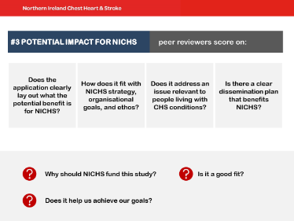 | the next criterion is potential benefit to us as an organisation.  - So, does your application clearly align with our strategies, our goals, and our overall ethos?  - does it raise our profile?  - How will you promote us and our research programme?  - will you require NICHS resources / staff time – clearly state these in your application.
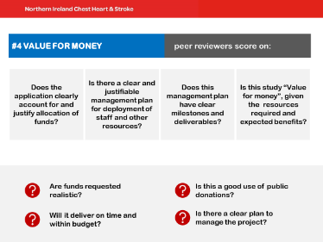 | the last criterion is value for money  your application should have a clear, sequential, and realistic management plan that demonstrates how you will deliver your study and deploy resources effectively  all successful applications must regularly report to us on progress and spend, so to facilitate this process your application should have clear, time specific milestones and deliverables  - Clearly outline resource allocation  - Clearly outline Roles and responsibilities  - Describe contingency plans, including those for the loss of the PI, key staff, and resources  the information you provide will be used to determine whether the funds you request are (1) realistic and  (2) proportionate to the potential of your study  it’s worth noting our research programme is 100% funded by public donations, so it is imperative that we can we go back to our donors and Justify how we used their donations. it’s up to you to demonstrate that your study is worth funding –

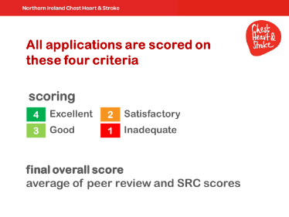 | in summary  - Be realistic and don’t overstate your research. We only fund research with clear milestones and deliverables  - Use plain English. On this point, you are asked to provide segments of your application in lay terms. This serves a number of functions – our lay reps on the committee comment on it. It used by our Senior Management team to consider whether your study is a good fit with us as an organisation. Our Comms department use it communicate about your research to our stakeholders. And Fundraising use it to communicate to donors, and to generate funds for the research programme. So, Don’t overlook the lay sections. They’re critical.  - Ideally, use plain English throughout your application.  - A useful tip – if you are using niche or specialist terminology, please provide a lay glossary. It helps us understand and better communicate your study.
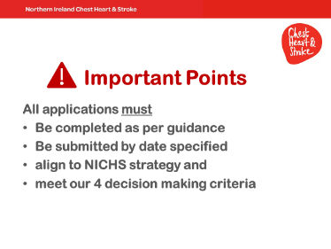 | without stating the obvious, please complete your application in accordance with the guidance and make sure you return it by the deadline
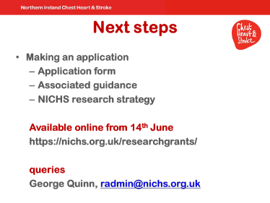 | finally, the application form, guidance, and all supporting materials, will be available online from 14 June  I am able to take queries about the process, but I am not in the position to take queries regarding the design or other specifics of your application.
 | thanks

