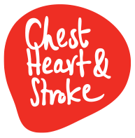
AMRC membership statement

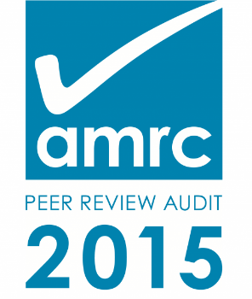

We are members of the Association of Medical Research Charities. As such, we ensure the research we fund meets the highest possible standards of quality, accountability, transparency and openness.

To achieve this, we have:
- implemented independent peer review processes,
- established an externally-led Scientific Research Committee,
- developed a research strategy aiming to provide funding to support research that shows the greatest potential impact and benefit for people living with, or at risk of, developing chest, heart and stroke illness.

Northern Ireland Chest Heart and Stroke’s research mission is to invest strategically in high quality research in Northern Ireland that demonstrates the greatest impact for the care and prevention of chest, heart and stroke illnesses.

We commit to providing around £300,000 of research funding every year.

Priorities for funding include research into the prevention, treatment, rehabilitation and care of chest, heart and stroke illnesses. As a consequence of adopting these priorities NICHS is currently funding research involving the study of people and populations, and not animal research.

Northern Ireland Chest Heart and Stroke is a member of the Association of Medical Research Charities (AMRC). All AMRC members support the AMRC position statement on the use of animals in research. Please visit the AMRC website for the full statement.

