How do we choose the research we fund?

We use a thorough process, which takes around five months, to help us choose the best local research. All researchers we fund must report back to us regularly to show that they are making progress and managing the grant wisely.

Our whole funding process is also independently reviewed on a regular basis. This way we can be sure that the money you donate is spent wisely, funding research that is high quality, and that will have real impact for people living with chest, heart, and stroke conditions.

WE ONLY FUND THE BEST LOCAL RESEARCH

Grant Selection Process
Local researchers apply to our research fund. As part of their application, they must demonstrate that their study is needed, and that it will be of real benefit to the people of Northern Ireland.
They must also clearly describe how they will carry out the study, and show that they will use high quality scientific techniques. They must show how they will ensure that any money we fund them is spent appropriately.
Our panel of experts, called the SRC (Scientific Research Committee – you can read more about the SRC in our leaflet “Our Scientific research Committee”), advises us which studies are good enough to fund.
Every application goes through several stages of review to identify the strongest:

#1 All applications are checked to make sure they have followed the application guidelines.
#2 Each application is sent to two independent experts to be reviewed. This is called “Peer Review”. The experts score the application against 4 criteria:
- is it “good science”?
- is it value for money?
- will it benefit the people of NI?
- does it fit with our strategy?

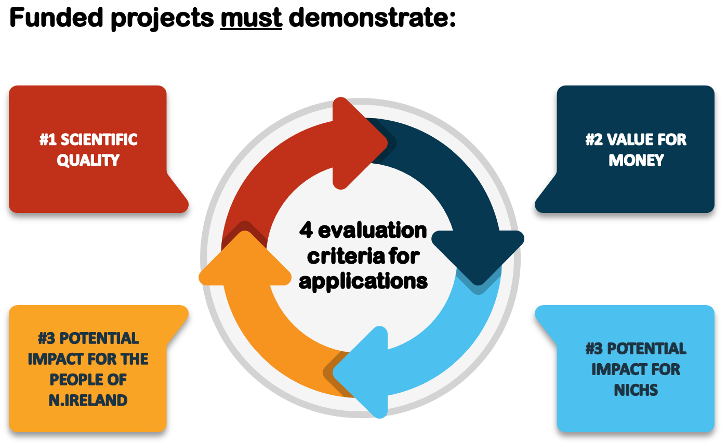

We also ask a member of the SRC to score one application against these criteria.
#3 After this review stage, our Senior Leadership Team consider whether the applications are a good fit with our goals.
#4 Then, our SRC (committee) meet as a group to score all applications on the basis of all the feedback from earlier review stages. We rank applications from strongest to weakest, based on the scores (using the 4 criteria) from this meeting.
#5 Our Governance Board use this information to decide whether to fund a piece of research.

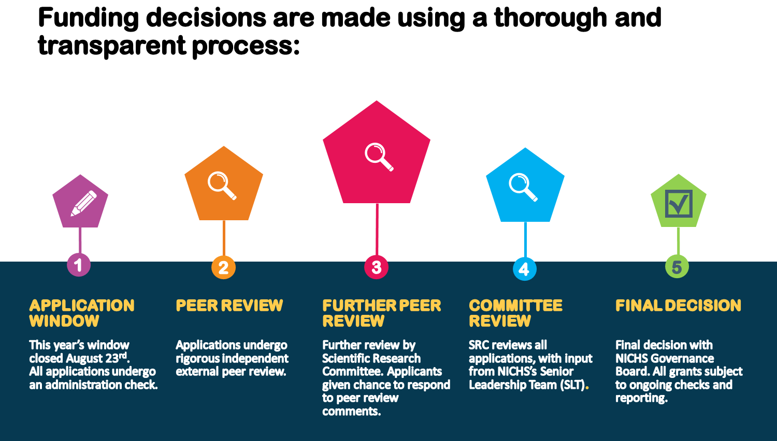

All researchers we fund must report back to us regularly to show that they are making progress and managing the grant wisely. They must provide us with a final report outlining what their research achieved.
The Association of Medical Research Charities (AMRC) regularly checks on our funding process. This helps us make improvements, and to keep the process fair and open.
This might sound like a long, complicated process – and it does involve many dedicated people – but it helps us make sure that we fund only the best quality research, and use your donations wisely.

