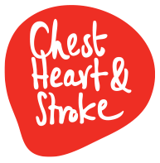Paula:Users:paulamclarnon:Desktop:NICHS_template_header.tif

**RESEARCH AND IMPACT STRATEGY**

**2018 - 2023**

1. **Introduction**

Northern Ireland Chest Heart and Stroke (NICHS) has been funding research for over 60 years increasing knowledge and identifying better ways to prevent, treat and care for people who have been affected by these conditions. Our work has led to the development of new health services, treatment guidelines, policy changes and scientific knowledge that have improved the lives of thousands of people within Northern Ireland.

We still have so much more to do. Every year 5,602 deaths are caused by chest, heart and stroke illnesses, this equates to 36% of all total deaths in Northern Ireland. 1 in 9 people are also living with chest heart and stroke conditions in Northern Ireland. This figure is set to rise as a result of advancements in medicine and an ageing population.

NICHS values the power of research to minimise the above impact of chest, heart and stroke diseases on people's lives. Research results will help us work towards achieving our mission to lead the fight against chest, heart and stroke illnesses in Northern Ireland. Northern Ireland Chest Heart and Stroke is making progress in leading the fight against chest, heart and stroke illnesses. Since 1994, we have committed an investment of up to r £7.25 million pounds into local research. To date, this investment has enabled us to fund 95 research projects in total, with 74 projects completed and a further 20 ongoing. Over the years, 45 respiratory projects, 33 projects in heart research and 11 stroke projects have been undertaken.

Over the next five years, we are committed to investing a further minimum of £2 million pounds in high quality research in our local universities and hospitals. We will strive to build stronger partnerships to deliver research that will lead to the most significant benefits for the people of Northern Ireland.

1. **Achievements and Impact**

Public donations fully fund our research due to the remarkable generosity of our supporters. We are fully committed to spending our donors' money wisely and to ensuring; all of our charitable activities are evidence-based and deliver maximum impact.

We conducted an impact review of research during a five year period 2006-2011. During this time we invested over £2 million (£2,031,276) in 33 research projects which led to changes in policies, services, further advancement in knowledge about chest, heart and stroke conditions. Local research capacity has increased through our funding which has also enabled researchers to access significant bigger pots of research funds to undertake larger studies.

* 1. **Measuring the impact of other charitable services**

NICHS’s research strategy also includes the responsibility for producing a framework for evaluating the impact or effect of other charitable activities. NICHS adopted the Outcome Based Accountability (OBA) model for its framework. This approach is used worldwide to improve outcomes for whole populations and for developing services. Northern Ireland's Programme for Government has also adopted this approach. The method asks the following three critical questions when assessing impact: **How much did we do**? **How well did we do it**? In addition, **is anyone better off?**

1. **Research Governance and Accountability**

The Governance Board through the Chief Executive is overall accountable for research, supported by the Director of Public Health and the Research and Impact Manager. The Scientific Research Grants Committee (SRG), made up of thirteen members (clinicians and academics) with an independent chairperson who makes recommendations to the Governance Board for funding of research projects following a robust evaluation process.

All research applications that pass the initial administrative assessment are subject to rigorous external peer review (2 reviews for each application) by experts from outside Northern Ireland. The peer reviewers and the SRC assess the applications against the following four criteria: scientific quality, value for money, the impact for people of NI and benefits for NICHS.

We are introducing a new stage for our research process to provide NICHS's Senior Leadership Team with an opportunity to comment on the potential impact of future research. The management team will mainly focus on research alignment with our strategic plan and the benefits of the research to NICHS. The Chief Executive who attends the SRC will represent SLT’s views at these meetings.

However, the independent Scientific Research Committee recommends only high quality research for funding. NICHS is a member of the Association of Medical Research Charities and adheres to its code of practice, with a quality mark awarded to NICHS funded research

The Governance Board have the responsibility of making the final decision to either fund or reject the Scientific Research Committee’s recommendations (See Appendix 1- SRC Decision making process). However, it would need to provide a robust case, as to why it is rejecting the SRC’s recommendations.

1. **NICHS’s Research Priorities for 2018 – 2023**

Our new research strategy builds on our strengths and achievements to date and sets out our new strategic themes, priorities and actions for the next five years that align with our new Strategic Plan 2018 – 2023. The diagram below outlines five strategic themes, vision and mission in our new research strategy

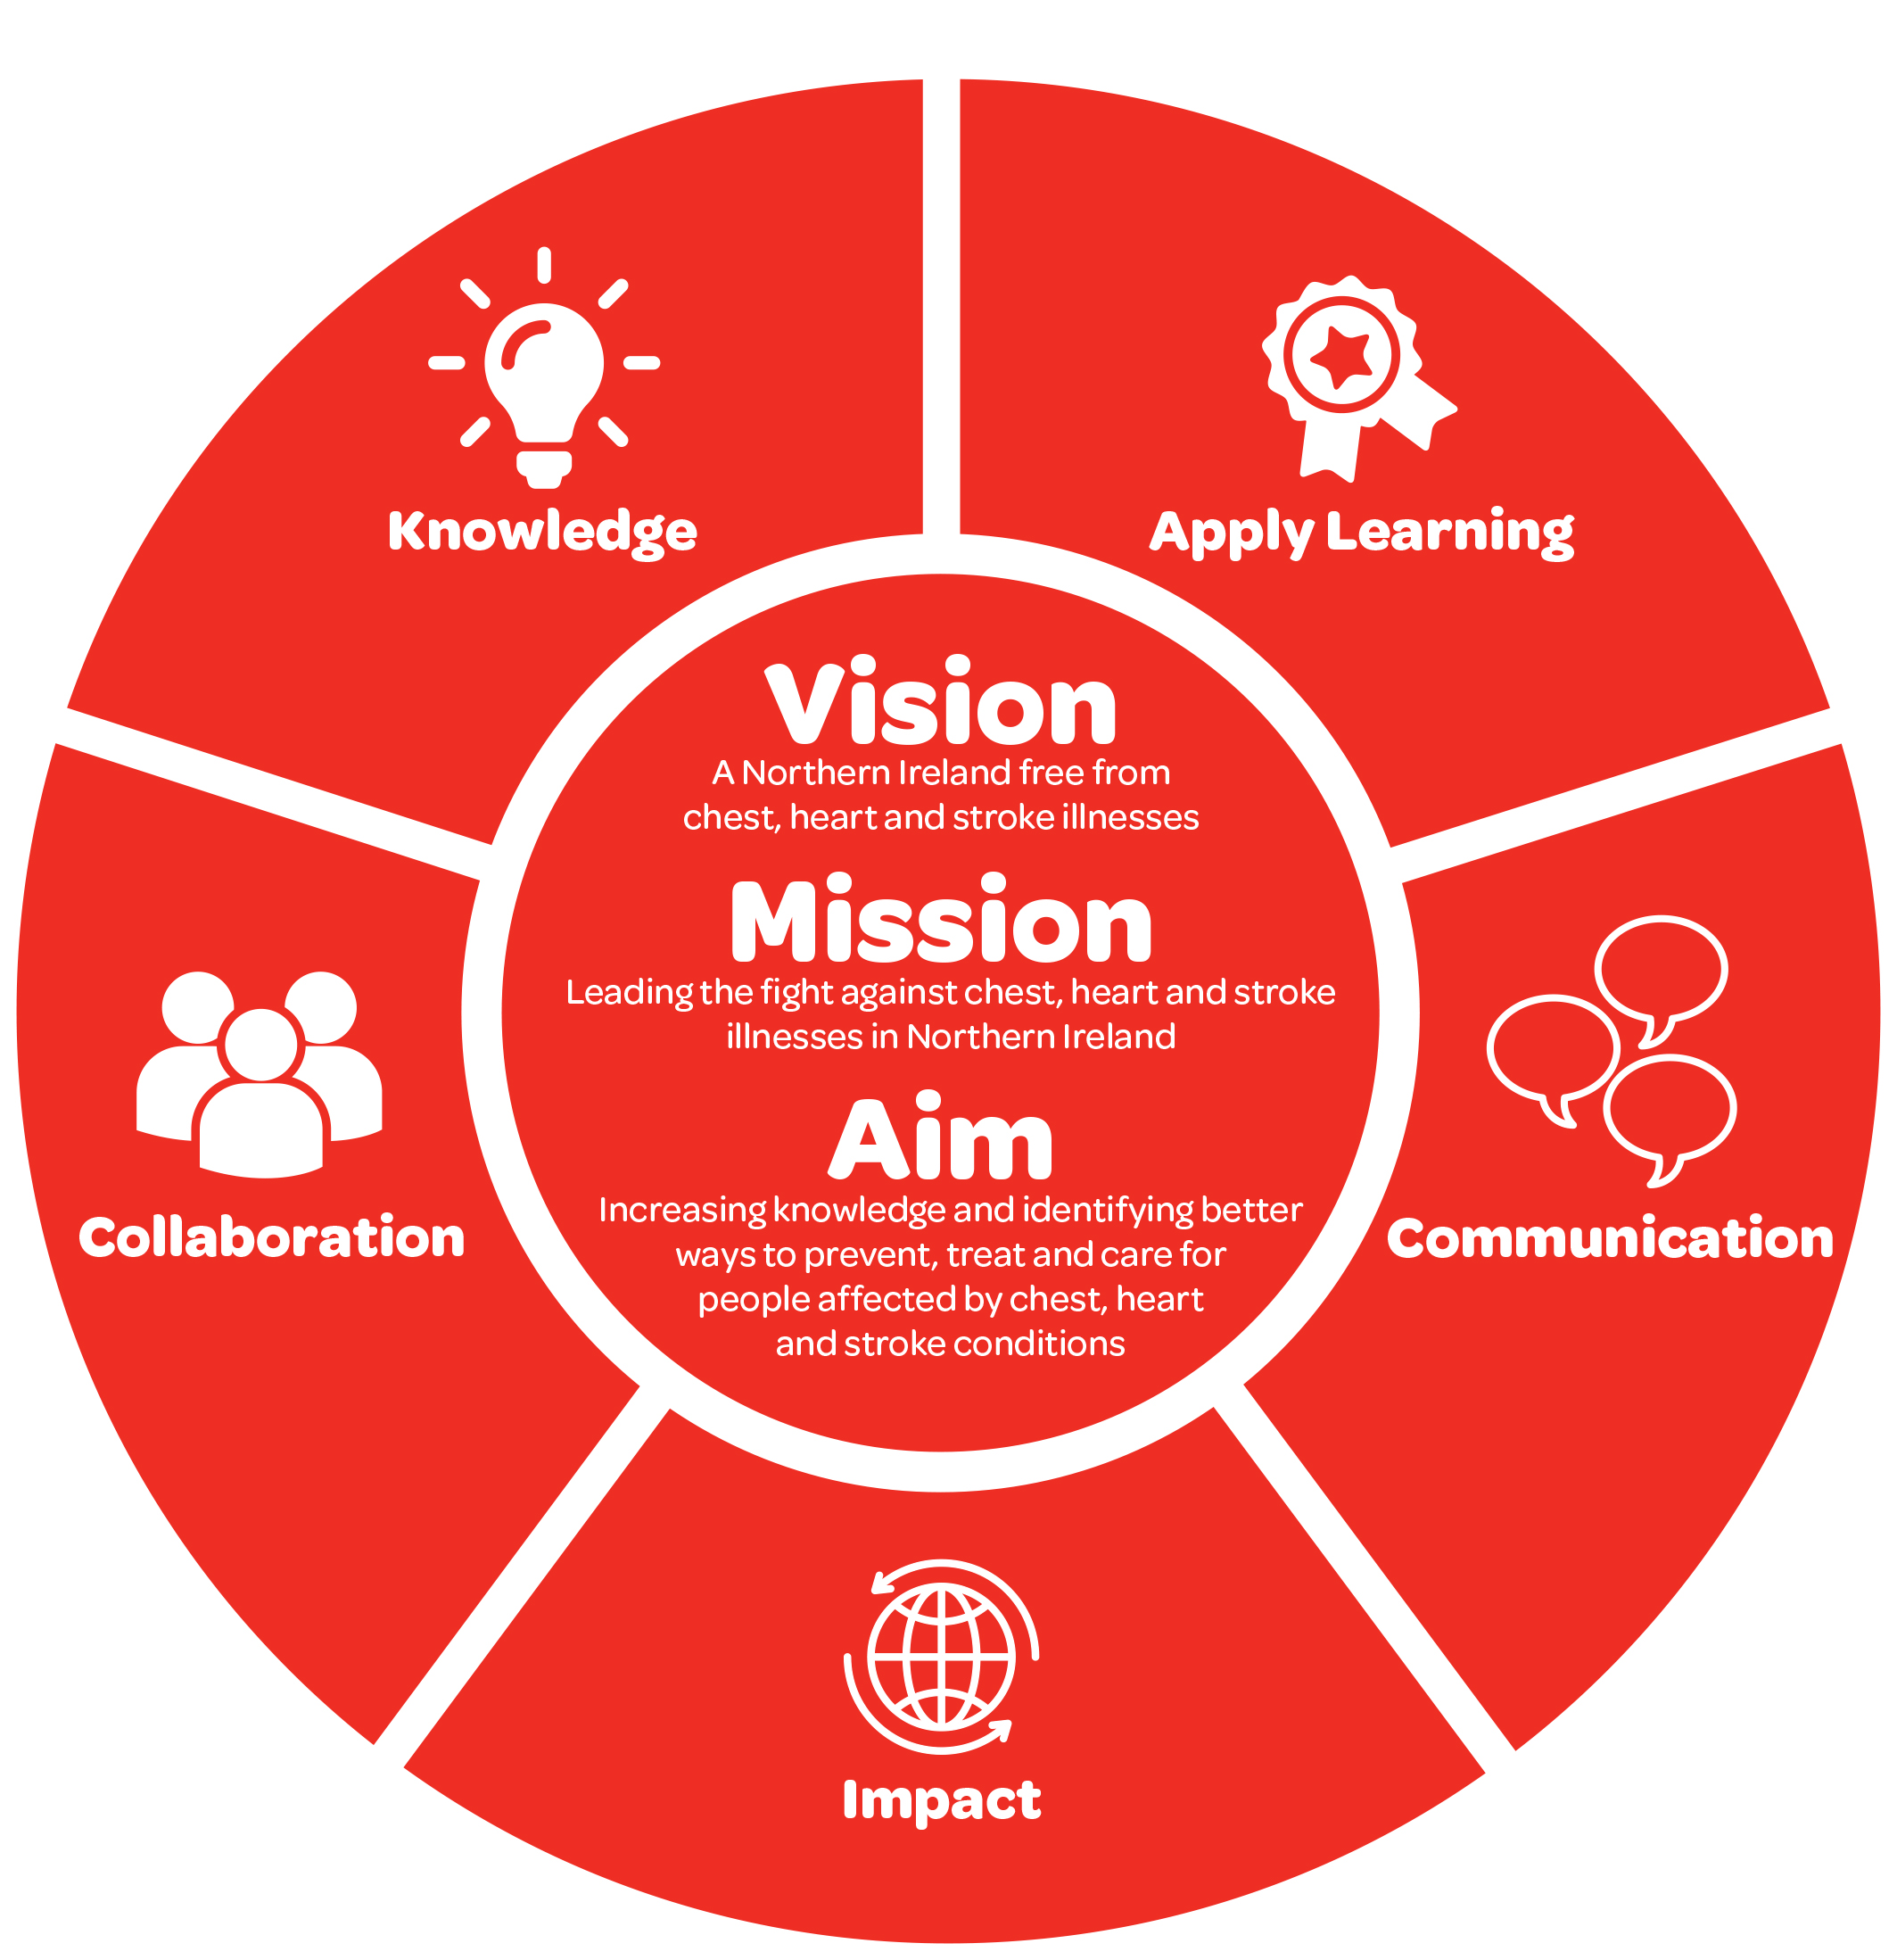

1. **Research Mission and Priorities**

The overall purpose of our research is **‘to increase knowledge and identify better ways to prevent, treat and care for people affected by chest, heart and stroke conditions’.**

Over the next five years, this strategy will focus our efforts on the following five strategic priorities; with further information on strategic actions linked to each of the priorities outlined in Appendix 1.

1. To fund high-quality local research that will deliver tangible benefits
2. To apply to learn from research to influence policy and services
3. To develop and explore working in partnership in areas which will provide greater benefit
4. To inform people about the difference that our research makes
5. To ensure that NICHS Research programme and charitable activities achieve impact.

This strategy will also give priority to research that aims to deliver potential patient and public benefit more rapidly.

1. **Budget**

NICHS is committed to investing a minimum of a minimum of £ 2 million pounds over the next five years in high-quality local research. We will capitalise on our research work to generate income and increase donor loyalty and accountability.

1. **Implementing our strategy**

* Organising an operational priority-setting workshop to identify specific priorities or gaps and to provide more focus to our research
* Advertising, evaluating and funding high-quality research
* Contracting and monitoring with successful research applicants
* Conducting five –year annual impact evaluation assessment
* Communicating the research findings through a range of platforms
* Ensuring robust, high-quality research processes and structures adhere too

1. **Measures of Success**

* maintaining and achieving AMRC Quality Peer Review Standards
* number of new policies and services informed by NICHS’s research
* number of new research collaborations with NICHS
* increased dissemination and awareness of our research
* achieving performance measures in the outcome and impact framework
* conducting 5-year research impact evaluation

**Fidelma Carter, Public Health Director**

**Dr Frances Campbell, Research and Impact Manager**

**11th June 2018**

|  |  |  |
| --- | --- | --- |
| Strategic Theme | Strategic Priorities | Strategic Actions |
| 1. Knowledge | * To fund high-quality local research that will deliver tangible benefits | * 1. To fund high-quality local research that aligns with NICHS' overall strategic plan. |
| * 1. To prioritise research, which aims to, deliver potential patient and public benefit more rapidly? |
| 1. Applying Learning | * To apply learning from research to influence policy and services. | * 1. To apply the learning from our research to ensure NICHS services are based on best practice evidence, and to inform our policy and campaigning work. |
| * 1. To explore different methods of engaging with our key stakeholders to help us inform and influence NICHS priorities. |
| 1. Collaboration | * To develop and explore working in partnership in areas which will deliver more significant benefit. | * 1. To explore options of co-funding and maximising NICHS’ contribution for potential impact. |
| * 1. To Leverage income generation and engagement opportunities using our research portfolio. |
| 1. Communication | * To inform people about the difference that our research makes. | * 1. To use appropriate platforms to maximise publicity and dissemination for NICHS. |
| * 1. Maximise the input from our research lay representatives to produce user-friendly communications. |
| 1. Impact | * To ensure that NICHS Research programme and charitable activities achieve impact. | * 1. To measure the impact of NICHS research programme, and complete an external validation of our progress and alignment towards our impact framework. |
| * 1. To commission an independent evaluation of NICHS' services, ensuring that evidence underpins our services. |

**NICHS Research and Impact Strategy 2018-2023**

**Appendix 1- SRC Decision-making process**

****