

KS2 Lesson 1: Take care of your body



Lesson 1
Talking Points and Slide Chart

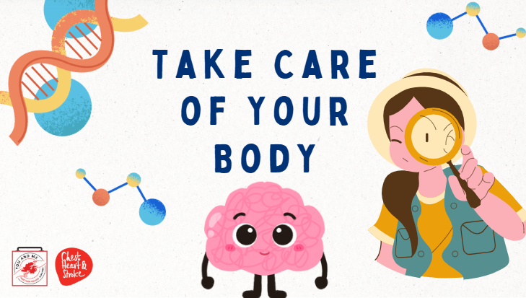

Slide | Image | Talking Points
1 |  | Hi class, we will be starting our unit today on e-cigarettes, other tobacco products, and nicotine!
2 |  | Educators - as you hopefully saw in the instructions to this lesson 1, we hope you will have registered for our dashboard, instructions and more information can be found at https://med.stanford.edu/halpern-felsher-reach-lab/curriculum-data-dashboard.html  Further, please have your students complete these pre and post surveys. They can access the pre-survey at the QR code on this slide, or at https://qrco.de/behk6D  At the end of the curriculum, please have students take the post survey, links can be found in the slides at the end of the curriculum. Thank you!
3 | 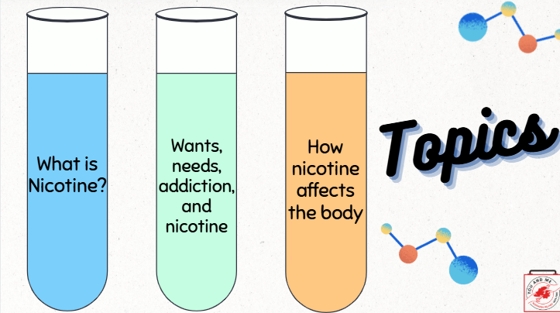 | Today we will cover the following topics:  (Teacher Note): Read from slides
4 | 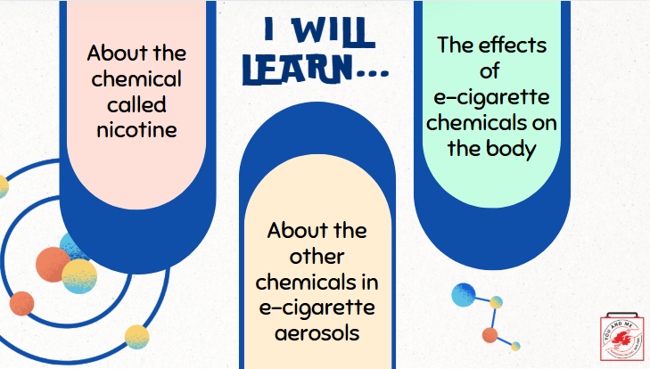 | Here's what we will learn:  (Teacher Note): Read from slides.
5 | 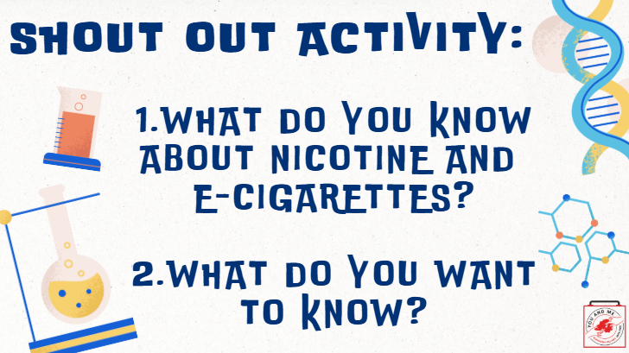 | (Ask Students): Shout out: What do you know about nicotine and e-cigarettes? (Pause for a few responses.)  Ok, now what do you want to know about nicotine and e-cigarettes that you don't know yet?  (Pause for a few responses and write the answers on the board or a piece of paper.)  Great! You all have some fantastic ideas. Let's move on.
6 | 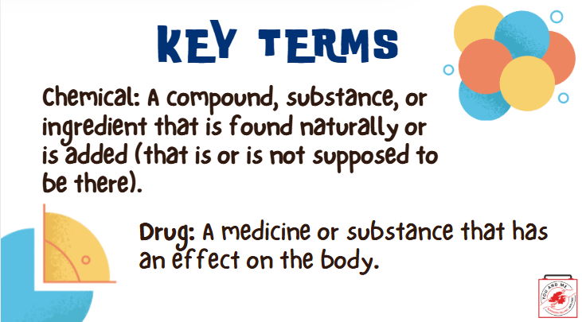 | Here are our key terms for this lesson! Keep these in mind as we continue.  (Teacher Note): Read definitions on the slide or pick one or two students to read aloud.  Ok, now let's answer the question about what nicotine is.
7 | 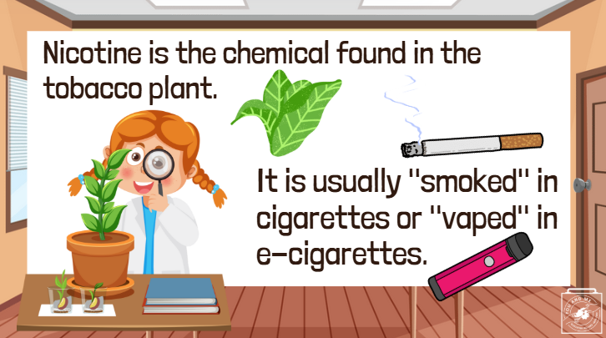 | Nicotine is the chemical found in the tobacco plant.  It is usually "smoked" in cigarettes or cigars (burned) or "vaped" in e-cigarettes (electronically heated).  When inhaled into the lungs, nicotine travels to the brain. Once in your brain, the chemicals trick your brain into feeling good. This can sometimes cause problems.  So, why are we concerned about the brain? (Take a few responses).
8 | 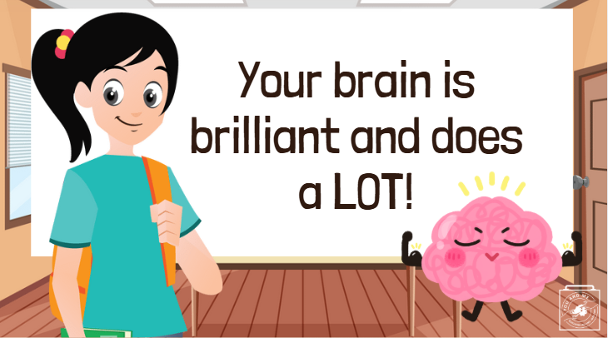 | We're concerned about your brain because it's brilliant and does a lot of amazing things!  As you're young and still growing, your brain is still figuring out what it likes and doesn't like.  While it's figuring this out, your brain may become impacted by something called "addiction."
9 | 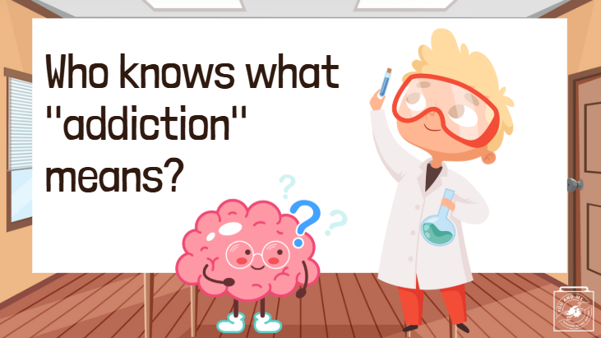 | (Ask students): Does anyone know what the word "addiction" means?  (Take a few answers).
10 | 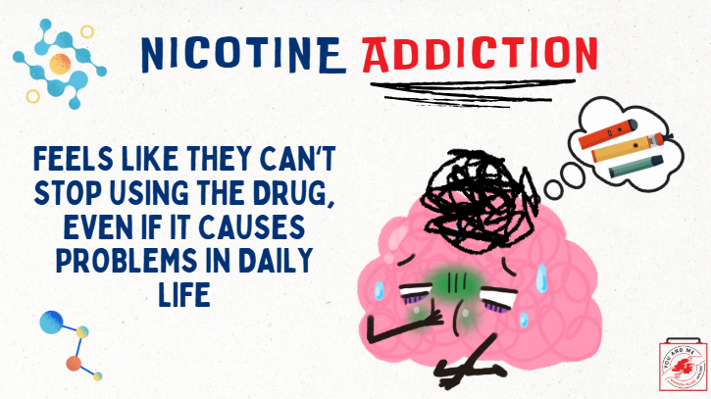 | When nicotine is introduced to a developing brain, it alters the brain's chemistry! It tricks the brain into feeling so good that nothing else feels pleasurable without the drug.  As a result, the user may feel unable to stop using the drug, even when it causes problems in their life, and using it may no longer be enjoyable.  This is addiction, and it is detrimental to a brain that is still developing.
11 | 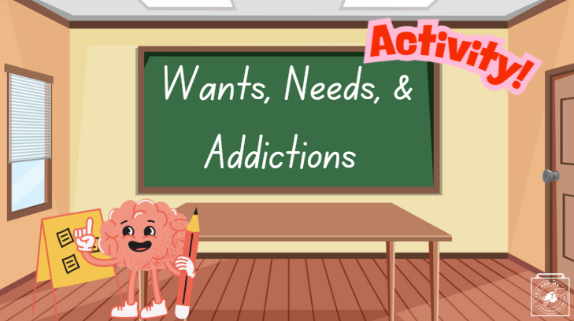 | Now that we know a little more about what an addiction is, we're going to do a wants, needs, and addictions activity!  (Teacher Note):  Instructions:  - Make three large signs that say "want," "need," and "addiction." Tape or hang these in separate parts of the room before beginning activity.  -When beginning the activity, tell the students "I am going to read a list of objects and activities. After I read it, walk to the poster that you think best describes the example given".  Examples (feel free to use others that are most relevant to your class):  - A cell phone  -Your computer  -Fast food  -Nicotine to people who smoke 1 cigarette  -Nicotine to people who smoke 5 cigarettes  -Nicotine to people who smoke more than 5 cigarettes  -Teenagers who drink because they want to be socially accepted  -Heroine  -Cocaine  -2+ hours of video games every day  -Facebook  -Water  -Instagram  -Friends  -Snapchat  -Food  Now, divide students into groups of 3-5. Give them 10 minutes to write down their own definitions of a "want" a "need" and an "addiction."  Discuss the definitions, particularly the similarities and differences between each group and the dictionary definitions (below):  Want (noun)  • the state or condition of not having any or enough of something  • something that is desired or needed  • the state or condition of being poor  Need (noun)  • a situation in which someone or something must do or have something  • something that a person must have  • something that is needed in order to live or succeed or be happy  • a strong feeling that you must have or do something  Addiction (noun)  • compulsive need for and use of a habit-forming substance (as heroin, nicotine, or alcohol)  • characterised by tolerance and by well-defined physiological symptoms upon withdrawal  • persistent compulsive use of a substance known by the user to be harmful
12 | 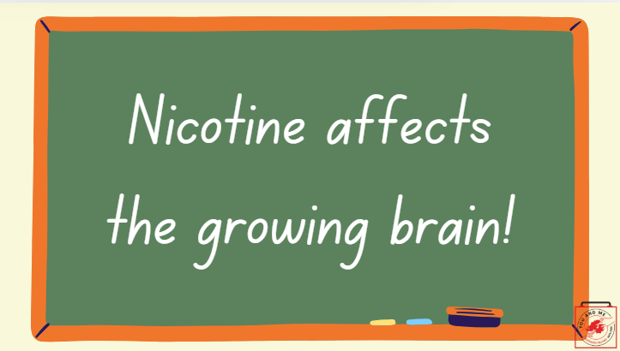 | Activity Discussion:  Hopefully, now you understand more about what things are addictions vs. what you want and vs. what you need.  This all goes back to nicotine and the growing brain. You are more likely to become addicted to drugs like nicotine when you are young and your brain is still developing.
13 | 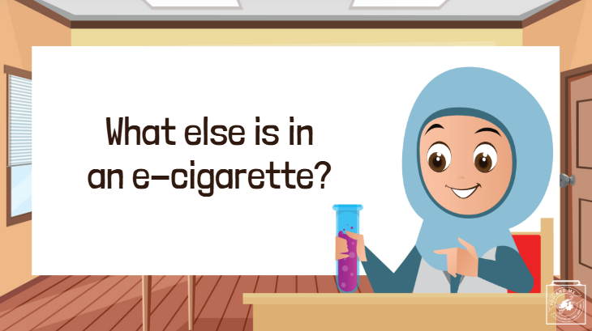 | Ok, we have discussed nicotine and addiction, but there are other ingredients in e-cigarettes and they affect your body too!  So, what else is in an e-cigarette?  (Teacher note): Take some responses.
14 | 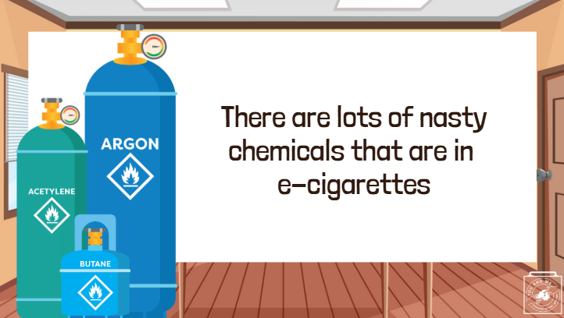 | Well, there are lots of nasty chemicals that can be found in the aerosol (cloud of smoke) from e-cigarettes!
15 | 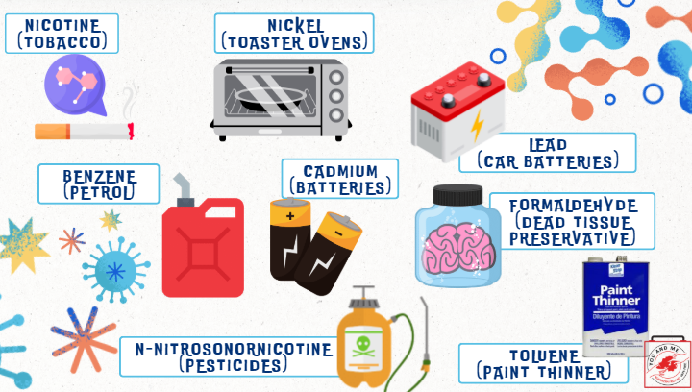 | Here are just a few of them!  Did you know that many of these ingredients found in e-cigarettes are also found in household products, products that I am sure you do not want to put into your mouth or body.  (Teacher Note): Have a few student volunteers read the chemical words on the slide (some of them will be unfamiliar with the words and have to sound it out, but that's the point!).
16 | 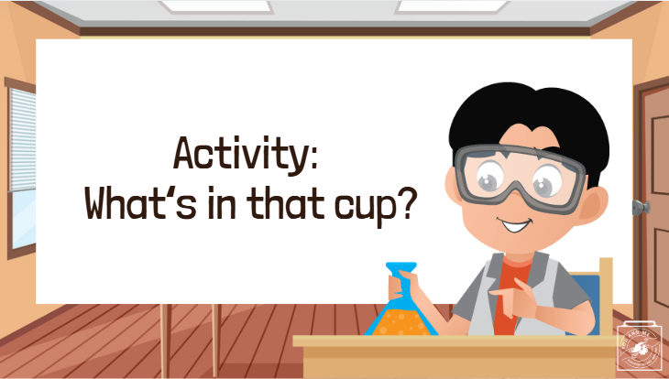 | OPTIONAL CLASSROOM ACTIVITY (10-15 minutes)  Prep work:  -Buy food colouring (many different colours)  -Disposal cups (Paper)  -Obtain 4-5 medium to large pitchers  Procedures:  -Label disposal cups with chemical names (Propylene Glycol (PG), Vegetable Glycerin (VG), Cinnamaldehyde, menthol, and vanilla).  -Put food colouring and water into disposable cups.  -Place the pitcher in the middle of the table of each group.  -Make 4-5 groups, each group should have 3-4 participants.  -Tell students who have the PG cup to pour it into the pitcher first.  -Tell students who have the Cinnamaldehyde cup to pour into the pitcher second.  -Tell students who have the menthol cup to pour into the pitcher third.  -Tell students who have the Vegetable Glycerin cup to pour into the pitcher fourth.  -Tell students who have the vanilla cup to pour it into the pitcher last.  Follow up:  (Ask students):  -Do you think this looks good to drink? Why or why not?  -Would you tell a friend to drink this?  -What would you do if someone offered you this to drink?  -How would you refuse to drink this?  -So if you would not drink this, that truly just has coloured water, why would someone put something with so many chemicals including ones you don't know into their mouth and body?  - Discuss as a class.
17 | 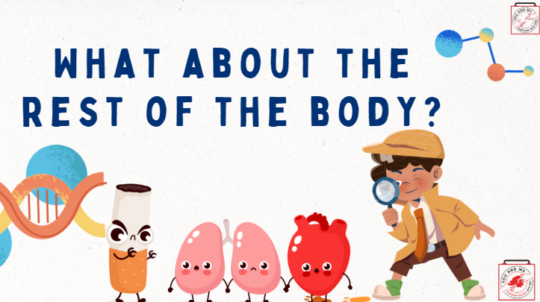 | Ok so now that we know about these chemicals in e-cigarettes, how do they affect the body?  Well...
18 | 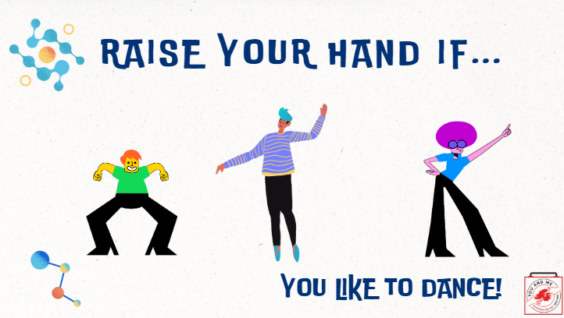 | Raise your hand if....  You like to dance?
19 | 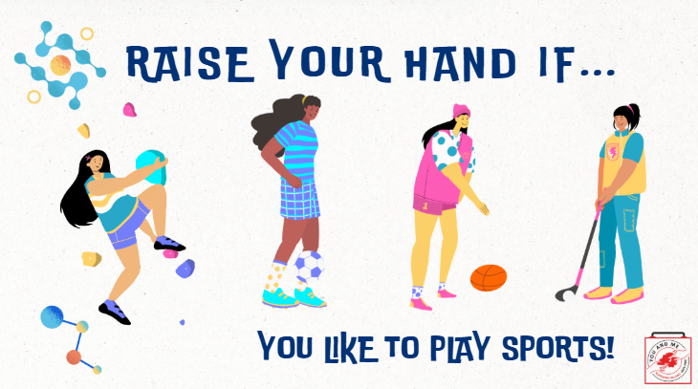 | Raise your hand if....  You like to play sports?
20 | 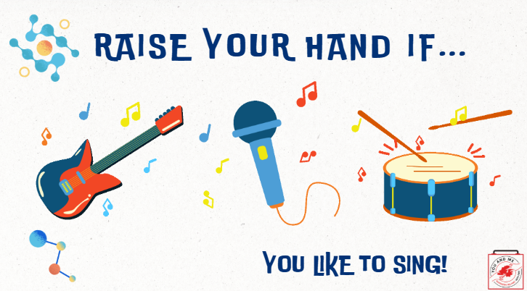 | Raise your hand if....  You like to you like to sing?
21 | 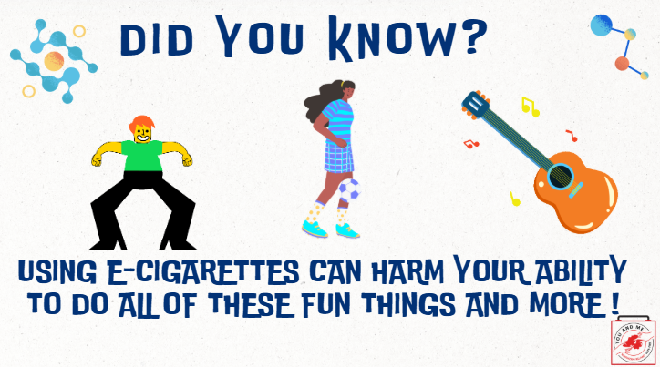 | Well, did you know that using e-cigarettes can harm your ability to do all of these fun things and more?
22 | 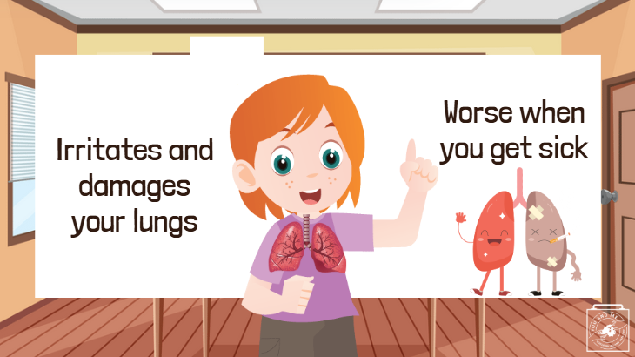 | Since e-cigarettes are used by inhaling, let's discuss how those chemicals can harm your lungs.  They irritate and damage your lungs and airways.  Because they damage your airways, your body also has a harder time healing when you become sick, such as with COVID-19 or other lung infections.  As a result, young people who use e-cigarettes may experience asthma, bronchitis, and other health issues
23 | 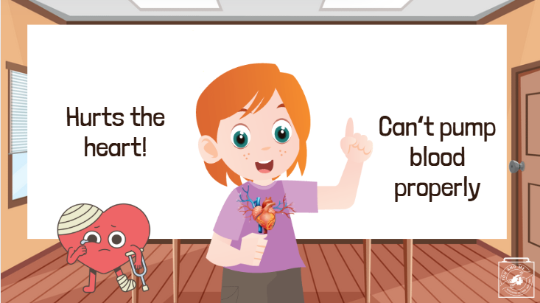 | In addition to harming the lungs, e-cigarettes also negatively affect your heart.  Breathing in the aerosol from an e-cigarette, even if you're not the one using it, is harmful to the heart.  As a result, the heart may struggle to pump blood properly through the body and into the brain.  This can make it difficult to engage in fun activities like dancing, playing sports, or singing.
24 | 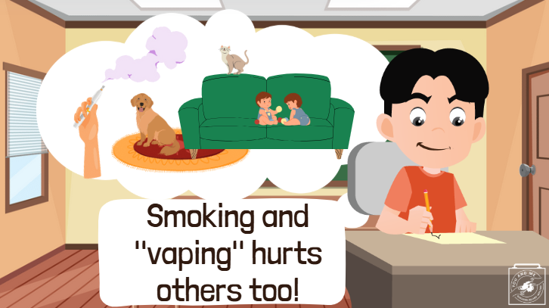 | Secondhand aerosol is the cloud of "smoke" that is released when someone is smoking or using an e-cigarette. This aerosol contains all of those harmful chemicals! If anyone nearby breathes it in, it can harm them.  Once the cloud dissipates, the chemicals can settle on nearby surfaces. This is known as thirdhand aerosol. We don’t want your pets or younger siblings stepping on those chemicals or accidentally ingesting them!  Therefore, smoking and using e-cigarettes can also harm others. The best way to avoid causing harm to yourself and others is to not use or try e-cigarettes at all.
25 | 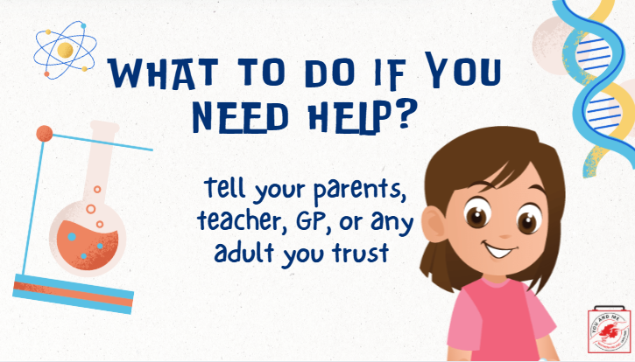 | So, what should you do if you need help?  If you or someone you know is using e-cigarettes and is having a hard time stopping, it’s important to ask a doctor, parent, teacher, or counsellor for assistance.  (Educator Note): Ask students to list three trusted adults they can approach for help with e-cigarette resources and support.  Ensure students understand that a trusted adult is a safe person they can talk to about sensitive topics concerning their health.  If you feel comfortable, suggest yourself as one possible adult for students to include on their list.  Be sure to read the room to gauge whether students are comfortable sharing or if they would prefer to keep their lists private.  OPTIONAL ACTIVITY: Have students partner up and role-play asking for help from one of their trusted adults. Then, switch roles with their partner.  Possible Starting Script:  "Hey (insert trusted adult's name), I learned about e-cigarettes in school but still have a question. Can you help me with (insert topic or question)?"
26 | 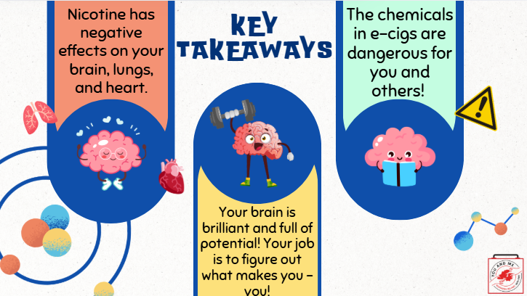 | Thank you for a great class! Let's review our key takeaways.  (Teacher Note): Read points on slide or have students read them.
27 |  | OPTIONAL HOMEWORK ASSIGNMENT - If doing the homework assignment, continue with the next few slides.  Talking Points:  Here is a sneak peek for our lesson next class.
28 | 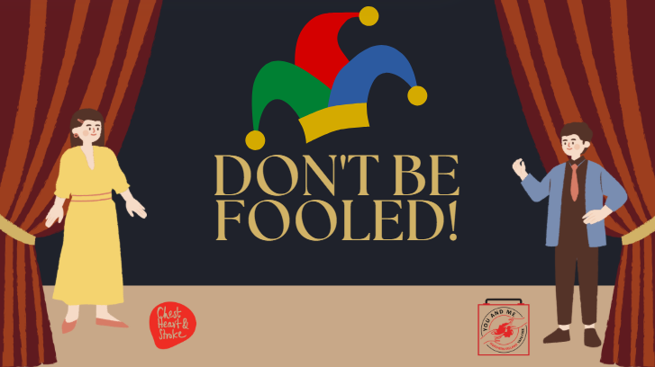 | Our next lesson is called "don't be fooled" and it's about how tobacco companies try to trick young people into thinking e-cigarette use is ok/cool.
29 |  | OPTIONAL HOMEWORK  Talking Points:  Let’s watch a video about a garbology project that uses a research tool called photovoice. Photovoice is employed by community advocates to document their community needs through pictures and storytelling.  This particular video was created by youth peer health educators. As a class, we will be undertaking a similar project.  (Play video)  So, when you go home tonight, you can take a picture with your phone (or use newspaper clippings or magazine pages) to document how e-cigarette use affects our school, community, and neighbourhoods. We’ll share this homework in our next class.
30 | 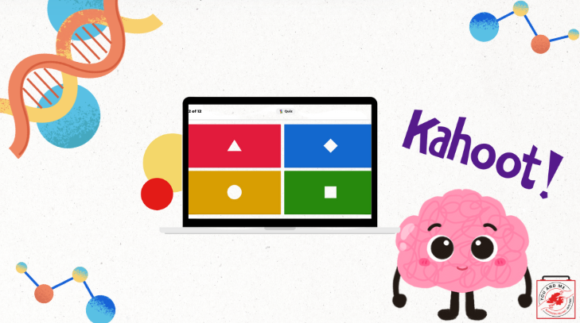 | Click on image for link to Kahoot! or see below  https://create.kahoot.it/details/ac73b6aa-0516-43e9-9a55-cd4ba45134ee

