

KS2 Lesson 2 : Don’t be fooled !

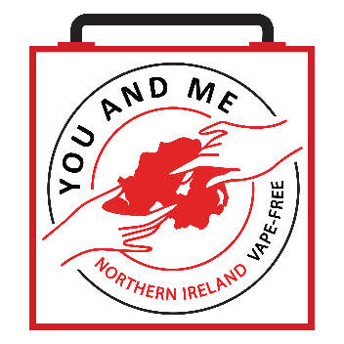

Lesson 2
Talking Points and Slide Chart

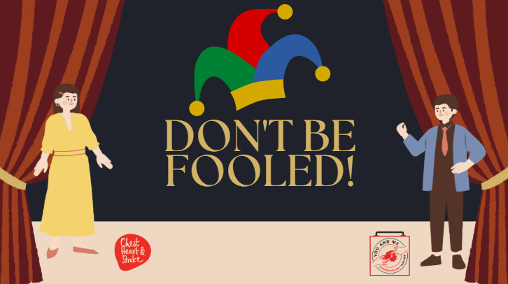

Slide | Image | Talking Points
1 |  | Welcome back, class! This is our second lesson on e-cigarettes, other tobacco products, and nicotine.
2 | 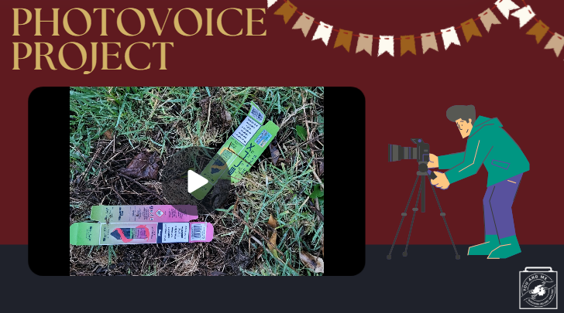 | Do you remember the video from our last class? How did your homework go?  (Teacher Note): Conduct a homework debrief and photovoice sharing session.  Ask students to share some of the images they took or drew.  How did they find the activity?  How do they think e-cigarette use affects their community?  Did any feelings come up during the activity?
3 | 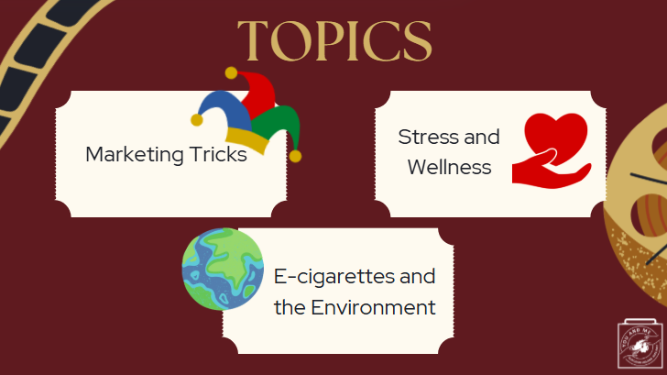 | Today, we will discuss the following topics:  (Teacher Note): Read from the slide.
4 | 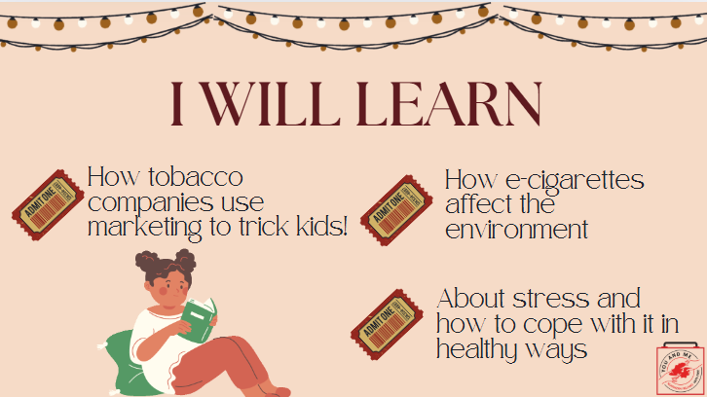 | I will learn...  (Teacher Note): Read from the slide.
5 | 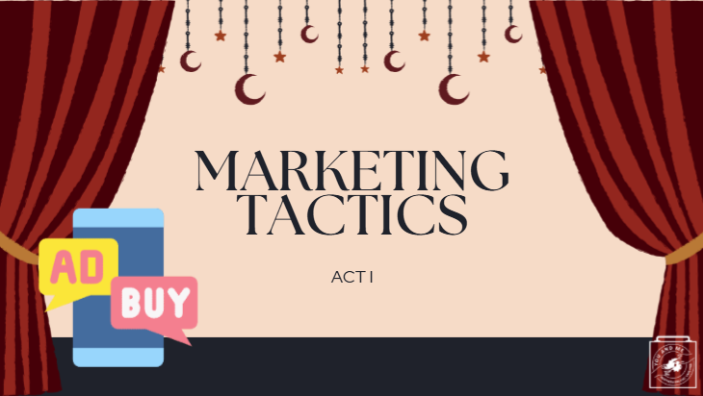 | Act I: Marketing Tactics!
6 | 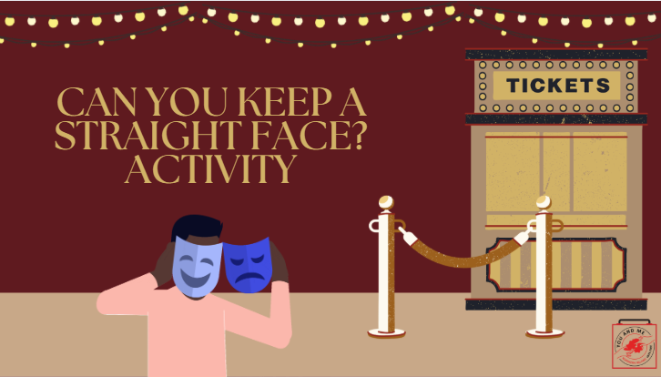 | Warm-Up: Keep A Straight Face!  Objective: This activity is designed for you to experience the pressure to behave in certain ways, despite any effort to resist.  Procedures:  - Organise students into pairs or small groups of four.  - Ask each pair or group to nominate one person as the ‘resistor,’ while the other members will be the ‘comics.’  - The three comics must do everything in their power (except for making physical contact) to make the resistor laugh.  - Meanwhile, the resistor must do everything they can to remain straight-faced.  - Each group has one minute for this challenge.  - After each minute, swap roles so that every group member has a turn as a ‘resistor.’  Discussion:  - (Ask Students): Do you think it can be hard to resist other people’s invitations, encouragement, and pressure to do certain things or behave in certain ways? Why or why not?  - (Ask Students): How can you resist the pressure to join in something that looks cool but actually leads to harm (to yourself and to others)?  Please keep these ideas and thoughts in mind as we now discuss tobacco marketing.
7 | 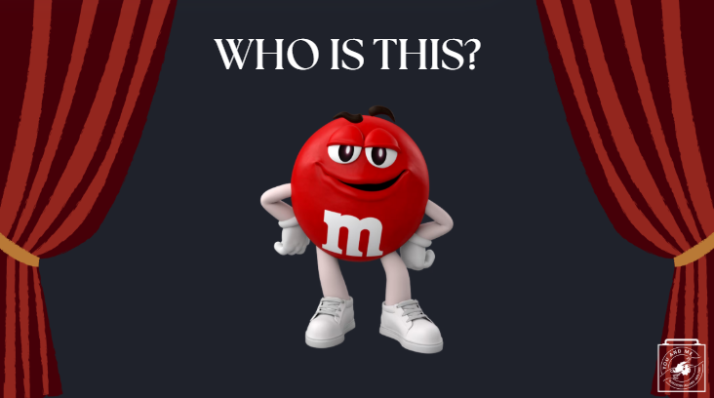 | Before we move on, I have a couple of questions: who is this? (Take a few answers).
8 |  | What do you think of when you see this? (Take some responses).
9 |  | How about this? (Take some responses).  (Ask Students): What age group do you think this is targeting? People your age? Younger? Older?  The reason you recognize all of these things, even without any words, is because of marketing!
10 | 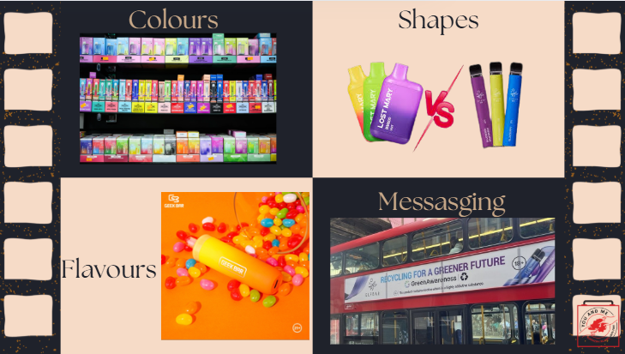 | BUT guess what? E-cigarette companies do the same thing! They target YOUth by using colours, shapes, flavours, and messaging designed to attract YOUth. These companies have found significant success in social media marketing and utilise platforms like Instagram, Snapchat, and even TikTok!  Does anyone know why they would want to target YOUth? (Take some responses
11 | 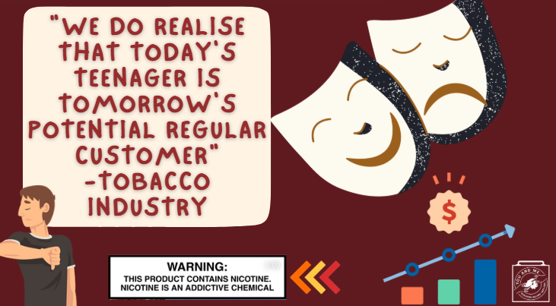 | Remember how we discussed that developing brains are sensitive to drugs and nicotine?
12 | 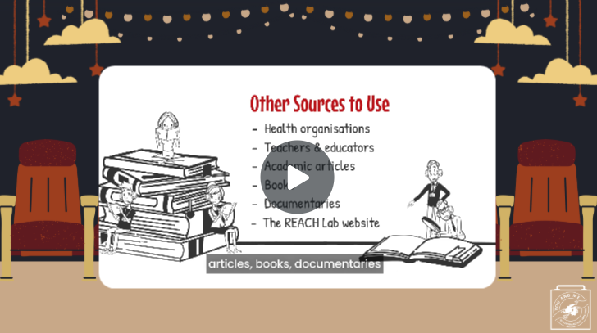 | From flavours to the packaging of their products, nicotine products are designed to make smoking look cool, fun, and exciting—all aimed at grabbing the attention of new and young consumers.  (Teacher Note): Play the embedded video about kids looking at tobacco products.
13 | 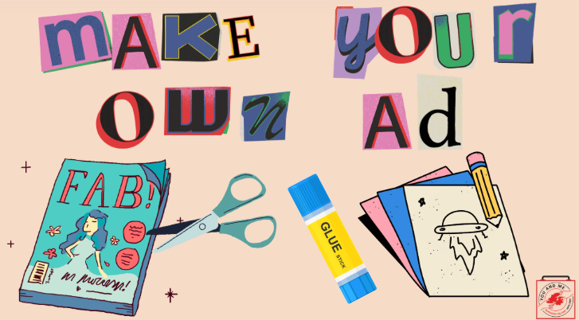 | OPTIONAL ACTIVITY  (Teacher Note): Using the tactics they learned (colours, shapes, etc.), have your students create their own advertisement. This time, they will flip the script and design an anti-vaping ad, as if the tobacco industry were telling the truth about their harmful products. They can choose to draw, make a poster, or cut out images from magazines or newspapers.  Procedures:  1. Gather old or new magazines, newspapers, scissors, glue, and any other craft supplies you would like to use.  2. Students will create their ads on a small to medium-sized white or black poster.  3. Have students use the materials to make an Anti-Vaping/Smoking ad.  4. Each student or group (2-3 students) can share their ad with the class.  Bonus: Hang all of the anti-vaping ads around the classroom or school.
14 |  | Great job, everyone! Our next discussion will focus on the environment and how e-cigarette use can harm it!
15 | 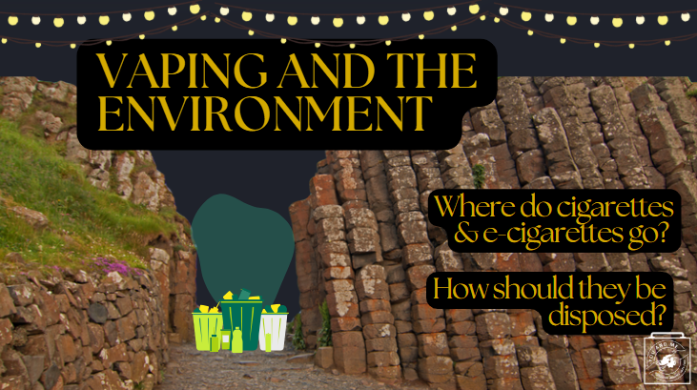 | (Ask Students): How do you think people dispose of cigarettes? (Pause for responses.)
16 | 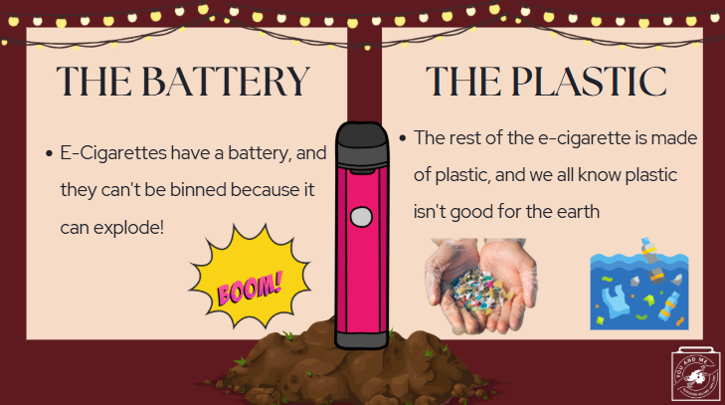 | Did you know that e-cigarettes contain a battery? They do! This battery is often made from dangerous metals like lithium-ion, which can explode when processed in bin lorries or rubbish dumps.  E-cigarettes qualify as e-waste and must be disposed of like other electronic devices.  The rest of the e-cigarette is made of plastic. As these plastics break down, they turn into tiny microplastics, which are small enough to enter ocean ecosystems and even the food we eat!  So, if you see an e-cigarette in the grass or in a park, be sure to tell your parents, teacher, or another adult, and remind them to take it to an e-waste disposal site.
17 | 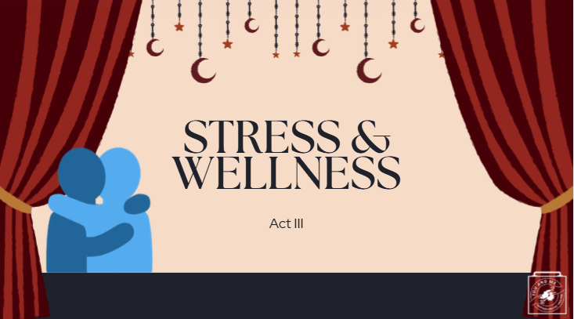 | Now that we understand that e-cigarettes aren't good for our bodies or the environment, let's move on to explore how e-cigarette use can affect our stress and overall well-being.
18 | 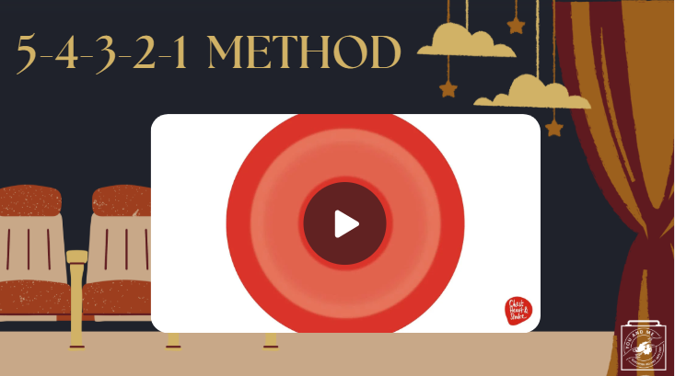 | To get started, let's do a grounding exercise called the 5-4-3-2-1 method.  (Play video)  Okay, how did that make you feel? (Take a few responses.)  Now that we've done it together, remember that you can use this exercise anytime you're feeling sad or stressed.  But what is stress?
19 | 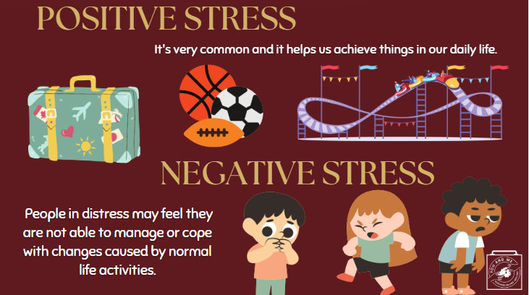 | There are two types of stress:  Positive Stress: This is short-term and is something everyone experiences. It can be motivating, exciting, and can help you achieve your goals. Here are some examples of positive stress: planning a trip, playing sports, and going on a rollercoaster.  Negative Stress: This can be either short-term or long-term. It feels unpleasant and can make you feel anxious or worried. People experiencing negative stress may feel overwhelmed and struggle to cope with the changes caused by normal life activities.
20 | 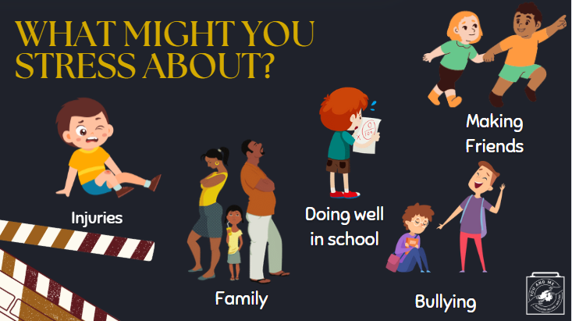 | Here are some things that you may stress about. (Read examples from the slide).  (Ask Students): What are some other things that you stress about nowadays? (Take a few responses.)
21
22 | 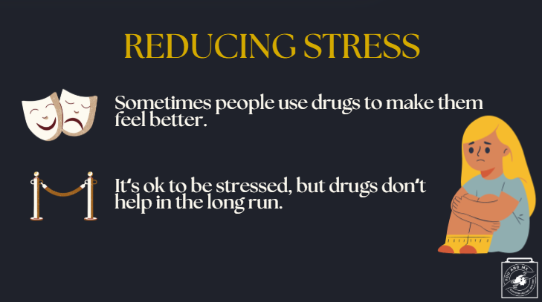 | When people become overly stressed, they sometimes turn to drugs like nicotine to try to feel better.  Just remember, it's okay to feel stressed, but drugs don't provide a long-term solution.  Instead, let's explore some healthy ways to cope with stress...
23 | 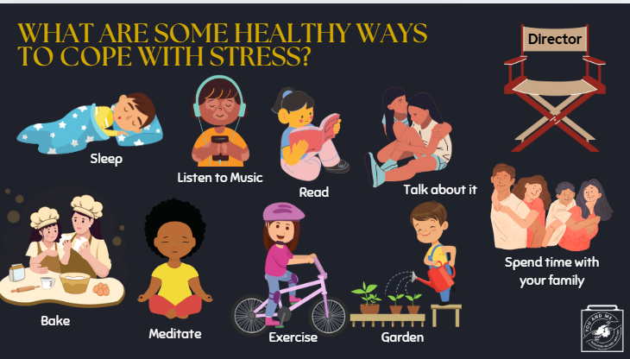 | Here are some healthy ways to cope with stress instead of using drugs like nicotine. (Read examples from the slide.)  (Ask Students): What are two other ideas that you use to cope with stress? (Take a few responses/ideas and write them on the board. Have each student write down their two ideas and share them with their neighbor or table/group.)  These are some great examples! Just remember that YOU are in the director's chair of your own life.
24 |  | Let's do one more example of an activity you can do when you're stressed. It's a type of breathing called Squared Breathing.  Let's watch the video now (click on video).
25 | 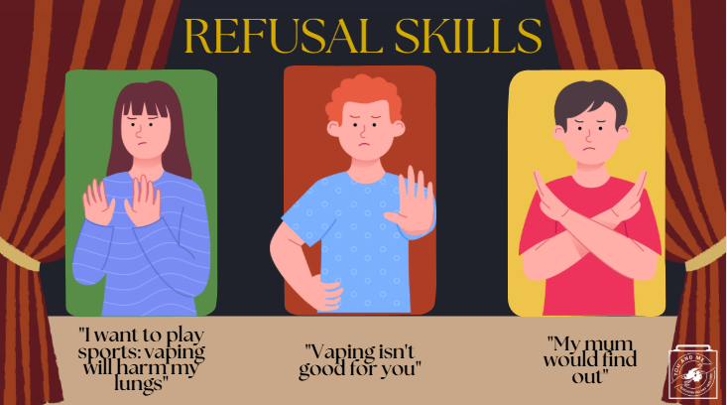 | Now that we know how to deal with stress, what would you do if someone you knew offered you an e-cigarette?  There are several ways to say "uh-uh, no thank you!" Here are a few examples:  - You could say, "I want to play my best at practice tomorrow so the coach will pick me to play in the big game. Vaping will harm my lungs."  - You might remind them that "vaping isn't good for you."  - Or you could say, "My mom would find out."  Now, let's try a roleplay activity, just like in a real theatre!  (Teacher Note): Break the class into groups of 3-5 students. Have the students turn to a friend and practice a refusal strategy. One student can pretend to offer an e-cigarette, while the others try out a refusal tactic (or come up with their own!). Then, have them switch roles!
26 | 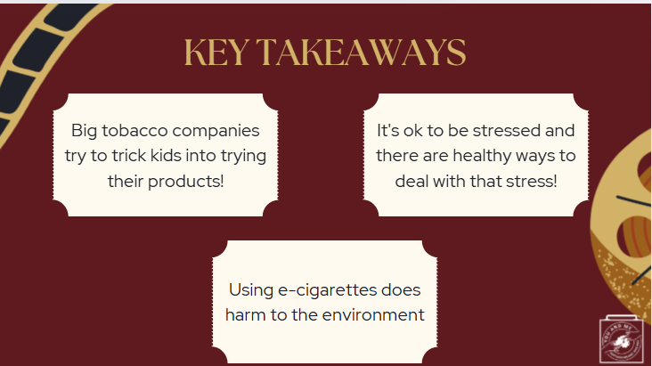 | Amazing job! That's it for our lesson today! We hope you learned these key takeaways (Read from slide).
27 |  | Educators - This is the post survey for our dashboard. Please have your students complete this survey after the pre-survey and the curriculum has been implemented.  More information can be found at https://med.stanford.edu/halpern-felsher-reach-lab/curriculum-data-dashboard.html  Students can access the post survey at the QR code on this slide, or at https://qrco.de/behk7d
28 | 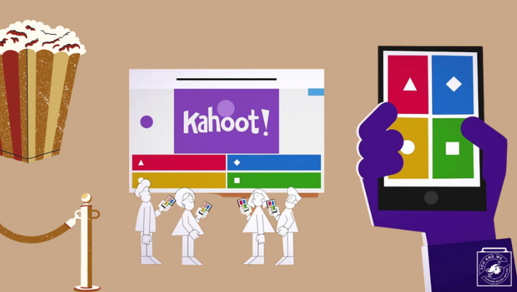 | Click on image for link to Kahoot! or see below  https://create.kahoot.it/details/a82d12d4-5adc-4017-9864-e32e498a6777

