

KS3 Lesson 1:
Full of Potential : Your Brain Nicotine-Free



Lesson 1
Talking Points and Slide Chart

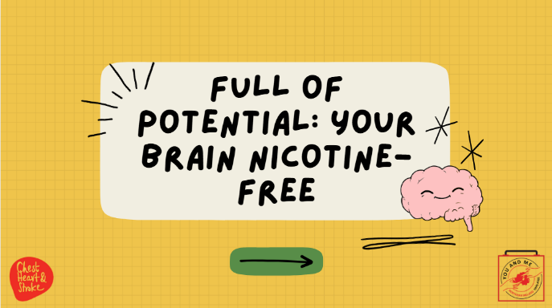

Slide | Image | Talking Points
1
2 | 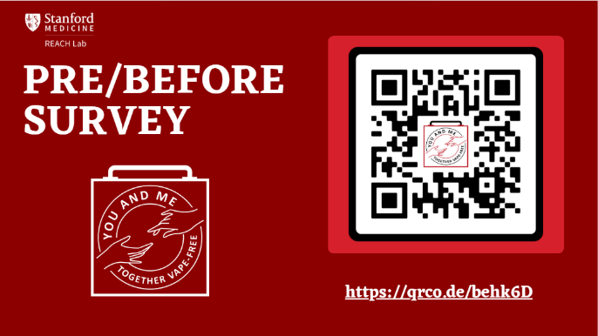 | Educators - as you hopefully saw in the instructions to this lesson 1, we hope you will have registered for our dashboard, instructions and more information can be found at https://med.stanford.edu/halpern-felsher-reach-lab/curriculum-data-dashboard.html  Further, please have your students complete these pre and post surveys. They can access the pre-survey at the QR code on this slide, or at https://qrco.de/behk6D  At the end of the curriculum, please have students take the post survey, links can be found in the slides at the end of the curriculum. Thank you!
3 | 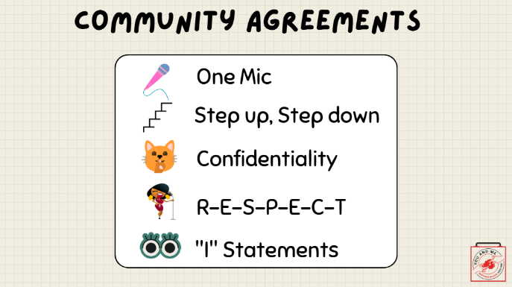 | (Note: this slide is optional; you may use these or use your own established classroom norms)  Talking Points:  Here are our community agreements:  One Mic (explain, if needed): one person talking and no interrupting.  Step up, Step down (explain, if needed): if you find yourself speaking a lot, take some time to listen and leave space for others. If you find yourself holding back your thoughts, speak up and share with us.  Confidentiality (explain, if needed): what is said here, stays here, or another way to say it is that our classroom is a confidential space.  (Spell out): R-E-S-P-E-C-T (song by Aretha Franklin)  "I" Statements (explain, if needed): say "I think" or "I feel" instead of "you don't care what I think or feel."  (ask students): Are there others you would like to add to our community agreements?  (Write these on the board or add to the slides).
4 | 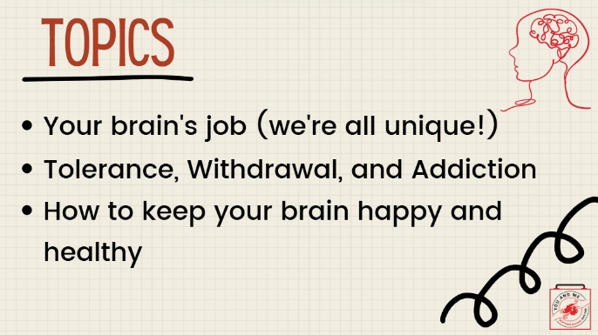
5 | 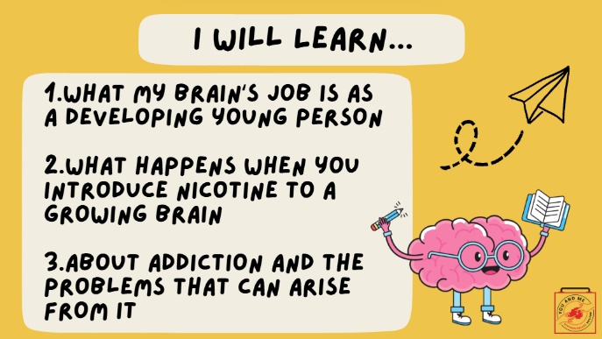
6 | 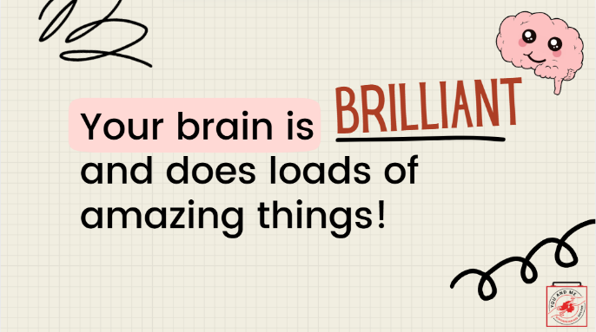 | Your brain is brilliant and does loads of amazing things!
7 | 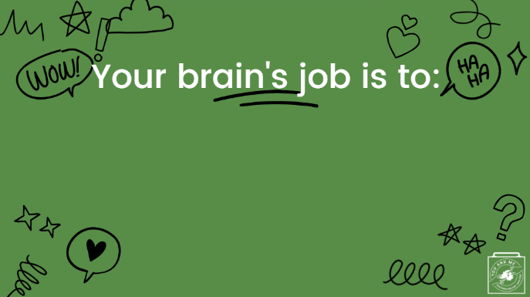 | Your brain’s job is to
8 | 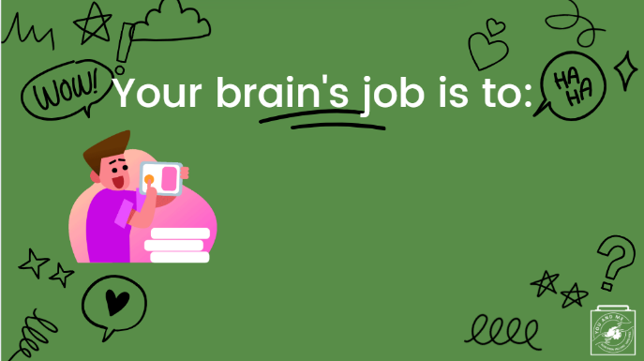 | Help you figure out what you like...
9 | 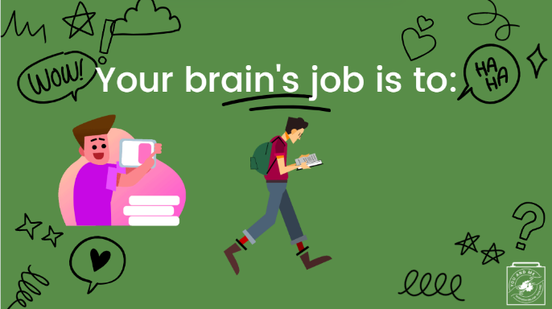 | Learn new things...
10 | 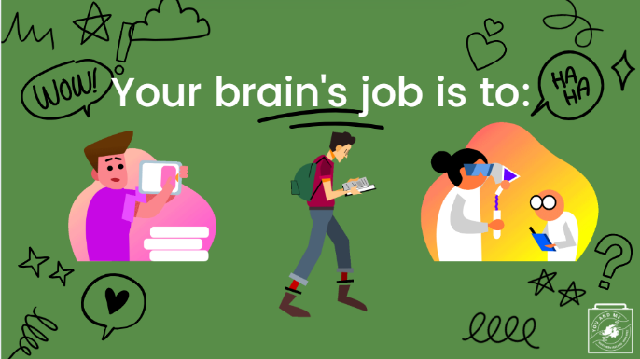 | ...and help you become the person you want to be.
11 | 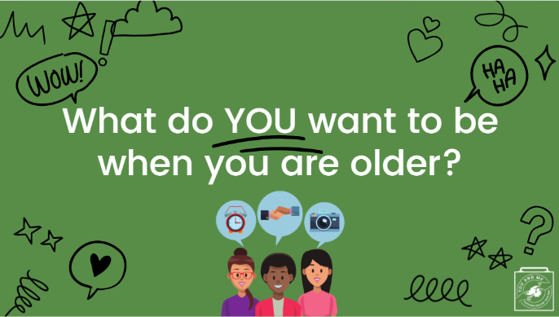 | (Ask students):  What do you want to be when you grow up?  (pause and wait for some responses).
12 | 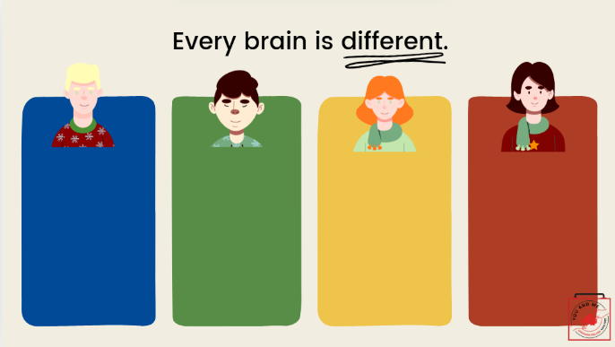 | Everyone’s brain is different.  This is why we enjoy different things, are good at different things, and have different personalities.
13 | 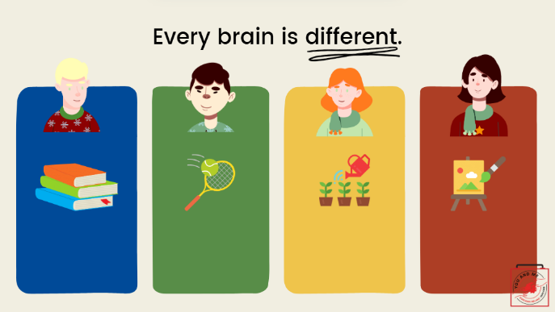 | Here are some examples.  One person likes to read books, another enjoys tennis, while another likes to garden, and someone else may enjoy painting.
14 | 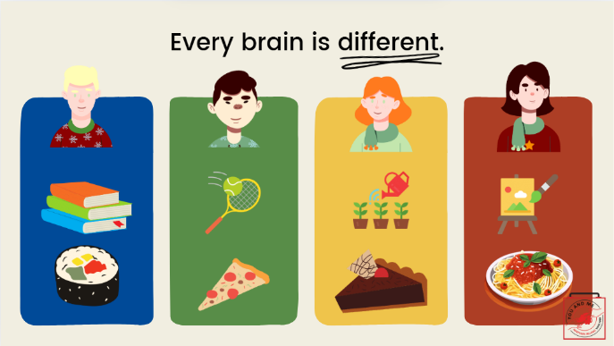 | And here are some more.  As you can see, everyone likes different foods like pizza, sushi, pie, and pasta.
15 | 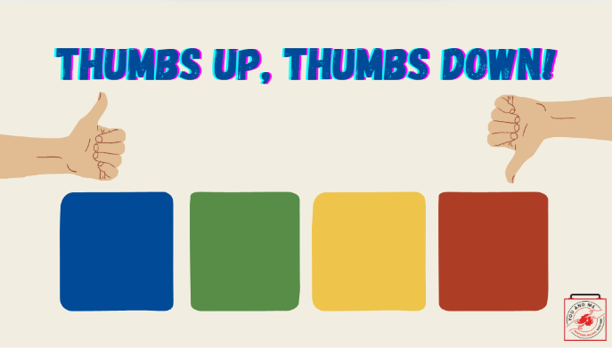 | Let's play Thumbs UP, Thumbs DOWN.  Give me a thumbs up if you LIKE it, and a thumbs down if you don't like it.  Ready?
16 | 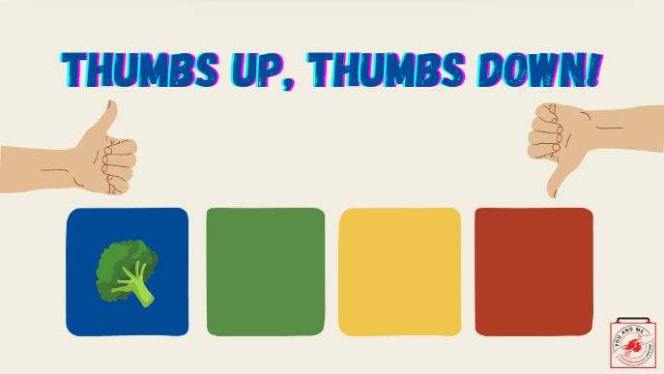 | Thumbs up or down?  Broccoli!
17 | 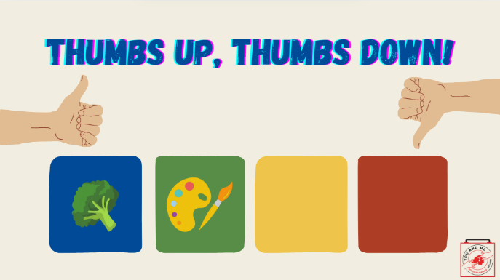 | Painting?  Thumbs up or down?
18 | 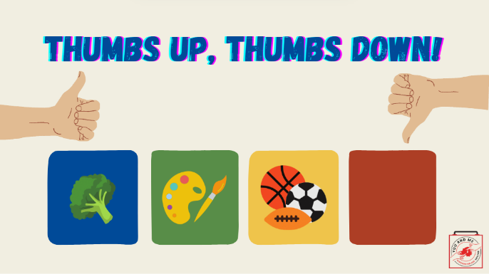 | Playing sports?  Thumbs up or down?
19 | 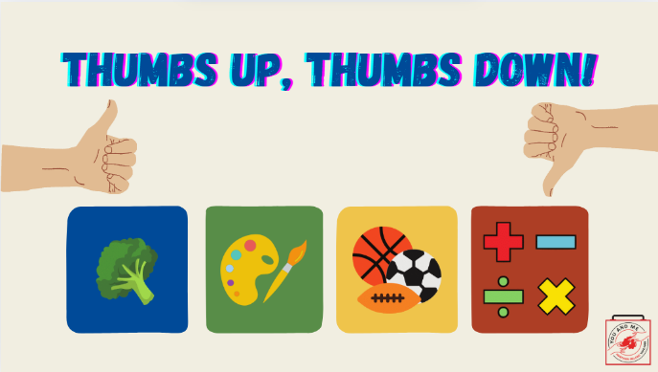 | Maths is my favourite subject.  Thumbs up or down?  Great participation, everyone! Let's continue.
20 | 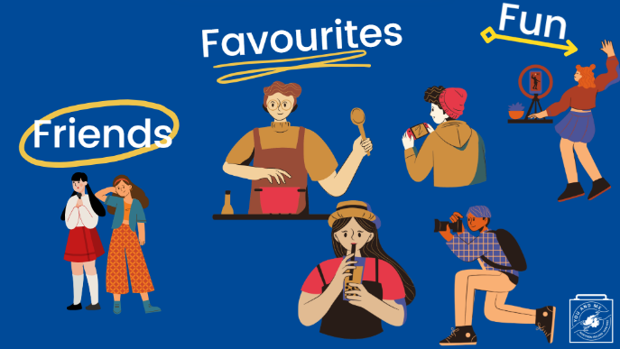 | Right now, your brain is looking for things that it likes.
21 | 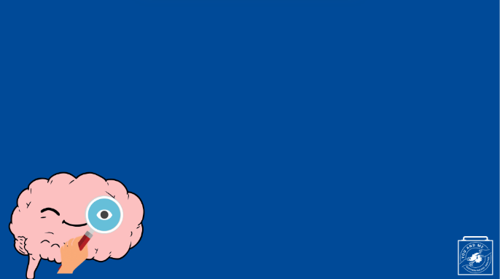 | This little brain is trying to find out what things she likes, and what things she doesn't like.  This is an important job.
22 | 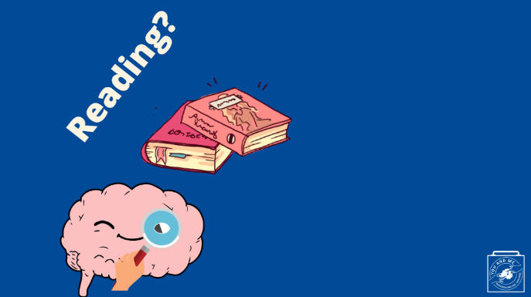 | because it helps her find new fun hobbies to enjoy;
23 | 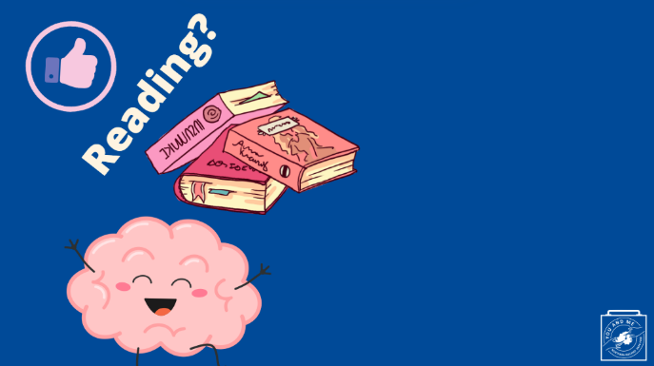 | like reading;
24 | 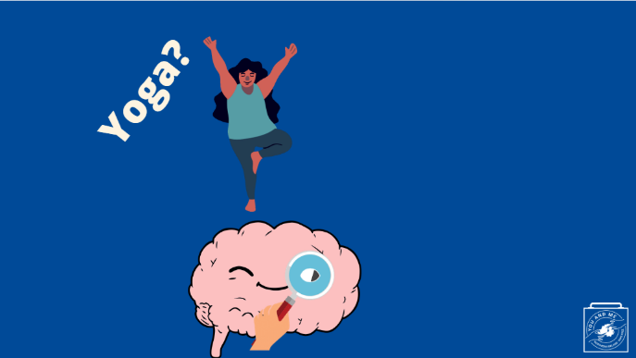 | and trying new activities, like yoga.
25 | 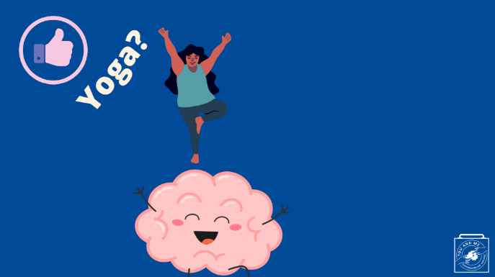 | And liking yoga.
26 | 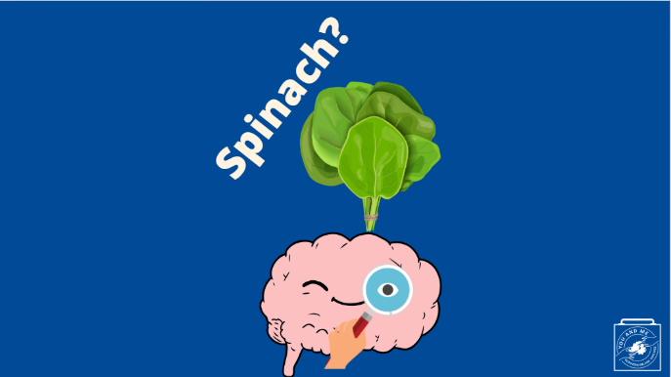 | She trying to figure out what foods she enjoys
27 | 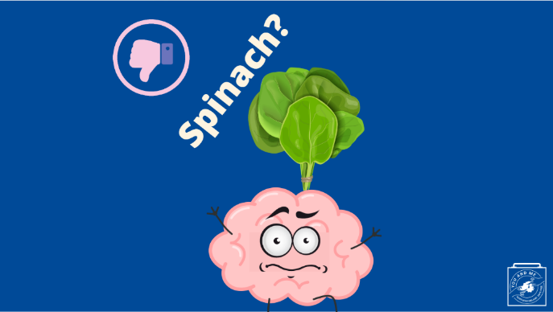 | and what she doesn't enjoy
28 | 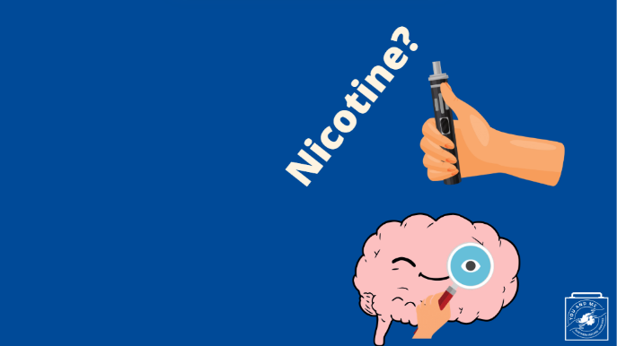 | While this brain is looking for what she likes, it’s at risk of getting tricked by things like drugs.  For example, nicotine is the drug that is in cigarettes, e-cigarettes, and other tobacco products.
29 | 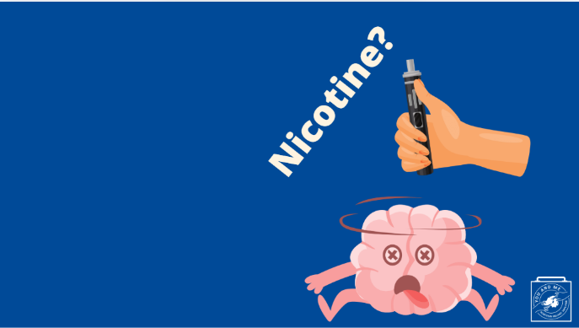 | Drugs can trick the brain by making it think it likes the drug and making it feel good at first.
30 | 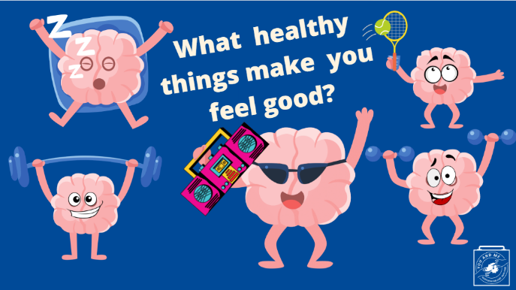 | It’s not a bad thing to want to feel good!  What are some healthy things that make you feel good?  (pause for some responses).
31 | 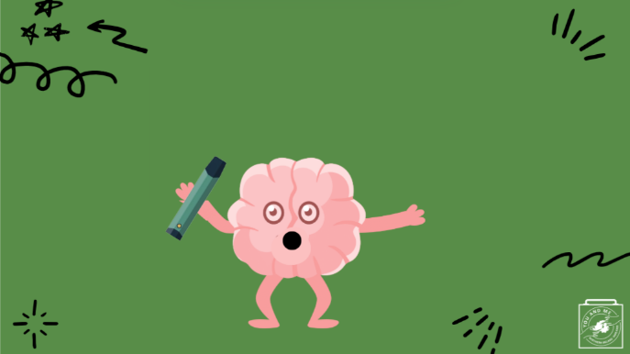 | But the problem with drugs like nicotine is that eventually, it takes more and more of the drug to make the person's brain feel good.
32 | 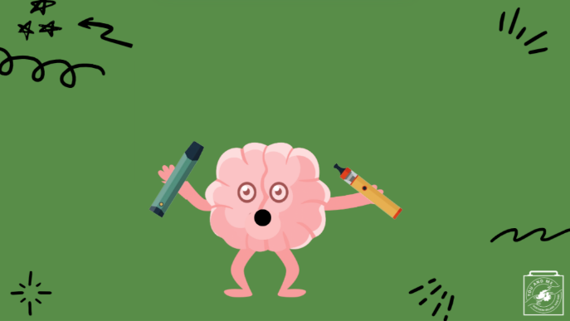 | Now the brain is using two e-cigarettes.
33 | 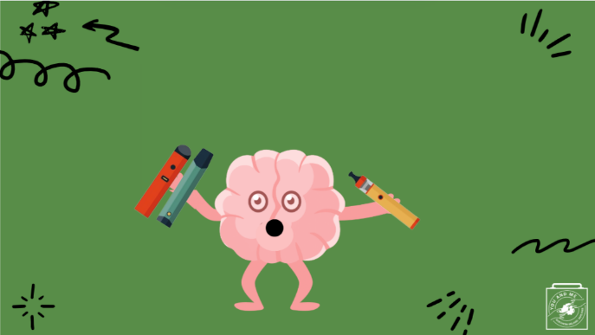 | Now the brain is using three e-cigarettes!
34 | 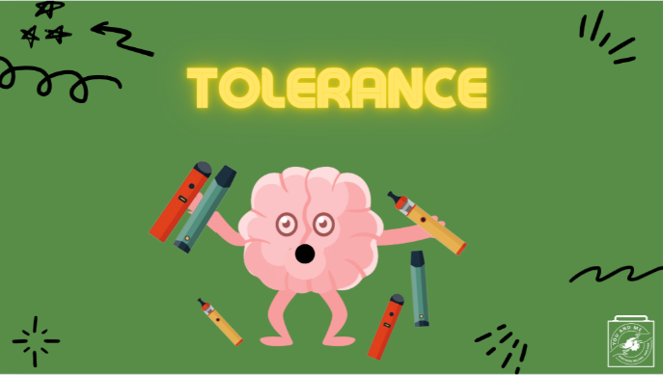 | This is called tolerance, which means it takes more and more nicotine to feel the pleasure someone used to.
35 | 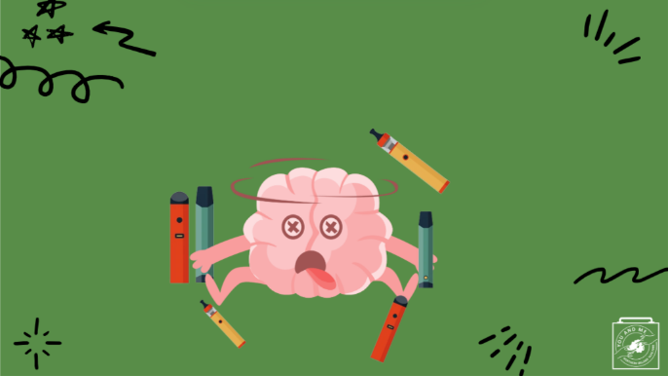 | This person's brain doesn’t feel good anymore, but it’s really hard to stop using the drug.
36 | 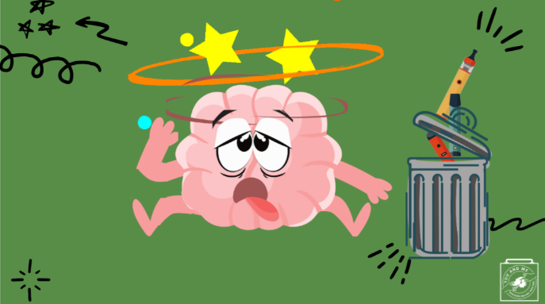 | Not only that, but when they try to quit, the brain and the body feel really bad.  This brain (and the person) feels tired and irritated.
37 | 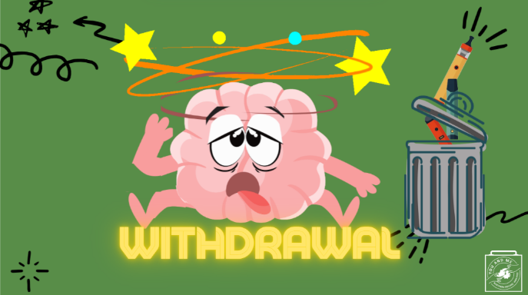 | This feeling is called withdrawal. It's a very uncomfortable feeling.
38 | 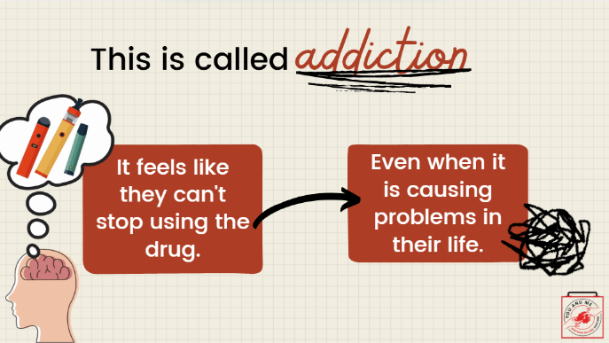 | So, the person feels like they can’t stop using the drug, even when it causes problems in their life and it isn’t enjoyable anymore.  This is called addiction.
39 | 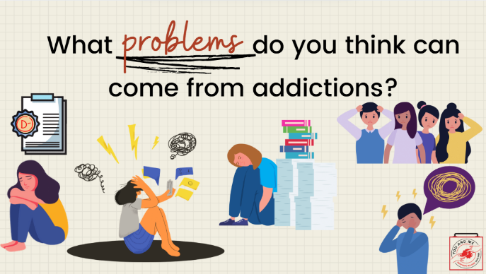 | What problems do you think can come from addictions?  (pause for responses, if they need examples):  it's hard to focus in school; parents and teachers can get mad and upset; losing friends; dropping grades; feeling lonely, sad, stressed; letting friends down; worse at sports
40 | 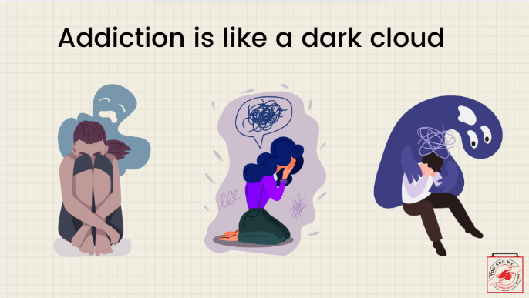 | Addiction can stop the brain from doing its job because it can’t focus on what’s important now that this drug is in charge.  And the brain can no longer do its job, which at this age is to figure out what you like, want, or want to be.  It can be like having a dark cloud always following you.
41 | 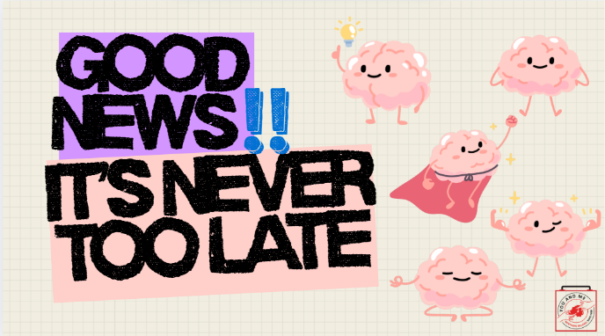 | But there is good news!  It's never too late for the brain to heal itself, even if it's struggling with addiction.
42 | 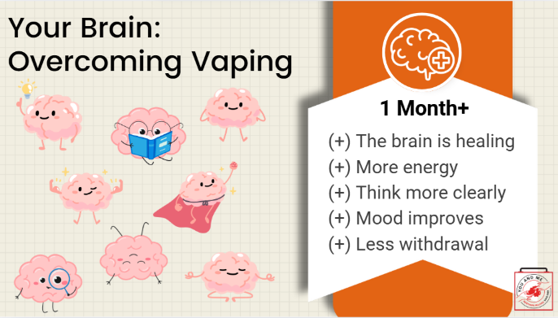 | It may take some hard work and determination, but if the brain can commit to quitting and getting off of drugs like nicotine, then it will see immediate benefits and healing to the brain!  After about a month of stopping vaping, the brain could see the following benefits (read off the slide).
43 | 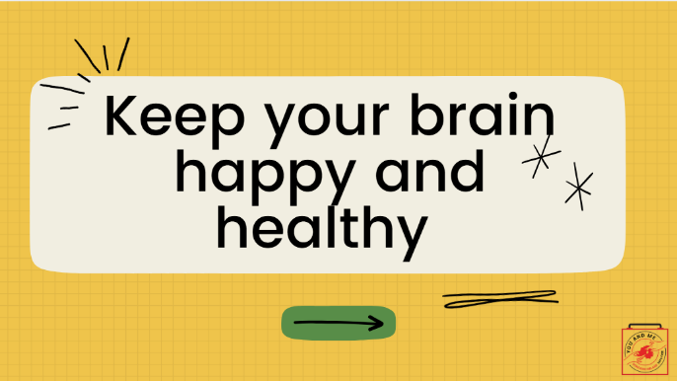 | Because nicotine interferes with your brain's development and it can be hard to end addiction, it's important to keep your brain happy and healthy.
44 | 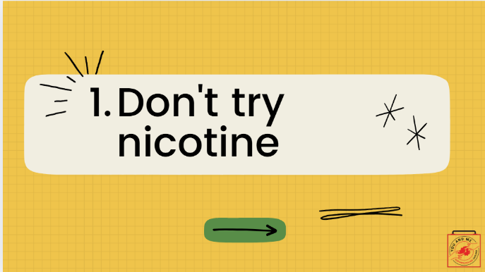 | The best way to stay out of addiction to nicotine is to not use it at all.
45 | 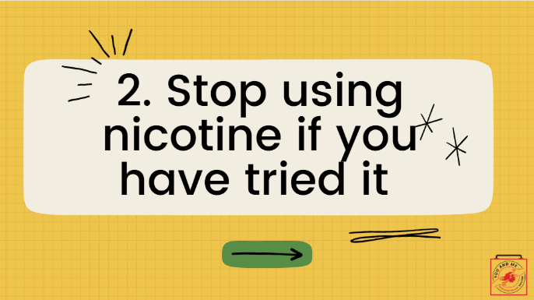 | If someone is already using nicotine, the best idea is to stop using it.  They can also encourage friends and family not to use to protect their health
46 | 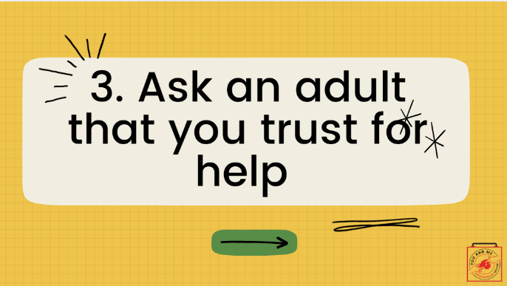 | If a person is having a hard time stopping, it is important to ask a GP, parent, teacher, or counsellor for help.  (Educator note): Have students pair up and write down/describe a situation that might require support from a trusted adult.  (Examples: still having a question after this lesson, having concerns about a friend who is using, how to dispose of an e-cigarette if they found one outside, how to deal with peer pressure.)
47 | 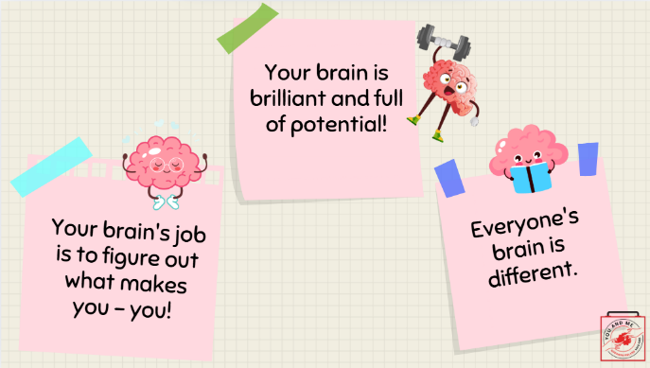 | Let's review our key takeaways.  The brain's job is to figure out what makes you - you!  Your brain is brilliant and full of potential!  Everyone's brain is different.
48 | 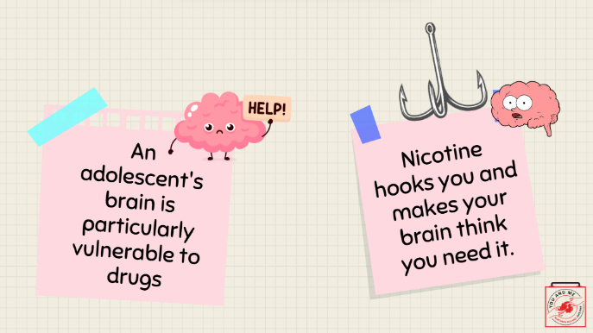 | An adolescent's brain is particularly vulnerable to drugs.  Nicotine hooks you and make your brain think you need it.
49 | 