

KS3 Lesson 2:
Healthy Body, Healthy You-th



Lesson 2
Talking Points and Slide Chart

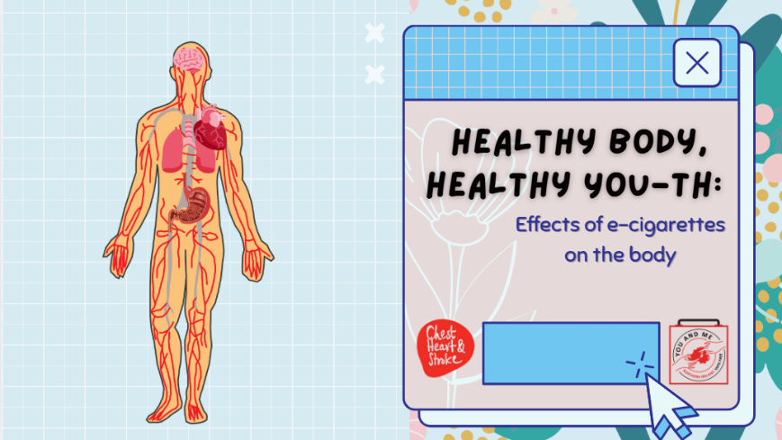

Slide | Image | Talking Points
1 | 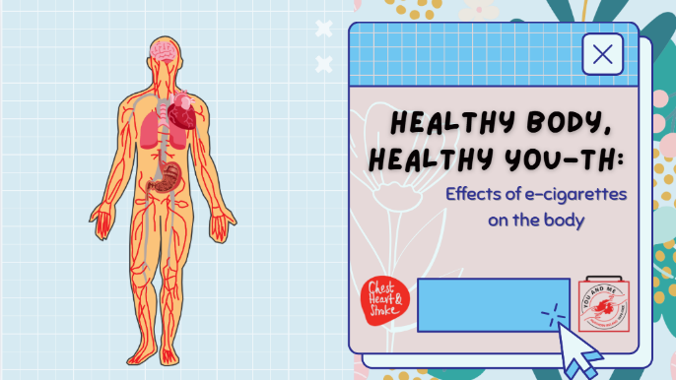 | Welcome back, everyone, and thank you for your amazing participation during our last lesson!  Today, we will continue discussing why many doctors, nurses, and your teachers are concerned about e-cigarettes.
2 | 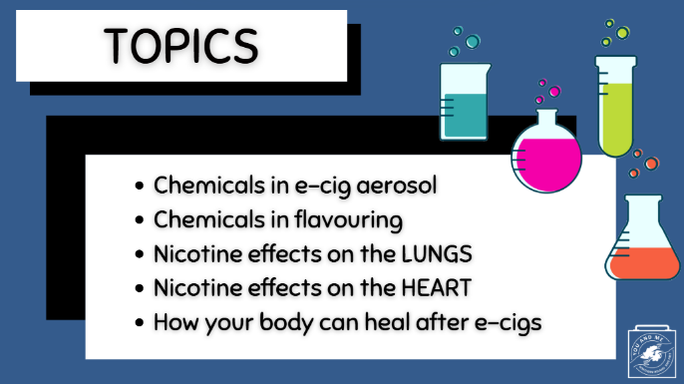
3 | 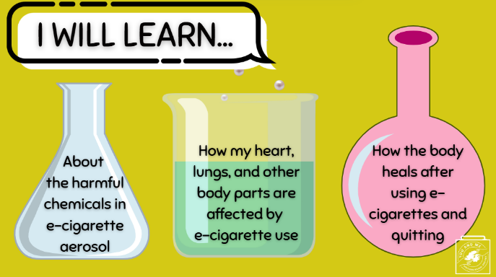
4 |  | Warm Up:  But first, during our last lesson, we discussed one ingredient in e-cigarettes that can affect adolescent brains. Does anyone remember what that was? (Take answers; then state it is nicotine).  (Ask Students): Why are we concerned about nicotine? (Take responses)
5 | 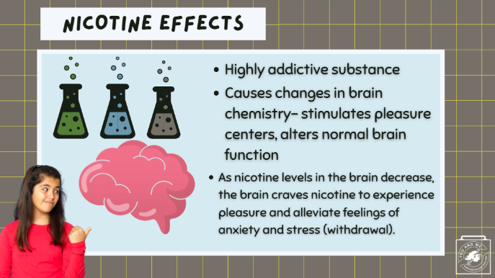 | Great. Thank you. Yes, nicotine can hurt the developing brain. So, as a review...  (Teacher Note): Read the bullets on the slide
6 | 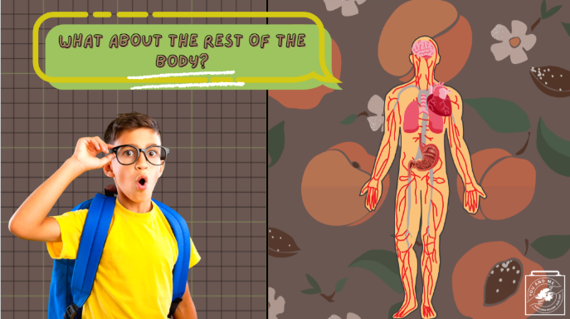 | So how do e-cigarettes affect the rest of the body?
7 |  | First, let's discuss what else is in an e-cigarette.  (Ask Students): Do you think e-cigarettes are just harmless water vapour?  They are not.
8 | 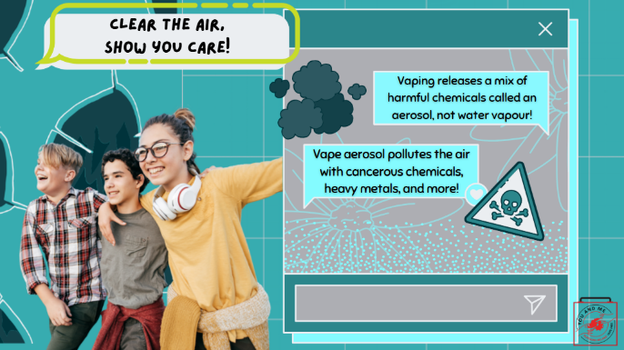 | E-cigarettes release a harmful aerosol, not harmless water vapour.
9 |  | (Teacher Note):  Play the brief video: (30 seconds)  https://www.youtube.com/watch?v=jWY-As9PTWo&t=4s
10 |  | Why does it matter that these e-cigarettes produce an aerosol?  What is in that aerosol?
11 | 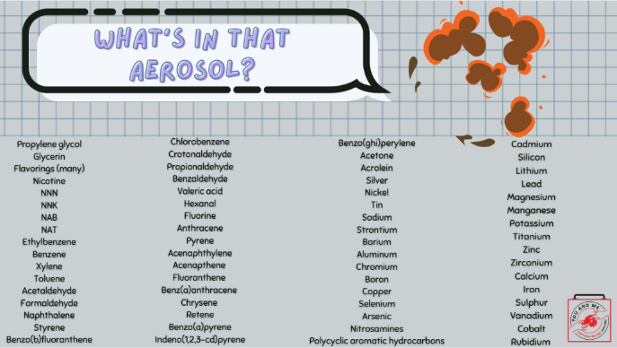 | All of these chemicals have been found in the e-cigarette aerosol.
12 | 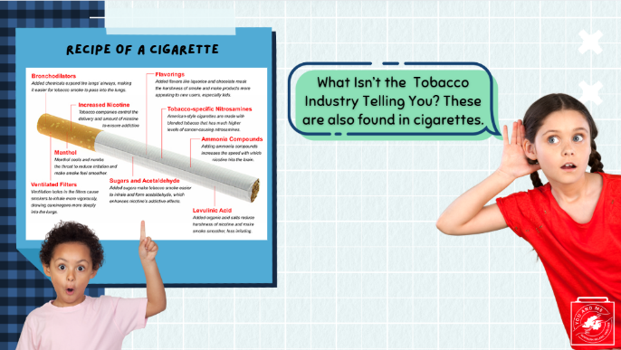 | And by the way, most of these ingredients are also found in cigarettes!
13 | 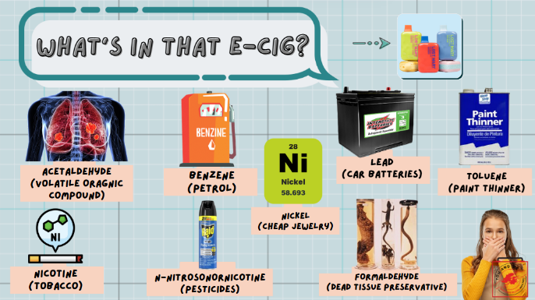 | Did you know that many of the ingredients found in e-cigarettes are also found in household products—products that I am sure you do not want to put into your mouth or body?  For example...  - Lung exposure to heavy metals such as nickel and lead can significantly increase your cancer risks.  - Acetaldehyde, which is a volatile organic compound, is linked to bronchiolitis obliterans, otherwise known as "vaper's lung."  - Other aldehydes, such as formaldehyde—which is used as a dead tissue preservative—can cause lung disease, as well as cardiovascular (heart) disease.
14 | 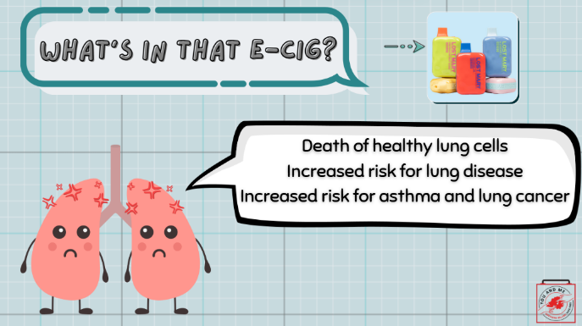 | Those e-cigarette ingredients can cause all sorts of harm to your lungs by killing or damaging otherwise healthy lung cells, increasing the risk for lung diseases like asthma and lung cancer.
15 | 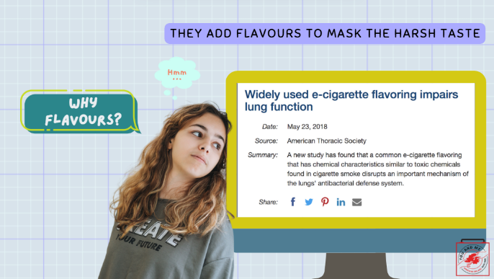 | E-cigarettes also have flavours and flavourants, like cinnamaldehyde (cinnamon), vanillin (vanilla), menthol, and others. When aerosolised through a vape, these flavours themselves are harmful.  You see, you can heat and eat these flavours, but if you heat them and then inhale the aerosol from them, that is where the concern lies!  These flavours can harm your lungs and heart, especially.  So, let's discuss the harms of flavoured e-cigarettes.
16 |  | Let's first discuss menthol.  (Teacher Note): Read slide.
17 |  | The tobacco and nicotine industry puts flavours in these e-cigarettes to attract young people.  Flavours that smell and taste good mask the harsh taste that tobacco and nicotine have, as well as the harms caused by e-cigarettes.
18 | 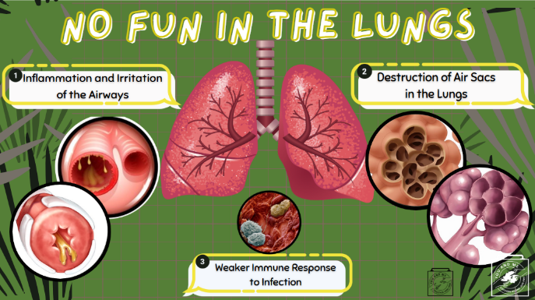 | Let’s now discuss the specific health effects of e-cigarettes.  First, let's discuss how e-cigarettes and their chemicals hurt your lungs
19 |  | This video explains how e-cigarettes can harm the lungs. Let's watch and listen.  Play embedded video (1:40).
20 |  | As you can see, e-cigarette use can do real damage to your lungs.  Let's hear from Ewan Fisher, who had a life-threatening case of e-cigarette and vaping-associated lung injury (otherwise known as EVALI).  Ewan Fisher switched from cigarettes to vaping, but at just 16, his lungs failed the night before he was due to start his GCSE exams. He spent weeks in intensive care and then needed an artificial lung to survive.  (Play video.)
21 | 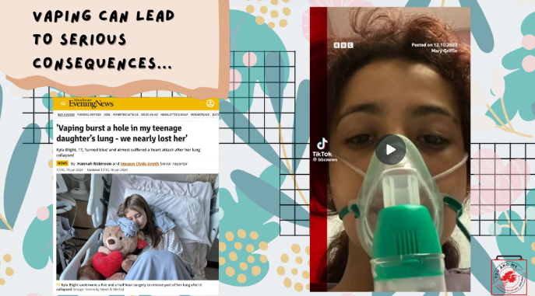 | Ewan is not the only young person to nearly die from vaping. More recent cases include 17-year-old Kyla Blight from Cumbria, who had to have part of her lungs removed after one of her lungs collapsed and she went into cardiac arrest.  Here in Northern Ireland, we've had similar cases.  (*Play video.)
22 | 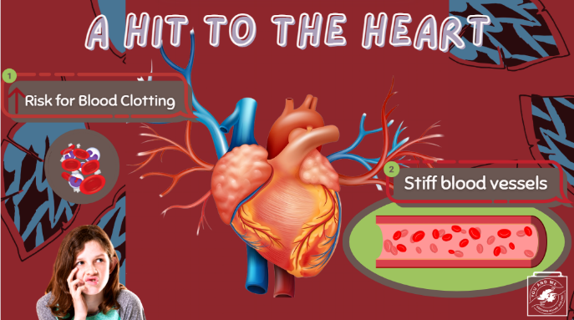 | In addition to harming the lungs, e-cigarettes can hurt your heart.  https://pmc.ncbi.nlm.nih.gov/articles/PMC9021536/
23 | 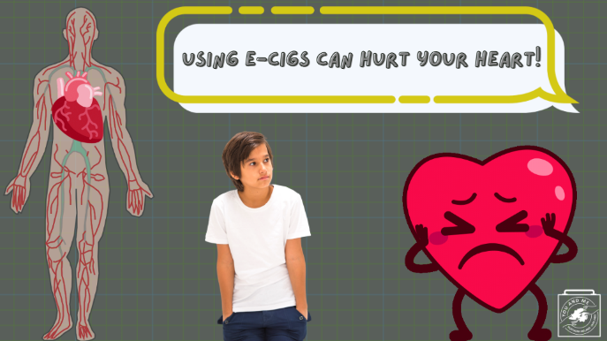 | The evidence that e-cigarettes increase cardiovascular or heart risk is piling up.  The heart is the center for pumping blood throughout a complex network of blood vessels in the body. These blood vessels are responsible for delivering fresh oxygen to organs or tissues.  Your cells need oxygen to survive and work properly.  Breathing in the aerosol from the e-cigarette, even if you're not the one using it, can lead to blood vessel stiffness and possibly affect your heart’s ability to move fresh oxygen to your brain, muscles, liver, and other parts of your body.  Ultimately, blood vessel stiffness and blood clotting can increase someone’s risk for a heart attack or heart disease.
24 |  | There is also evidence that using e-cigarettes can give you acid reflux or heartburn.
25 | 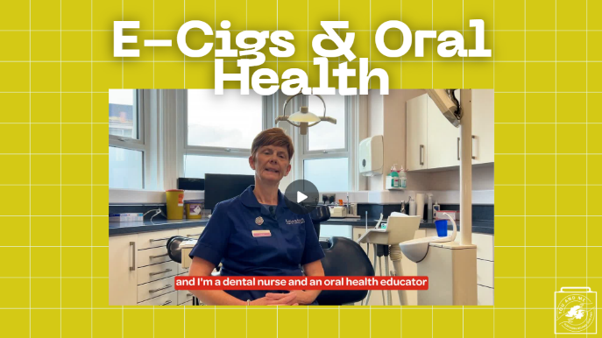 | The effects of vaping on your health don't stop there. Here is how it can affect your oral health as well.  (Play video.)
26 | 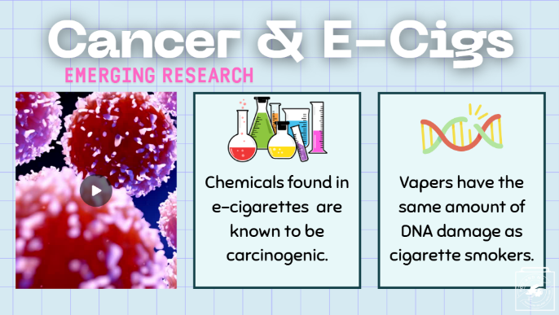 | Lastly, while the direct link between cancer and e-cigarettes is still being studied, there is emerging research that connects the two.  Here is some emerging research on the topic:  As we discussed earlier in the lesson, there are certain chemicals in e-cigarettes that are known to cause cancer.  Studies in humans found that vapers had the same amount of DNA damage as cigarette smokers, which is concerning since DNA damage is a critical part of cancer development, and cigarettes have long been known to cause cancer.  But, again, more research on this link is needed.  PEER-REVIEWED CITATIONS:  1.https://europepmc.org/article/MED/40278584  2.https://academic.oup.com/ntr/article/25/6/1145/7035481
27 |  | On the bright side, health risks decrease as soon as you stop using e-cigarettes.  For example, the risk of having a heart attack can drop immediately after quitting e-cigarettes.  Someone could take action right away to protect their heart by stopping any e-cigarette (or cigarette use).
28 | 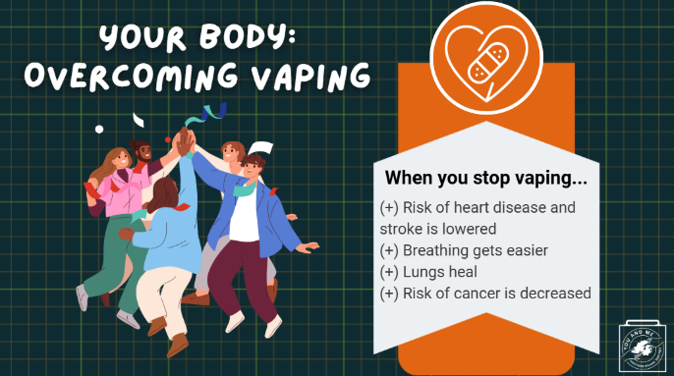 | In fact, your body begins to heal itself almost immediately after you stop vaping. While it might not be easy and the body will likely experience some withdrawals like we discussed last lesson, there’s a lot of healing the body could experience if a person chooses to quit.  (Read the healing processes on the slide.)
29 | 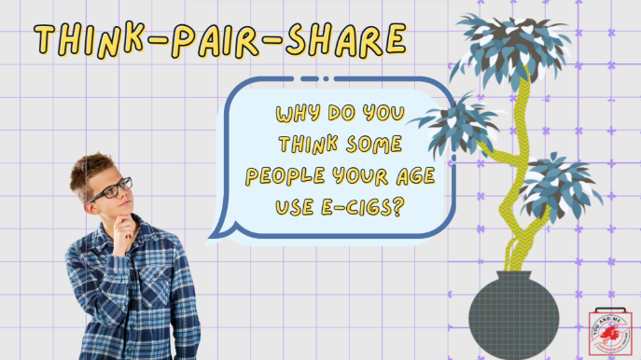 | (Think-Pair-Share): Even with all of these health concerns, why do you think it's common for people your age to use e-cigarettes?  (Teacher Note): Allow for discussion between students. Use the questions below to facilitate discussion if desired.  (Ask Students): What are some examples of myths or misinformation about e-cigarettes that are truly affecting young people's health?  (Ask Students): Do you think many flavour options make it hard for teens to be conscious of the harmful effects of e-cigs/vapes to young people?
30 | 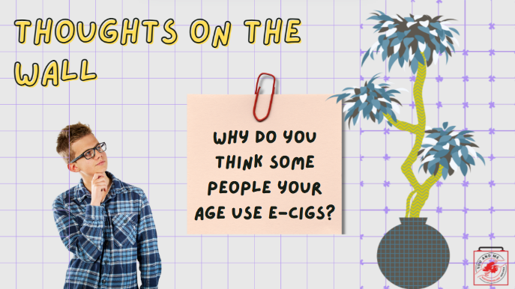 | Even with all of these health concerns, why do you think it's common for people your age to use e-cigarettes?  On a post-it note, write down your response and post it on the wall when you're done.  (Ask Students): What are some examples of myths or misinformation about e-cigarettes that are truly affecting young people's health?  (Ask Students): Do you think many flavour options make it hard for teens to be conscious of the harmful effects of e-cigs/vapes to young people?
31 | 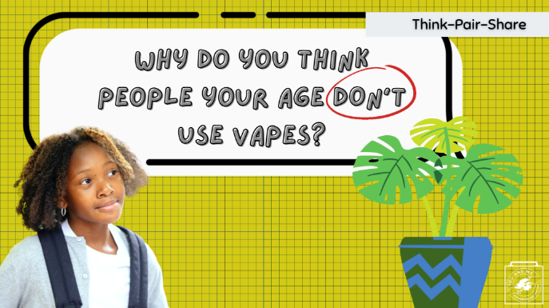 | Now, let's think about this topic in reverse: why do people your age not use e-cigarettes?  (Teacher Note): Allow for discussion between students. Use the question below to facilitate discussion if desired.  Q: Do you think there is a stigma against people your age who use e-cigarettes?
32 | 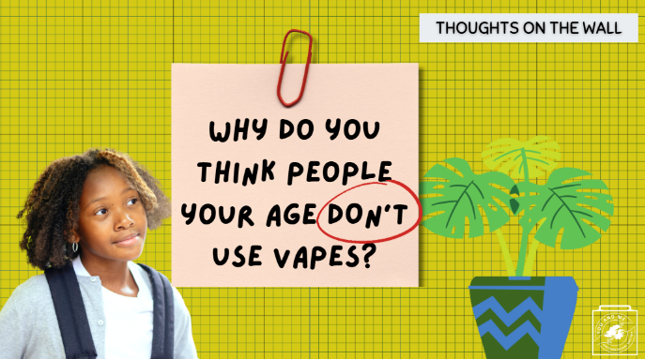 | Now, let's think about this topic in reverse: why do people your age not use e-cigarettes?  (Teacher Note): Allow for discussion between students. Use the question below to facilitate discussion if desired.  Q: Do you think there is a stigma against people your age who use e-cigarettes?
33 |  | So, given all you have learned today, what would you say to a friend who wants you to vape with them? (Take responses).
34 | 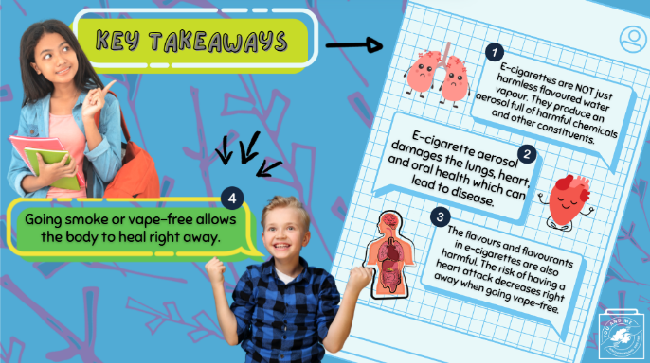 | (Teacher Note): Ask four students to each read one takeaway:  E-cigarettes are NOT just harmless flavored water vapour. They produce an aerosol full of harmful chemicals and other constituents.  E-cigarette aerosol damages the lungs and heart, which can lead to disease.  The flavours and flavourants in e-cigarettes are also harmful. The risk of having a heart attack decreases right away when going vape-free.  Going smoke or vape-free allows the body to heal right away.
35 | 

