

KS3 Lesson 3: What A Waste! Impact of Cigarettes and
E-cigarettes on the Environment

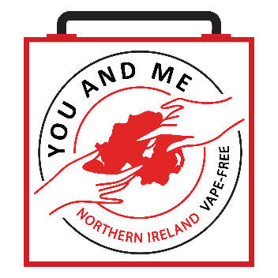

Lesson 3
Talking Points and Slide Chart

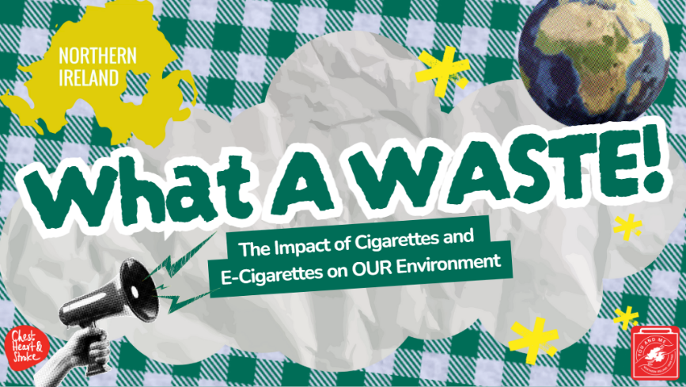

Slide | Image | Talking Points
1 | 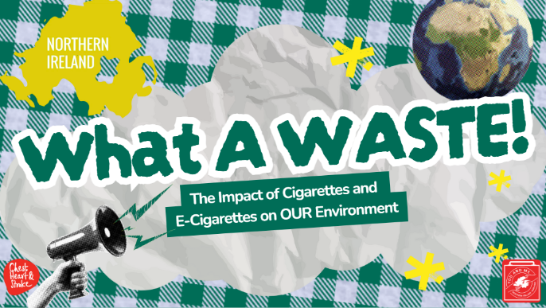 | This next lesson is all about how tobacco products, like cigarettes and e-cigarettes, affect OUR environment here in NI.
2 | 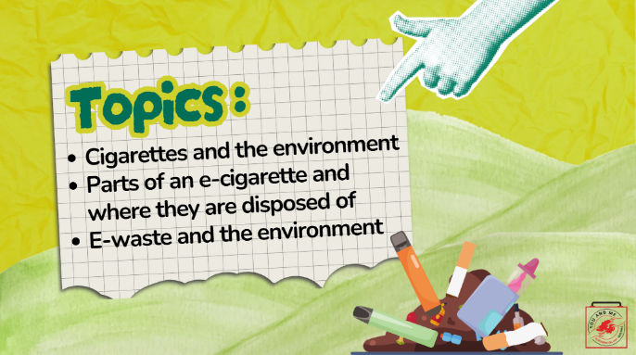
3 | 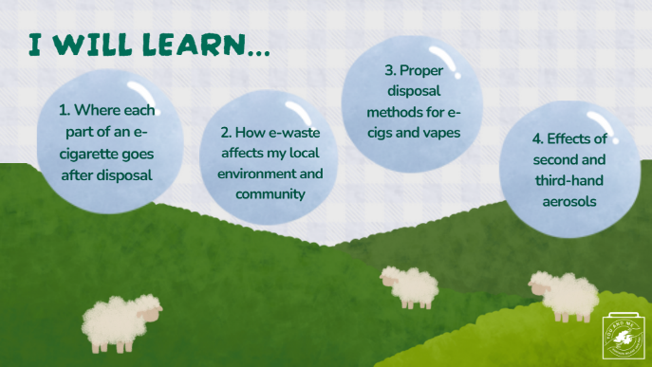
4 |  | As a warm-up: how many e-cigs do you see in the picture?  Let’s count how many e-cigs you see hidden in this picture.
5 |  | 10 Total: 2 puff bars (yellow and blue), 3 lost Mary’s (green, teal, and purple),2 cigarettes, 1 brandless vape, and 2 SKE Crystal.  The purpose of this activity is to start our discussion on e-cigarette and cigarette trash and how it’s everywhere.
6 | 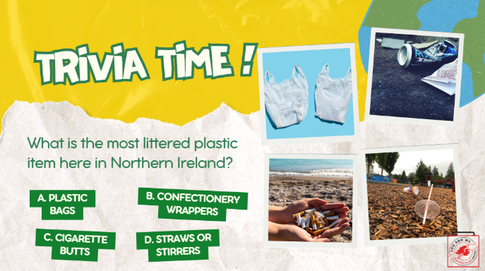 | What is the most littered plastic item here in Northern Ireland?  *Correct answer on the next slide.
7 | 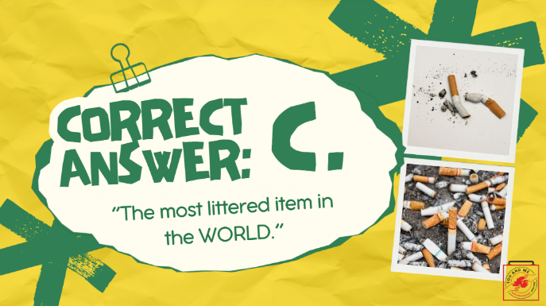 | The answer is cigarette butts! In fact, not only are they the most littered item in Northern Ireland, they're also the most littered item in the world.  (Ask students): What do you think about that? (pause for responses).  The most commonly found piece of trash on beaches isn’t plastic bags or straws.  Littered cigarette butts leach toxic chemicals such as arsenic (used to kill rats) and lead, to name a few, into the environment and can contaminate water.  The toxic exposure from cigarettes can poison fish as well as animals that eat cigarette butts.  Cigarettes are not biodegradable. The plastic fibres, called cellulose acetate, in cigarette butts are non-biodegradable, meaning they won’t organically break down from living organisms.  References:  https://hub.jhu.edu/2024/04/22/cigarette-butt-filter-litter/  Eco watch  https://www.ecowatch.com/cigarette-butts-litter-2635534590.html  National Geographic  https://www.nationalgeographic.com/environment/article/cigarettes-story-of-plastic
8 | 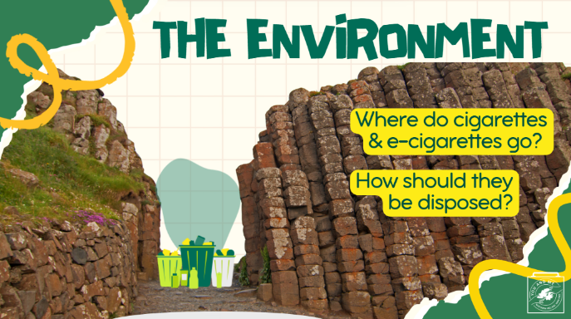 | So let’s talk about the environment.  (Ask students): How are people disposing of cigarettes? (pause for responses).  How about e-cigarettes (including nicotine and non-nicotine ones)? (pause for responses).  We will find out what happens when these products are improperly disposed of.  We will also find out how they should be disposed of.
9 | 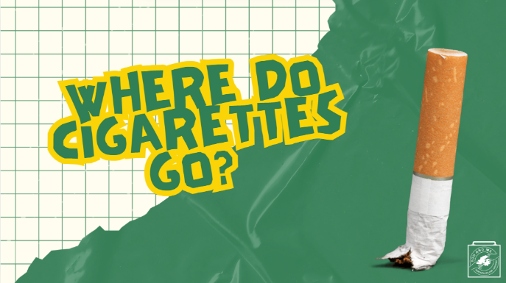 | So, where do cigarettes go?
10 | 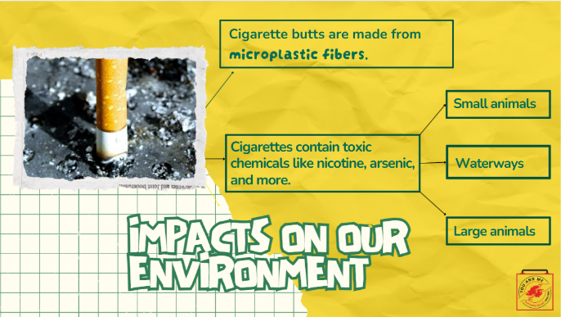 | The cigarette butt is non-biodegradable because it's made of over 15,000 microplastic fibres.  Cigarettes also have toxic chemicals like nicotine and other heavy metals, which can go into the waterways.  Small animals can be killed by cigarettes.  Large animals might eat cigarettes thinking they are food.  References:  https://www.undo.org/little-big-lie?gclid=Cj0KCQjw_7KXBhCoARIsAPdPTfgY2TK5ZgfHzX8SfdD7HPnlHeGF9cB_mPi62fZS6GuMKlCkXryY5AcaAiebEALw_wcB  https://truthinitiative.org/research-resources/harmful-effects-tobacco/toxic-plastic-problem-e-cigarette-waste-and-environment  Image by <a href="https://pixabay.com/users/422737-422737/?utm_source=link-attribution&amp;utm_medium=referral&amp;utm_campaign=image&amp;utm_content=488400">Hebi B.</a> from <a href="https://pixabay.com//?utm_source=link-attribution&amp;utm_medium=referral&amp;utm_campaign=image&amp;utm_content=488400">Pixabay</a>
11 | 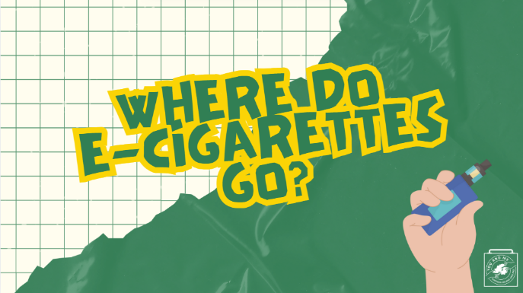 | Now, where do e-cigarettes go?
12 | 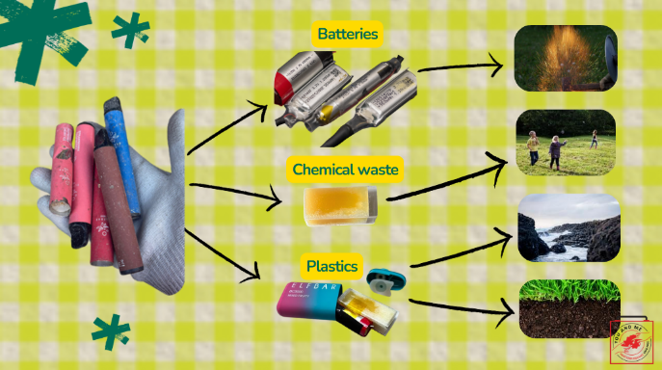 | E-cigarettes affect the environment in three main ways: through the disposal of their batteries, chemical waste, and plastic.
13 | 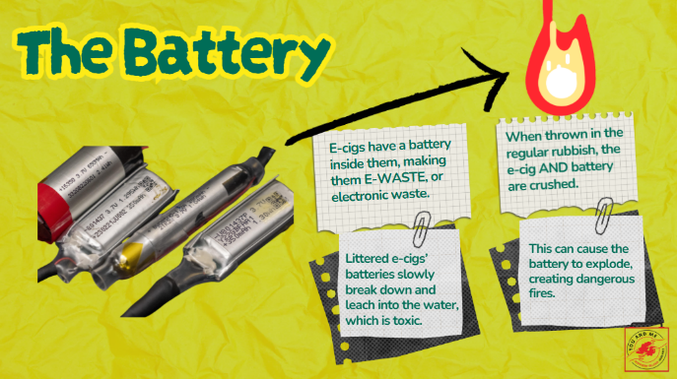 | The first way it affects the environment is through the battery.  E-cigarettes have a battery that is used to vaporise the liquid for a person to vape.  This battery is often made from dangerous metals like lithium-ion, which can explode in bin lorries or when processed in waste facilities.  If left outside, the battery slowly deteriorates, and the heavy metals leach into the water, which is toxic for the environment.  E-cigarettes qualify as e-waste and must be disposed of like other electronic devices.
14 | 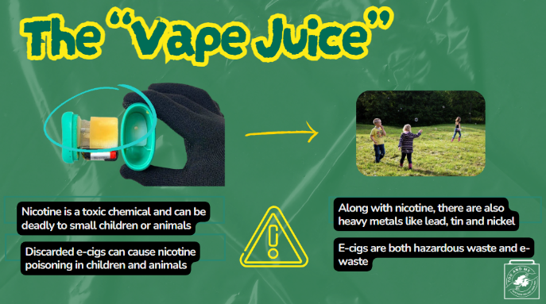 | The second way that e-cigarettes affect the environment is through the nicotine pods.  Nicotine is a toxic chemical and can be lethal to small children or animals if they come into contact with it.  Pods (even if vaped as much as possible) contain trace levels of nicotine and other heavy metals, which can directly harm animals and children or seep into the soil and nearby water sources.  Along with nicotine, there are also heavy metals like lead, tin, and nickel that are toxic.  Discarded e-cigarettes that come into contact with children or animals can cause accidental nicotine poisoning.  Due to the nicotine and other heavy metals, e-cigarettes are considered hazardous waste. They are also classified as e-waste.  Additionally, they may contain solvents and other contaminants.  Reference:  https://www.publichealthlawcenter.org/sites/default/files/inline-files/What-a-Waste-Legally-Disposing-of-E-Cigarettes-and-Nicotine-Products.pdf  https://www.ozonesmoke.com/media/catalog/product/cache/2e5dd8b74949a298dd2cd2cebdc06e35/j/u/juul-pods-classic-menthol.jpg
15 | 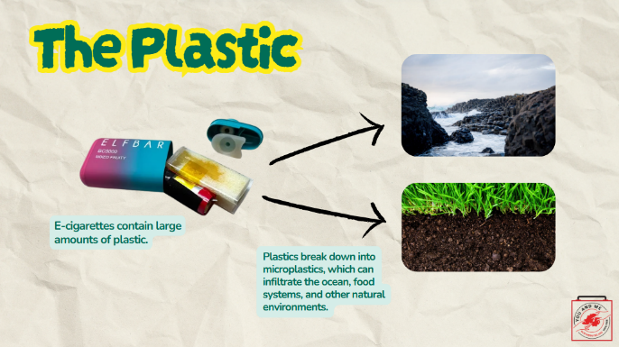 | The third way that e-cigarettes affect the environment is through the plastic components. This effect is similar to that of any other plastic product you might buy.  Plastic can take centuries to decompose.  As they break down, the plastics turn into microplastics, which are small enough to enter ocean ecosystems and the food chain, ultimately affecting what we ingest.  References:  https://truthinitiative.org/research-resources/harmful-effects-tobacco/toxic-plastic-problem-e-cigarette-waste-and-environment
16 | 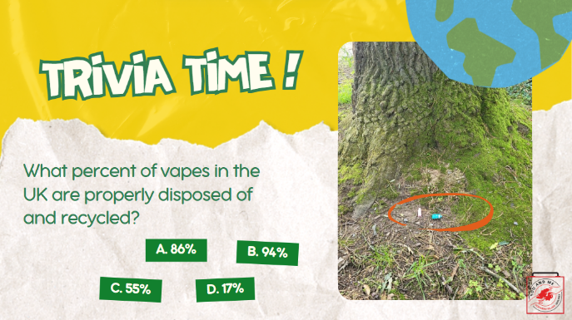 | Let's do another trivia question: What percent of vapes in the UK are properly disposed of and recycled?  *Correct answer on the next slide.
17 | 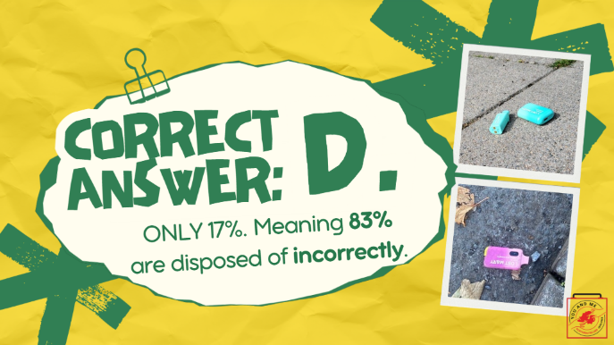 | The answer is just 17%! This means that 83%, the vast majority, of vapes are disposed of incorrectly.  This improper disposal means that their parts cannot be recycled for new uses, they are more likely to start dangerous fires in bin lorries and landfills, and their hazardous chemicals can leach into our natural environment.
18 | 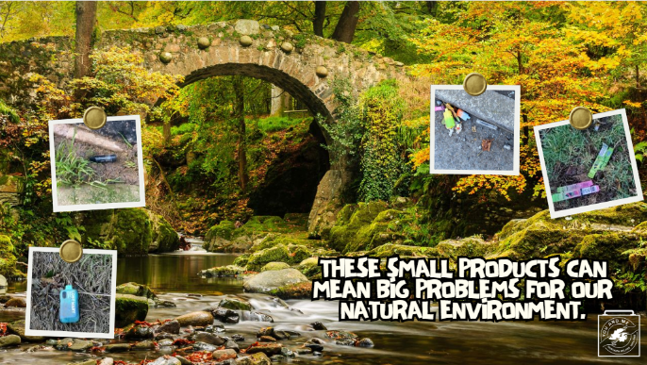 | (Read off the slide)
19 | 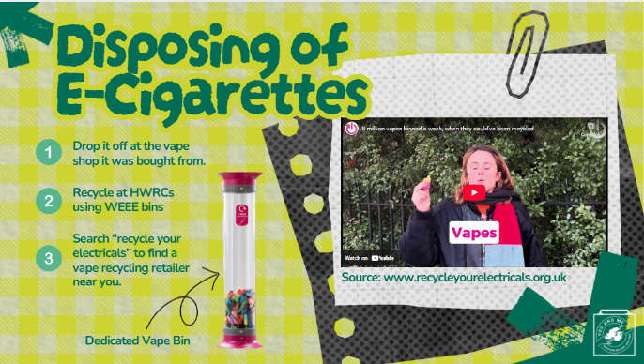 | There are a number of ways you can dispose of e-cigarettes PROPERLY.  (Read off the slides and play the video.)
20 | 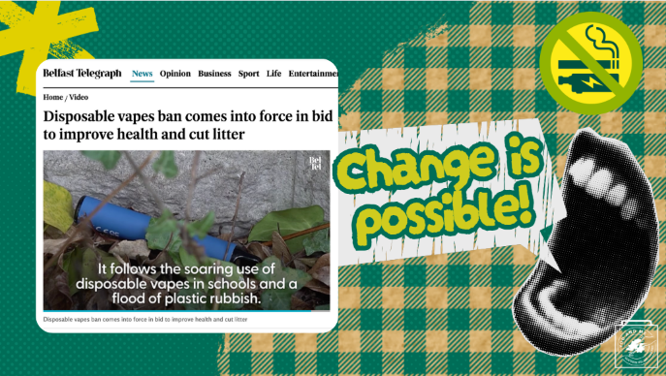 | Given what we have discovered, one way for us to protect the environment is to not smoke cigarettes or use any e-cigarette products, including nicotine and non-nicotine e-liquids.  We've been successful in banning disposable vapes, but disposable products aren't the only offenders. We still need to work together to get ALL vape products disposed of properly.
21 | 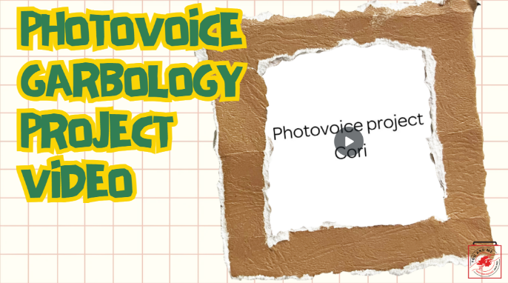 | So what can we do? We can raise awareness about the problem of cigarettes, vapes, and related litter happening in our neighbourhoods and communities.  Photovoice is a research tool used by advocates to document their community needs through pictures and storytelling.  Let’s watch a video on a garbology project using photovoice created by peer health educators in an effort to raise awareness about this issue in their community.  As a class, we will be doing a similar project, so please pay close attention to what they did.  (Click video)  References:  https://ctb.ku.edu/en/table-of-contents/assessment/assessing-community-needs-and-resources/photovoice/main
22 | 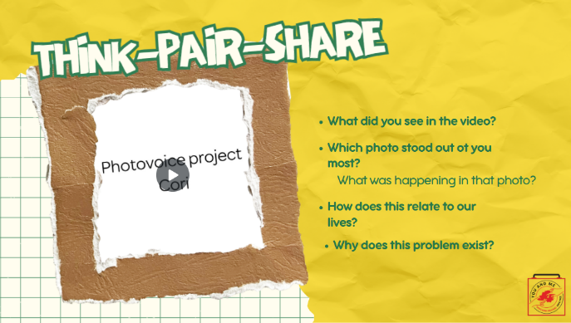 | Let's reflect on what we saw in the video.  In groups of two (think-pair-share), discuss and answer the questions on the slide.  Afterwards, we will do a share-out.  (Teacher note: give students about 5-7 minutes, then open to discussion for 2-3 minutes).  Reference:  https://www.pathwaysrtc.pdx.edu/pdf/proj5-photovoice.pdf
23 | 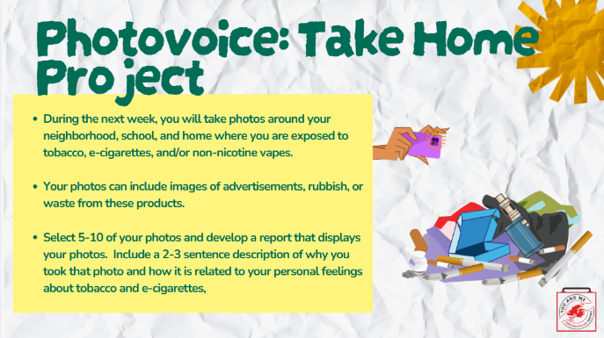 | (Read slide with instructions on photovoice assignment).  (Teacher Note: suggest assigning this on a Thursday with a Mon due date for students to have enough time to gather their photos).
24 | 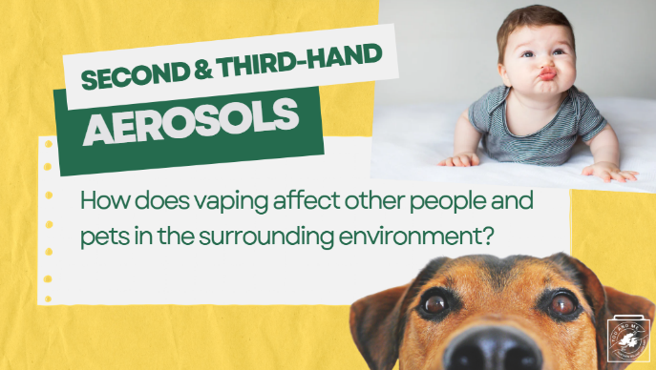 | Using e-cigarettes not only hurts you and the natural environment, but the aerosol can harm others in our built environment as well.  Let's discuss how and why.
25 | 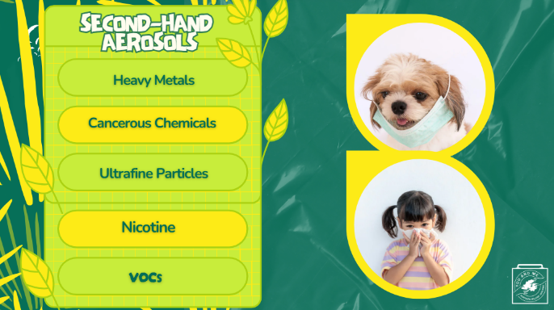 | Second-hand aerosol, similar to second-hand smoke, is the plume of chemicals released into the environment directly from the e-cigarette and from the lungs of the user.  Common places for exposure to second-hand aerosol include restaurants, parks, vehicles, and designated smoking areas.  Chemicals that are released include harmful substances such as nicotine, heavy metals, ultrafine particles that penetrate deep into the lungs, cancer-causing chemicals, and volatile organic compounds (VOCs).  Some of the most vulnerable to second-hand smoke and aerosol are children. Research has shown that children exposed to second-hand smoke tend to get sick more often.  Children exposed to second-hand smoke are likely to experience:  - More bronchitis and pneumonia  - More wheezing and coughing  - More ear infections  - More severe and frequent asthma attacks  Think about your younger siblings, family members, or loved ones and how second-hand aerosol could affect them. What are your thoughts on this? How can we protect those who are most vulnerable?
26 | 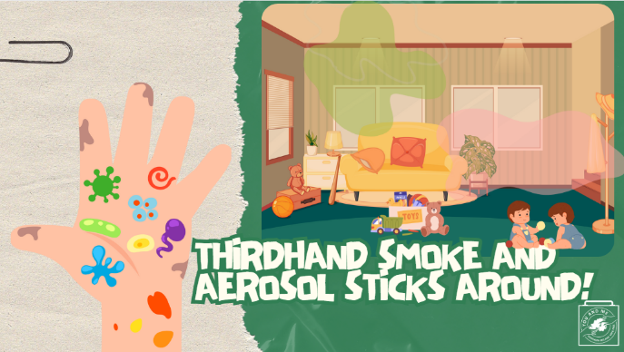 | Another way that e-cigarettes pose a danger to people other than the user is through third-hand aerosol.  Third-hand aerosol is the mixture of chemicals in e-cigarette aerosol that remains on surfaces and in dust, even after the aerosol has dissipated, and reacts with other chemicals in the environment to form toxic substances.  These potentially harmful chemicals can expose other people or animals through the respiratory system, through ingestion, and through skin contact.  Small children are especially at risk for third-hand aerosol exposure because they tend to put things into their mouths, and they have more vulnerable skin.
27 | 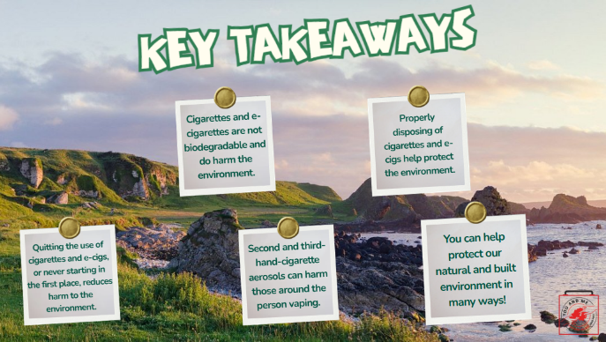 | Let's review our key Takeaways.  (Read off slides)
28 | 