

KS3 Lesson 4: Don’t be played! How Tobacco
Marketing Targets You-th

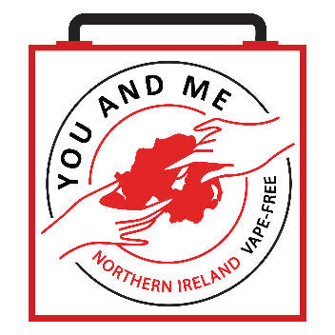

Lesson 4
Talking Points and Slide Chart

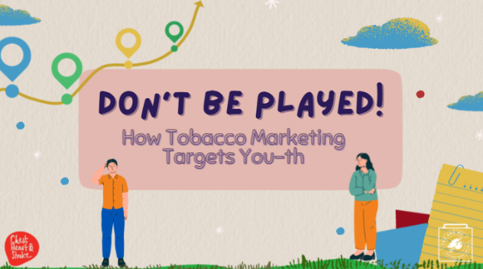

Slide | Image | Talking Points
1 | 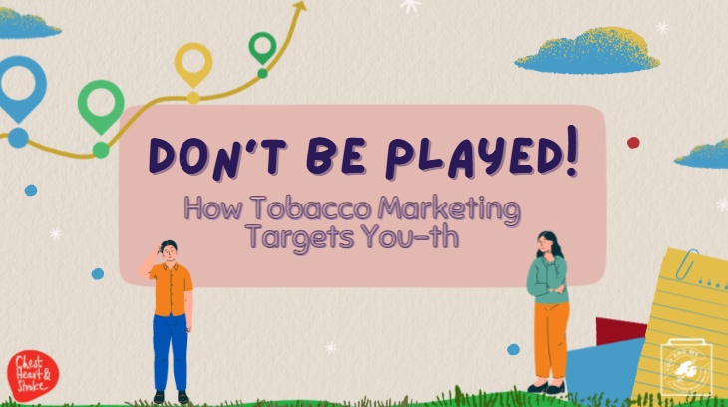 | In this lesson, we’re going to talk about marketing, messaging, and targeting from the tobacco industry.  Today, we will be looking at real-world examples of tobacco industry marketing, and I want to remind you that this is a non-judgmental space for you to think critically about the images and messages the tobacco companies try to feed you.
2 | 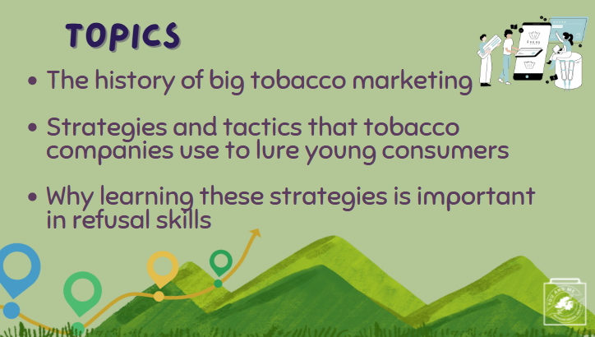 | Read slide
3 | 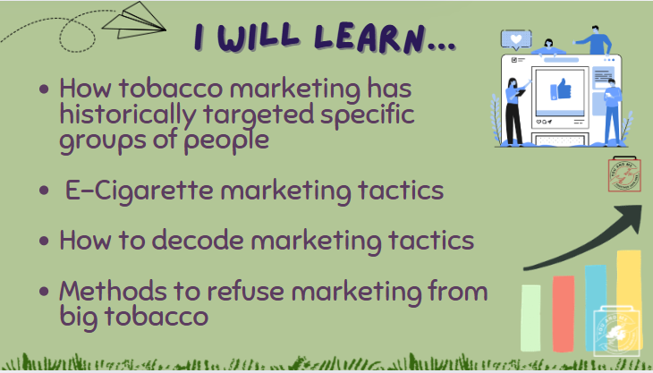 | Read slide
4 |  | Warm up:  Keep A Straight Face  The objective of this activity is for students to experience pressure to behave in certain ways, despite their efforts to resist.  Procedures:  - Organise students into pairs or small groups of four.  - Ask each pair or group to nominate one person in their group to be the ‘resistor’, while the other person or other three will be the ‘comics.’  - The three comics must do everything in their power (apart from actually making physical contact) to make the resistor resist laughter.  - Meanwhile, the resistor must do everything in their power to remain straight-faced.  - They have one minute for this challenge.  - Swap roles after each minute so that every group member has a turn as a ‘resistor.’  After Warm-Up Discussion:  (Ask Students): Do you think it can be hard to resist other people’s invitations, encouragement, and pressure to do certain things or behave in certain ways? Why or why not?  (Ask Students): How can you resist the pressure to join in something that looks like fun but leads to harm to yourself or others?
5 | 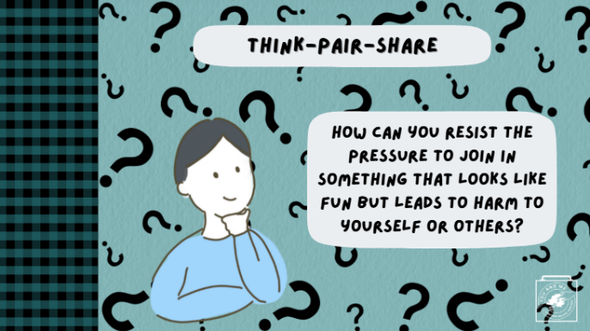 | (Think-Pair-Share): How can you resist the pressure to join in something that looks like fun but leads to harm to yourself or others?
6 |  | How can you resist the pressure to join in something that looks like fun but leads to harm to yourself or others?
7 |  | Before we discuss marketing today, let's explore the history of cigarette marketing. It is important to understand the history of tobacco and smoking because it all leads us to the present day.  Starting in the 1800s (and continuing today!), companies began making and selling cigarettes and eventually other tobacco products. In fact, by 1896, the largest tobacco factory in the world was HERE in Northern Ireland.  Gallaher Ltd was a cigarette company founded in Derry/Londonderry, which later built the largest tobacco factory of its time in Belfast. It's last factory was only closed in Ballymena in 2017.
8 | 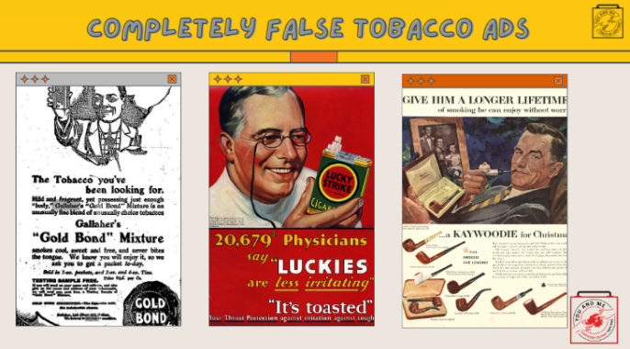 | Cigarette production here in NI began in the 1800s, and back then, people didn’t understand the dangers of smoking. It was not until the 1960s that researchers and the Royal College of Physicians finally published a report stating that cigarettes are harmful and linking them to lung cancer. In 1965, advertising of cigarettes was restricted.  Surprisingly, for many years, cigarettes were advertised with misleading messages, and some doctors even promoted smoking!  Now we have ample evidence that these advertisements were completely false.
9 | 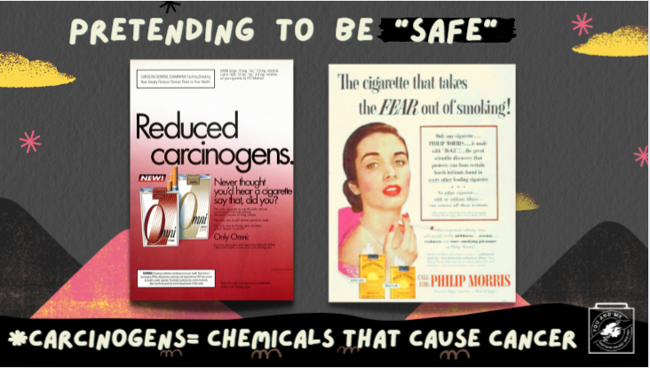 | Tobacco companies, sometimes referred to as "Big Tobacco," were able to make a significant amount of money by selling cigarettes, so they began trying to attract more and more consumers.  Around 1950, people started to become aware of the negative health effects of smoking, such as cancer and heart disease.  Tobacco companies were concerned about losing customers as people learned more about these health risks.
10 | 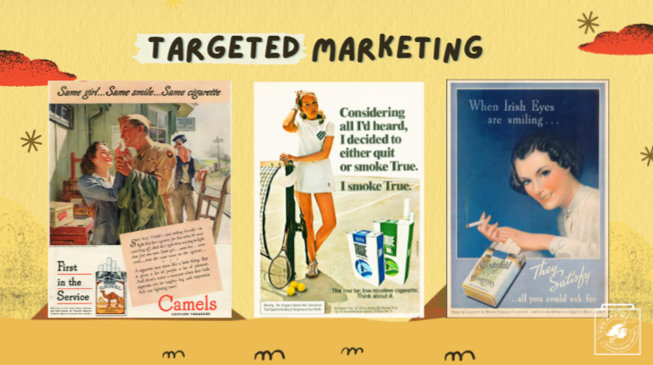 | Big Tobacco companies expanded their marketing tactics by targeting certain groups.
11 |  | Kids are the age group most likely to like cartoons, and tobacco companies know this.  From flavours to the packaging of their products, cigarette ads were designed to make smoking appear cool, fun, and exciting, all aimed at capturing the attention of new and young consumers.  None of the ads focused on the well-known health risks.  (Ask Students): Why do you think tobacco companies use ads to target youth? (Take responses).
12 | 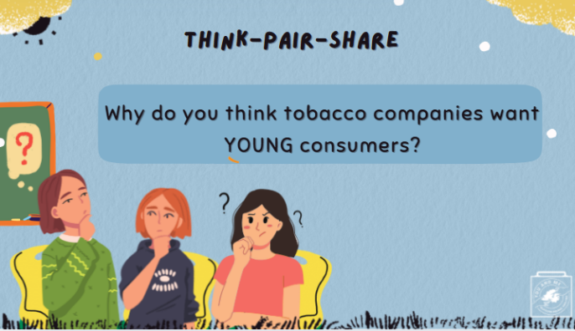 | Quick Chat #1:  Think: ask students to think about the question on the slide (1 minute/60 seconds).  Pair: put students into pairs or small groups to discuss together (1 minute/60 seconds).  Share: students will pick one person to share what they discussed. Only take one or two examples for the sake of time.
13 | 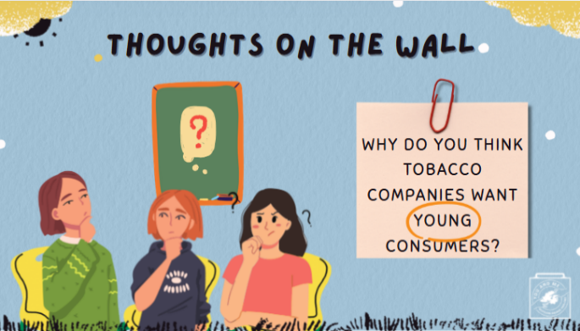 | Why do you think tobacco companies want YOUNG consumers?  On a post-it note, write down your response and post it on the wall when you're done.
14 | 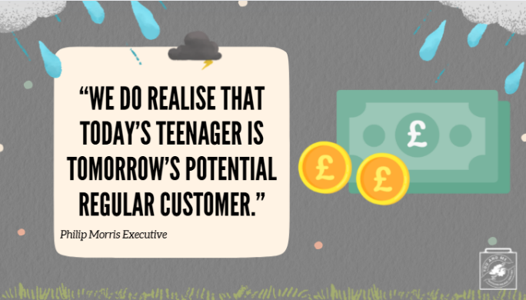 | Remember discussing how the adolescent brain is particularly sensitive and likely to become addicted to nicotine? Well… tobacco companies know this and therefore want young consumers because they know they could get addicted early in life and be lifelong consumers.  This means more money for tobacco companies, which, overall, is the main marketing strategy.  An executive working for Philip Morris, the largest tobacco company, said in 1981, "We do realise that today’s teenager is tomorrow’s potential regular customer."  There are no limits to what the tobacco industry will do to gain more money.  So, ask yourself if making the tobacco industry richer by consuming their deadly products is what is best for your well-being?
15 | 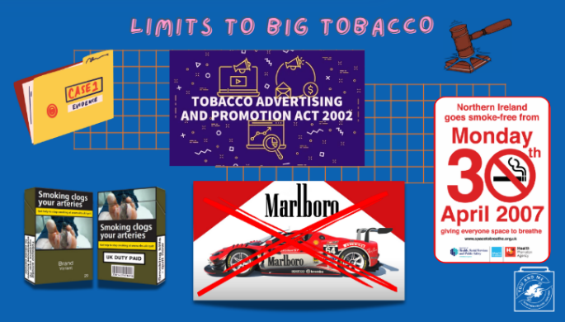 | Eventually, the UK and EU banned tobacco advertising on television and in cinemas, and they required tobacco companies to print warning labels on their products so that people would know about the dangers of tobacco and nicotine.  In 2002, the Tobacco Advertising and Promotion Act put new limits on Big Tobacco companies, such as further limiting general advertising at shops, pubs, and clubs, and ending sponsorships of global events such as Formula 1 races.  And by 2007, the NI and the UK succeeded in becoming smoke-free in nearly all public spaces.
16 |  | (Ask Students): Why do you think I’m telling you this story if it all happened before you were born? (Take responses).
17 | 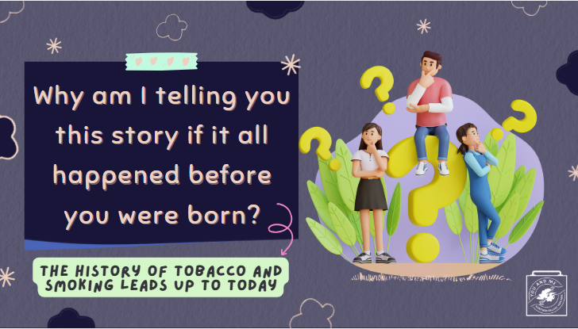 | It’s important to know about the history of tobacco and smoking because it all leads us to today.  Today, there are new products that have become popular, especially with young people.  (Ask Students): Can anyone guess what I’m talking about? (Take responses).
18 | 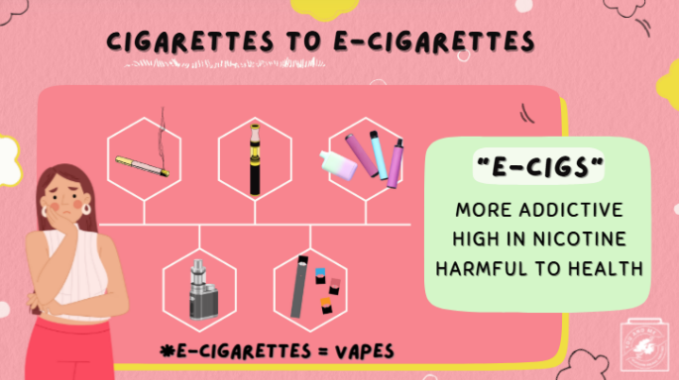 | I’m talking about e-cigarettes.  Over time, tobacco companies have shifted to creating different products so that they can continue to make money by getting people addicted to their products.  Many companies that sell cigarettes now also sell e-cigarettes.  And the tobacco industry uses the same tricks to attract new and young customers!
19 | 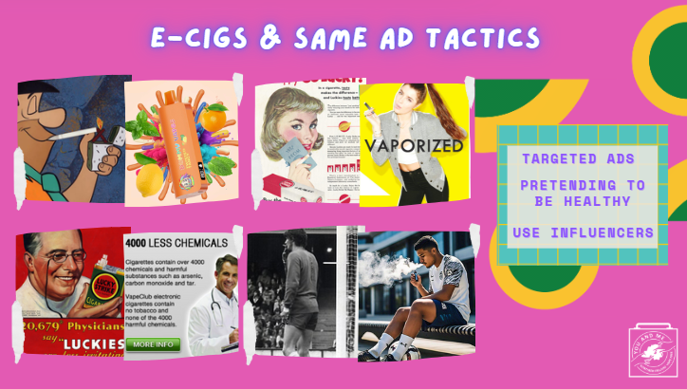 | Tobacco companies continue to target specific groups of people.  The tobacco industry creates advertisements that portray vaping as cool, fun, and exciting, just as they did with cigarettes.  They also use celebrities in their ads and suggest that e-cigarettes are safe.  These are the same deceptive tactics we discussed earlier regarding cigarette advertisements.  (Have students discuss):  - What similar marketing tactics have you noticed in e-cigarette ads that were also used in cigarette ads?  - How do you think these similarities impact the decision to use e-cigarettes or nicotine?  (Possible answers): Increases the normalisation of use, raises health-related risks, plays on the "cool" factor, and enhances marketing efforts and advertisements.
20 | 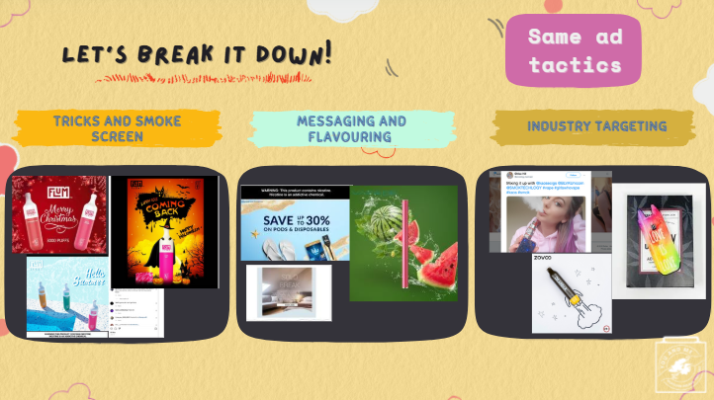 | These tobacco companies spend millions of pounds on designing marketing strategies and products to make them very easy to get hooked on.  Now we are going to talk about the ways tobacco companies use the same marketing tactics found in cigarette ads to attract and hook new young consumers to e-cigarettes.
21 | 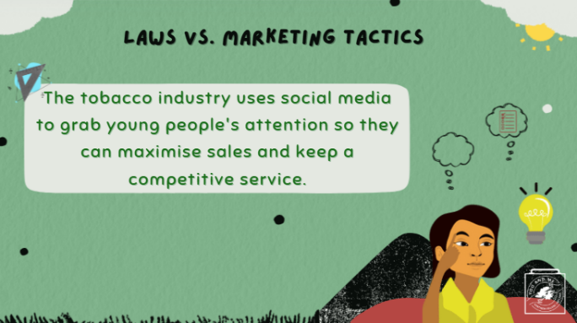 | Since e-cigarette companies cannot advertise on traditional media like TV and radio, they have found significant success in social media marketing through influencers and small businesses.  As I am sure you know, most young people are on social media, and almost all teens use the internet on a daily basis.  The tobacco industry knows exactly what strategies to employ and will go to any length to find and target new young consumers to get them addicted to their products, including advertising on social media, even when it's not legal for them to be the ones advertising.
22 | 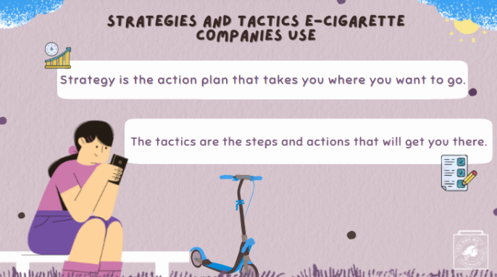 | Just like ads for cigarettes, e-cigarette companies use tactics such as emotional appeal, celebrity or influencer endorsements, cartoons, and animation on social platforms to appeal to young people.  E-cigarette companies also encourage their followers to share and interact with their content on social media.  This ultimately leads to people purchasing their products.  Let’s break this down a bit further!
23 | 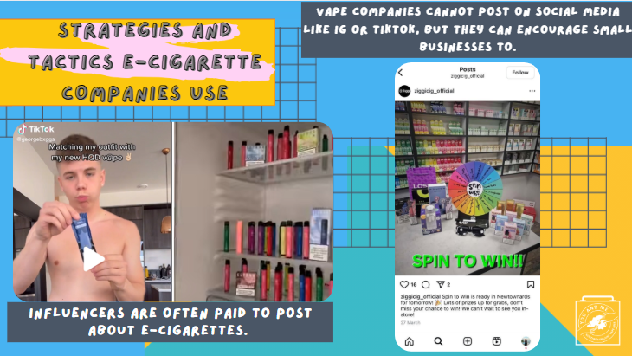 | E-cigarette companies know that by using influencers, celebrities, and even small business accounts to promote their products on social media, they can get away with advertising to young people without being on the hook for it.  These influencers, celebrities, and small business social media accounts then encourage their followers to share and interact with their content on social media. Many times, these influencers and businesses are paid to make these posts, but do not tell their viewers that it is an ad.  So, you may think they are posting about these products on their own and because they genuinely recommend the product, when they are actually being paid to do so. This is another way the industry might trick you.  This ultimately leads to people purchasing their products.  Let’s break this down a bit further!
24 |  | First, e-cigarette companies use product placement in advertisements, TV shows, movies, and other media to attract customers, especially young ones.  Product placement affects the subconscious mind of the viewer because the branded product is integrated into the overall picture.  Tobacco companies understand that product placement is an effective way to advertise their products because it does not distract the viewers’ attention and engages potential consumers with their product.  Some young people may not even realise they are watching or looking at an advertisement for e-cigarettes or vapes.  (Ask students): Have you ever watched or seen something where you didn't realise a product or service was being advertised? (Take responses).
25 | 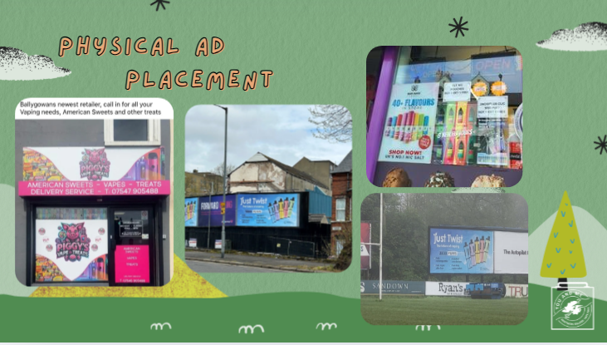 | E-cigarette companies also strategically place ads around our physical environment. Here in NI, that includes sweet shops, ice cream shops, on busy roads, and even on rugby fields.  Notice how these are places young people often find themselves near. This is not a coincidence; it's targeting.  (Ask Students): Where else have you seen e-cigarette advertisements out and about? (Take responses).
26 |  | Attractive colour schemes are also essential to advertising because they can alter the mood of potential consumers.  Tobacco companies know that certain colour combinations can convey the right emotions to encourage young consumers to want to buy and use their products.  Colour combinations can also lead potential and existing consumers to associate those emotions with the product every time they think about the brand.  The emotional connection with the e-cigarette product also makes it easier for young people to become addicted to it.
27 |  | Instruct the students to:  - Get into pairs or small groups.  - In 30 seconds, please write down as many words connected with this ad as you can.  (Ask students): Consider the placement of the product in the ad, the shapes, and the colour scheme.  Total up the words for each group.  Now, give each pair or group 60 seconds to write down what they think is the overall message of the ad and who the target audience is based on the words they listed.  (Teacher Note): For fun, you can say that the team that finishes first with the most words and the best explanation of who they think is the target audience wins!
28 |  | After watching the video:  (Ask Students): Do you think it may be hard for young people to resist the messaging used in e-cigarette advertisements? Why or why not? (Allow 2-3 minutes for discussion).  Follow-up Talking Points:  Decoding the messaging used in e-cigarette ads is vital in building resistance against using tobacco products. By demystifying the appeal of using these substances, we can reveal how the tobacco industry is manipulating kids and teens to use their products.  Understanding these tactics can empower young people to make informed choices and resist the pressures of advertising.
29 |  | (Ask Students): What messages do you see in these ads?  Who do you think is the target audience for these ads?  Why do you think it’s important for young people to be aware of misleading messaging in ads?
30 | 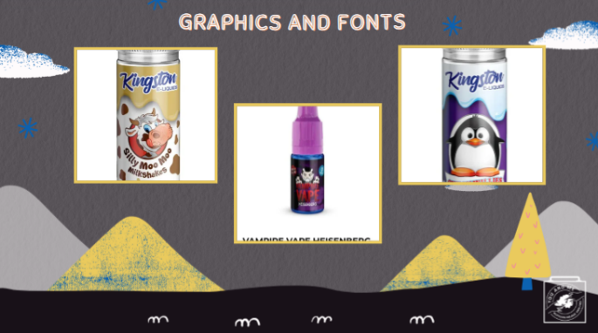 | Silly cartoons such as this cow, vampire, and penguin are not exactly designed to appeal to adults, are they?  E-cigarette companies often use youth-enticing images and graphics in their packaging to lure them in. Bold fonts are also used to immediately capture the attention of the reader.  The goal is for young people to absorb the idea without having to fully pay attention.
31 |  | While seeing e-cigarette ads encourages the re-normalization of smoking, flavoured e-cigarette ads like gummy bear, mango, and strawberry ice also encourage the re-normalisation of young people smoking, which may lead new users (especially young people like you) to use.  Tobacco companies know the flavours in e-cigarettes make it easier for kids and teens to use these addictive drugs.
32 |  | (Ask Students): Based on the ads we saw today, do you agree with the claim that e-cigarette ads are using tactics to appeal to young consumers like you? (Take Responses).  Follow-up: how does that make you feel? (Take Responses).  Here’s an opportunity for you to create an Anti-Vaping/smoking ad, as if the tobacco industry told the truth about their harmful products.  (Teacher Note): Gather old or new magazines, newspapers, scissors, glue, and other craft supplies that you would like to use.  - Students make their ads on a small to medium-sized white or black poster.  - Have students use the materials to make an Anti-Vaping/Smoking ad  - Each group can share its ad with class
33 |  | (Ask Students): Why do you think the tobacco industry created e-cigarettes?
34 | 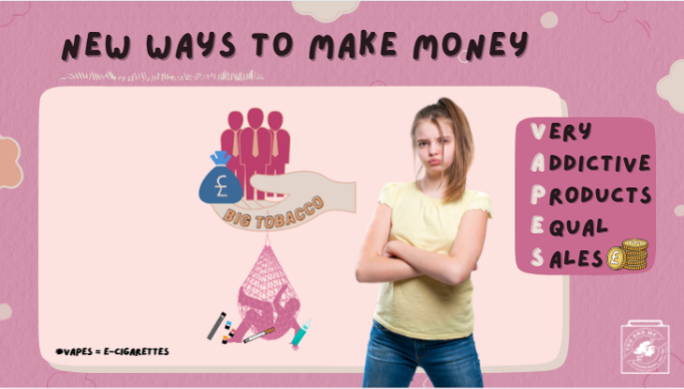 | Big tobacco companies just want to make big sales from e-cigarettes/vapes.  The tobacco industry works hard and spends millions of pounds to get young people like you addicted to their products by tricking young people into thinking their products are safe and fun to use.  In reality, the tobacco industry does not care about your safety or well-being; they just want to make money.  So, it's important to understand these manipulative tactics to resist the marketing influences from e-cigarette companies.
35 |  | (Teacher Note): Play embedded video.
36 | 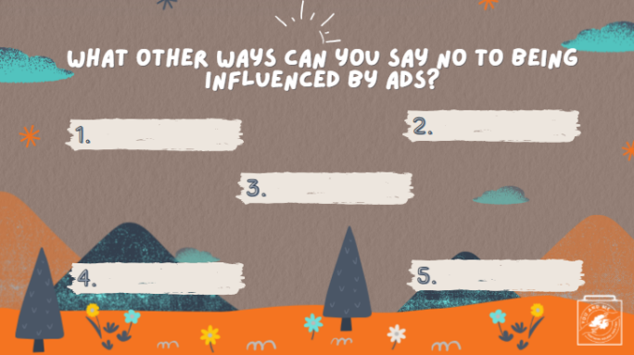 | (Ask Students): What other ways can you say no to being influenced by ads?  (Teacher Note): Write a few ideas down on the whiteboard/ chalkboard/ piece of poster paper
37 |  | Let’s look at today’s key takeaways.  (Teacher Note): Play embedded video of key takeaways.
38 |  | Now, we will play a quick game of Kahoot!

