

KS3 Lesson 5:
Be Your Strength: Stress, Coping & Wellness



Lesson 5
Talking Points and Slide Chart

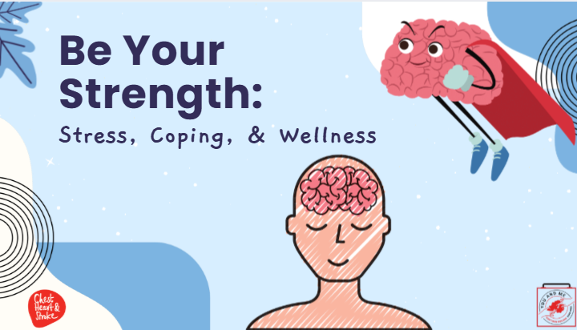

Slide | Image | Talking Points
1 | 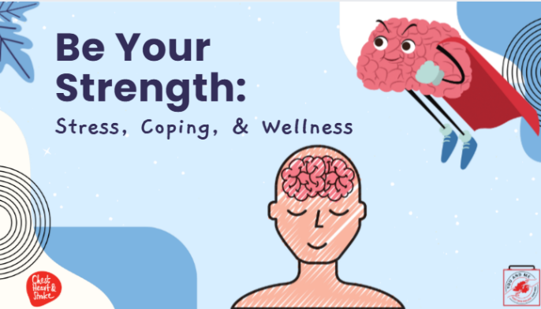 | Today’s lesson is on wellness.  We will discuss what stress is, identity triggers, and causes of stress, plus practice some strategies to manage stress and discover what works for you.  We will also discuss mental health and substance use and provide resources on where and when to seek help.
2 | 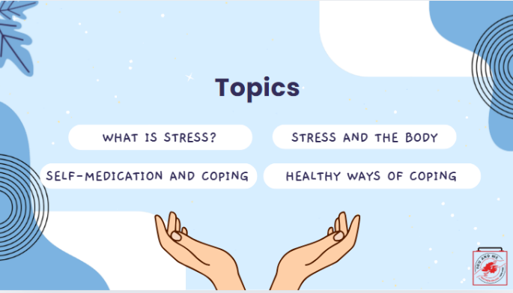 | Read slide
3 | 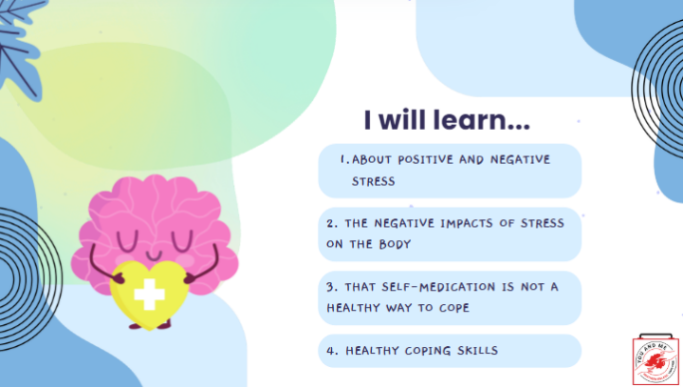 | Read slide
4 | 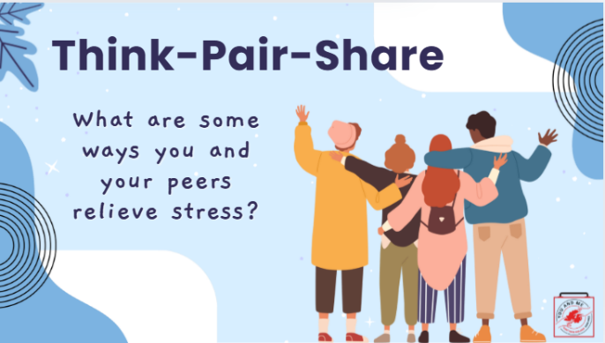 | (Ask students): In groups of two (think-pair-share), let's brainstorm some ways you and your peers relieve stress. We will take 2-3 minutes, so write down a list of at least 4 ways you relieve stress. Then we will share what some of you said in your groups.  (After 2-3 minutes, ask the students): What did you come up with?  (Take a few responses and write down answers on the board).  (Possible responses: sleep, ride my bike, play with my dog, listen to music).
5 | 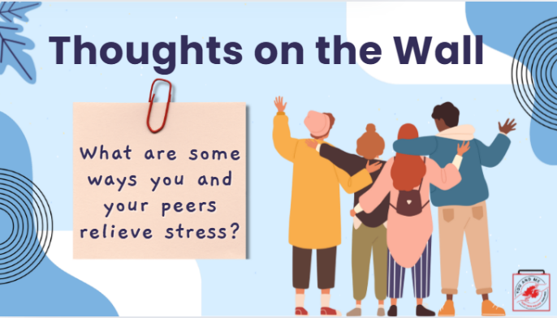 | Let's brainstorm some ways you and your peers like to relieve stress.  On a post-it note, write down a list of at least 4 ways you relieve stress and post it on the wall when you're done.  (Possible responses: sleep, ride my bike, play with my dog, listen to music).
6 | 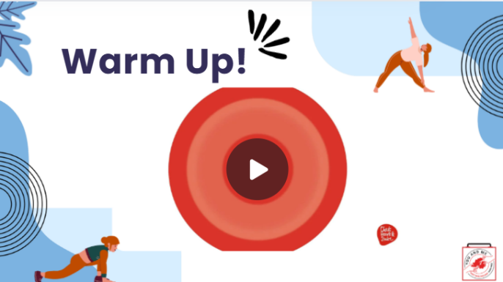 | Let's start off our lesson on stress, coping, and wellness by listening and doing a grounding (deep breathing) activity together as a class.  We will then do a share-out.  Reference:  https://youtu.be/30VMIEmA114
7 | 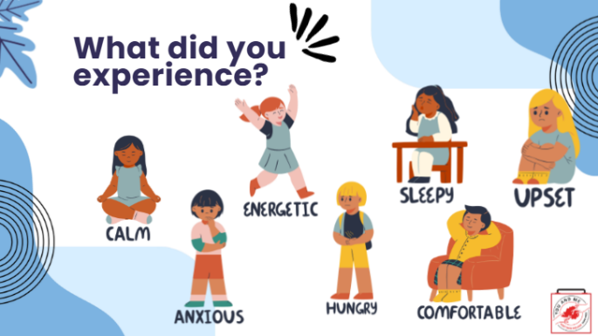 | (After the activity is over, ask students): What emotions or feelings did you experience during or after meditation?  (pause for responses)  Were there other emotions or feelings that you experienced that are not on the slide?  (other possible responses: relaxed; sleepy; didn't like it)  Consider this grounding exercise as one of many techniques in your wellness toolkit. We will do another technique later in our lesson.
8 | 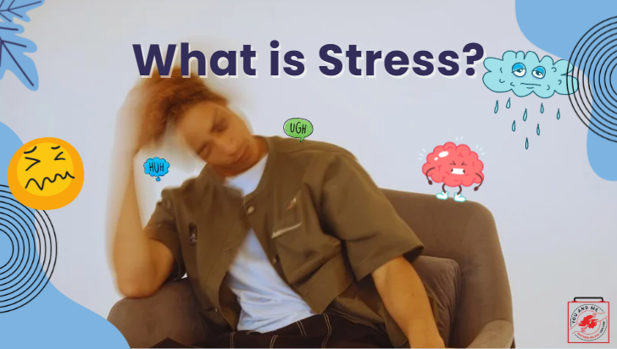 | When you hear the word 'stress', what does that mean to you?  (Pause and wait for students to respond)  Possible responses:  not feeling good; tired; cranky; under pressure; lack of time management.
9 | 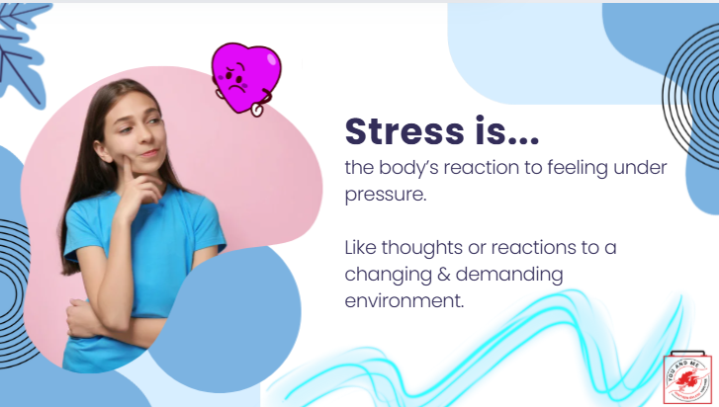 | Stress is a body's reaction to feeling under pressure, like thoughts or reactions to a changing and demanding environment.
10 | 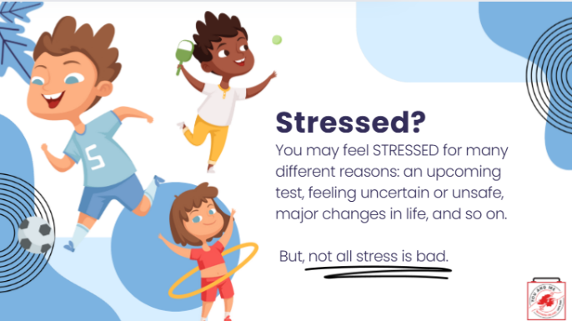 | A way to think of stress is as a reaction to a changing, demanding environment.  Stress is really more about our ability to handle change than it is about whether that change makes us feel good or bad.  Change happens all the time, and stress is, in large part, what we feel when we are reacting to it.  Reference:  https://www.mentalhelp.net/stress/
11 | 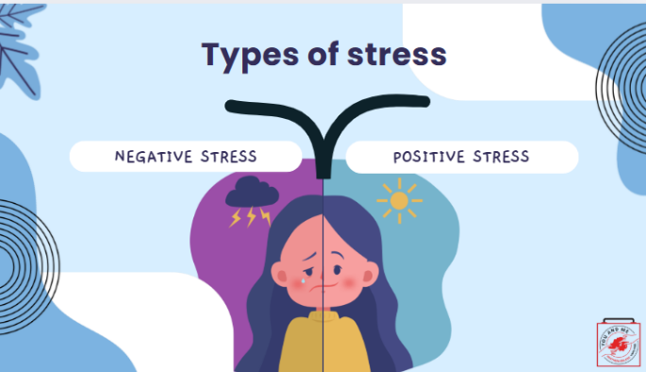 | There are two types of stress, both positive and negative.
12 | 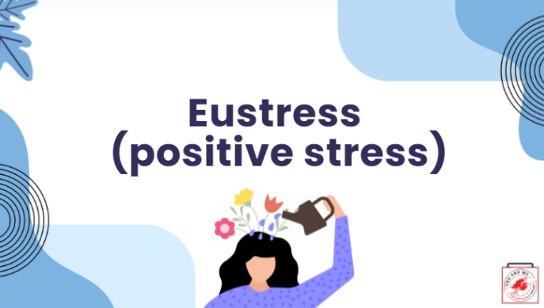 | Eustress is positive stress.
13 | 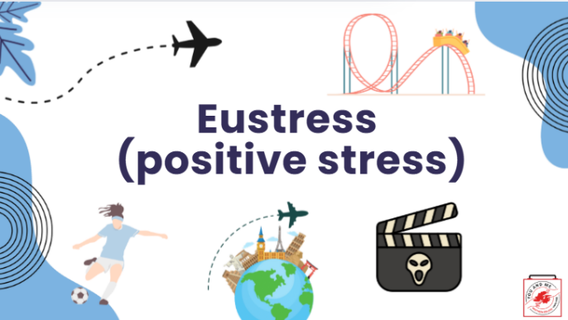 | It's short-term.  It motivates you.  It can be exciting and can improve performance.  Here are some examples on the slide: planning a trip, playing sports, going on a rollercoaster, or watching a scary movie.
14 | 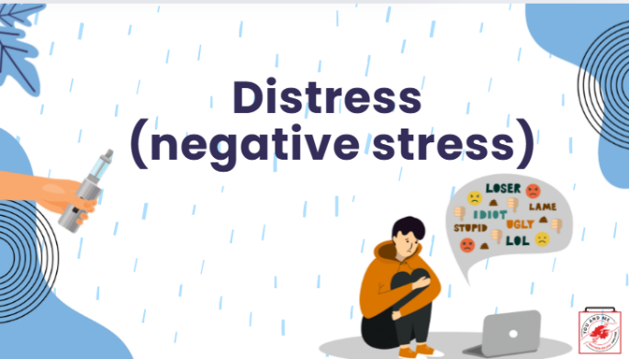 | Distress is negative stress.
15 | 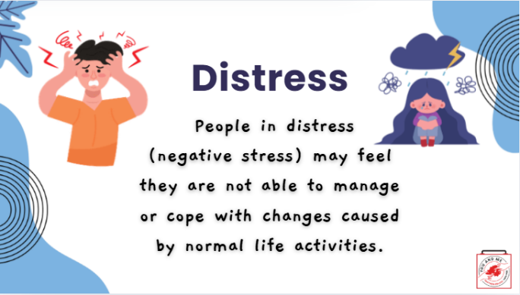 | It can be short or long-term.  Feels unpleasant.  Decreases performance.  It may cause anxiety or concern.  People in distress may feel that they are not able to manage or cope with changes caused by normal life activities.
16 | 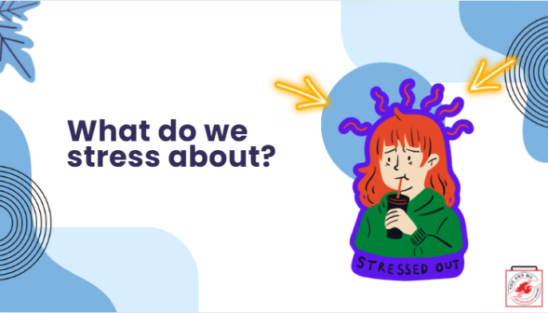 | So what do young people stress about?  Let's take a look.
17 | 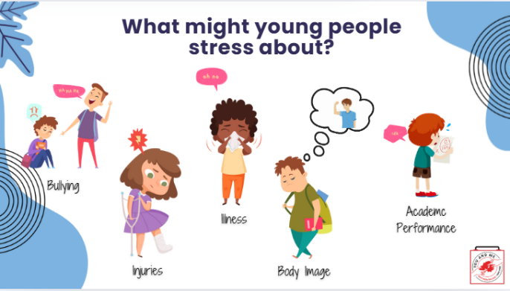 | Young people may stress about many things.  (Ask students): What are some other things that young people might stress about?
18 | 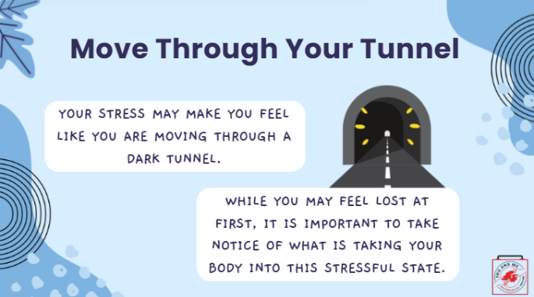 | When someone is under a lot of stress, they may feel like they're in a dark tunnel.  While you may feel lost at first, take notice of the kind of stress or rather, your reaction to that stress, and how your body is responding.
19 | 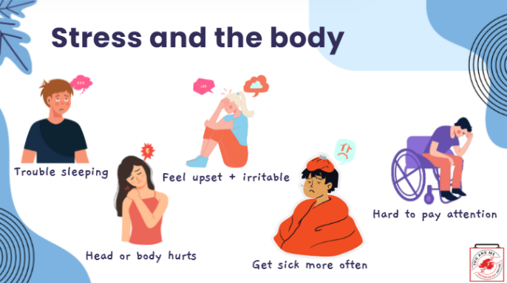 | When you are stressed, the body responds.  You might notice feeling tired all the time because of sleep issues. You might sleep more than usual or have trouble falling asleep.  Your behaviour changes. Others may notice that you are not as outgoing as you used to be, or you want to be left alone. Sudden changes like these can be a sign of high stress levels.  You might be argumentative and irritable, more than usual.  Stress often shows up as physical symptoms. You may experience more headaches or stomachaches. Additionally, your eating habits may change from eating too little or too much.  If a person suddenly forgets obligations like homework and other activities, or starts to procrastinate, stress could be a factor.  References:  https://www.apa.org/topics/child-development/stress#:~:text=Prolonged%20stress%20can%20cause%20high,becoming%20more%20common%20in%20youth.
20 | 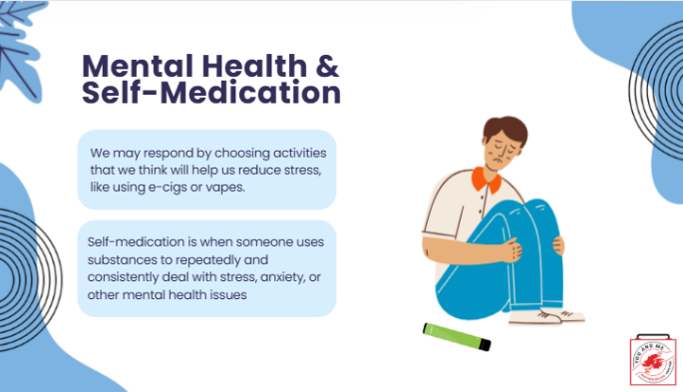 | We may respond to stress by choosing activities that we think will help us reduce the stress like using e-cigs or vapes.  This is called self-medication. It's when someone uses substances to repeatedly and consistently deal with stress, anxiety, or other mental health issues.
21 | 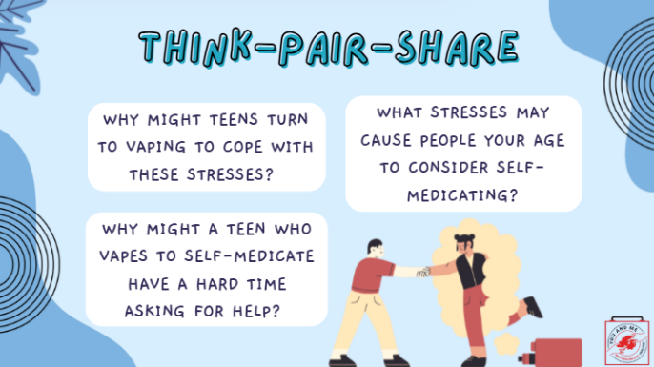 | In groups of two (think-pair-share), let's discuss this topic a little deeper using the following questions. After 10 minutes, we will share what some of you said in your groups.  (After 10 minutes, ask 1-2 students per question what they came up with. You can ask others to chime in if others had different responses in their groups.)  What stresses may cause people your age to consider self-medicating?  (Possible answers: struggling with gender, sexuality, helping to take care of siblings; getting good grades; succeeding on a sports team; problems at home; living in a dangerous neighbourhood; money troubles; fitting in socially).  Why might teens turn to vapes to help cope with these stresses?  (Possible answers: Because they are easy to access; because a friend suggested it; because it’s how their friends/families cope; because they don’t have access to other help.  Why might a teen who vapes to self-medicate have a hard time asking for help?  (Possible answers: They may be afraid of getting in trouble; they could be worried about what people think; they may think nothing else would help; etc.)
22 | 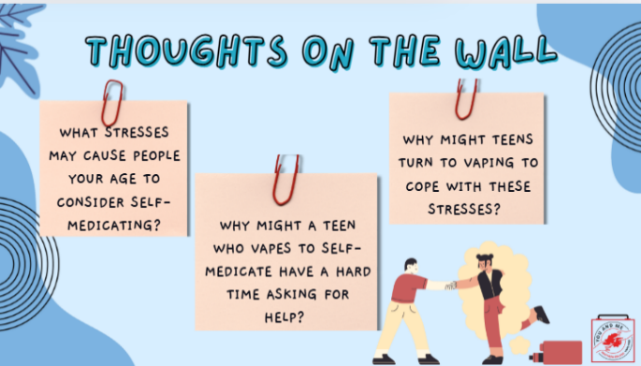 | Let's discuss this topic a little deeper using the following questions. On a post-it note, write down your response and post it on the wall when you're done.  What stresses may cause people your age to consider self-medicating?  (Possible answers: struggling with gender, sexuality, helping to take care of siblings; getting good grades; succeeding on a sports team; problems at home; living in a dangerous neighbourhood; money troubles; fitting in socially).  Why might teens turn to vapes to help cope with these stresses?  (Possible answers: Because they are easy to access; because a friend suggested it; because it’s how their friends/families cope; because they don’t have access to other help.  Why might a teen who vapes to self-medicate have a hard time asking for help?  (Possible answers: They may be afraid of getting in trouble; they could be worried about what people think; they may think nothing else would help; etc.)
23 | 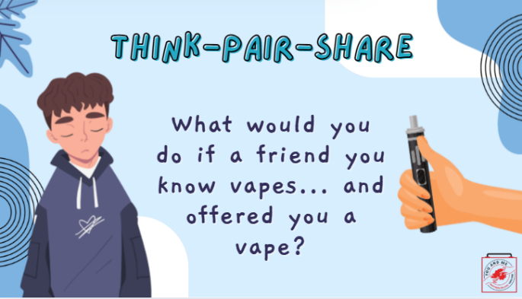 | (Ask students): In groups of two (think-pair-share), let's brainstorm what you would do if a friend you know vapes and offered you a vape. We will take 2-3 minutes, so write at least 2 ways you would respond. Then we will share what some of you said in your groups.  (After 2-3 minutes, ask the students): what did you come up with?
24 | 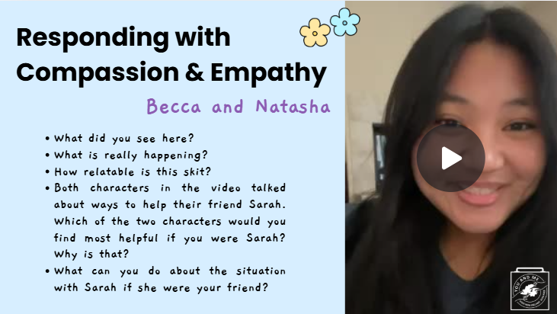 | Let's first discuss the difference between compassion and empathy.  Empathy is the ability to feel for someone: "I understand what you're going through. I've been there."  Compassion is feeling for someone with a desire to help: "I can understand your distress, and I want to help."  We want to let the other person (for example, the person who is using e-cigarettes and/or cannabis vapes) know that they are not alone. Essentially, you're creating a connection with the other person.  We are going to watch a short roleplay (video) that shows one of the characters, Natasha, responding with compassion and empathy. (Click on video.)  We will then break into small groups. (Teacher note: once they are in groups): Each group will write up the answers to the questions you see on the slide. We will then do a large group share-out for each question.  Please have one representative be the group spokesperson, one take notes, and everyone share in the discussion.  (After watching the video and completing the assignment, the teacher will ask each question, and everyone will share their findings.)  References:  https://www.betterup.com/blog/compassion-vs-empathy  https://www.psychologytoday.com/us/basics/empathy  https://www.drstevesilvestro.com/teaching-kids-empathy-and-compassion
25 | 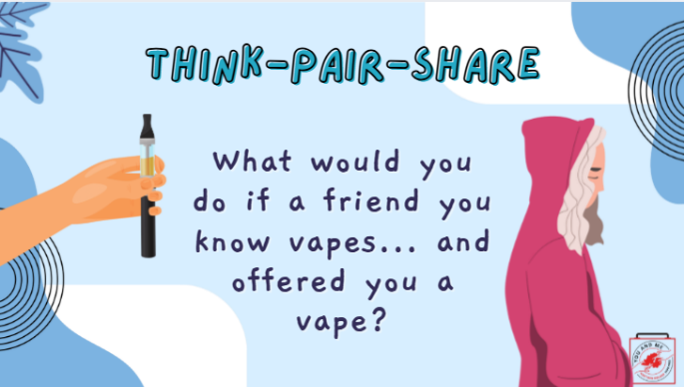 | Knowing what you know now, how you refuse with compassion and empathy if a friend offered you a vape?
26 | 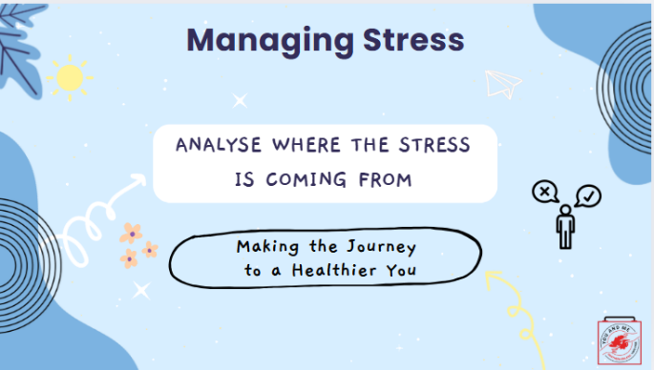 | In summary, when managing stress, analyse where the stress is coming from.  Pick the coping technique that works for you.
27 | 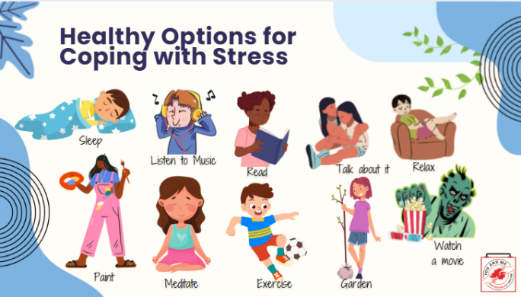 | Here are some healthy options for coping with stress.  What are your healthy options for coping with stress? Write down a list of five techniques you can use.
28 | 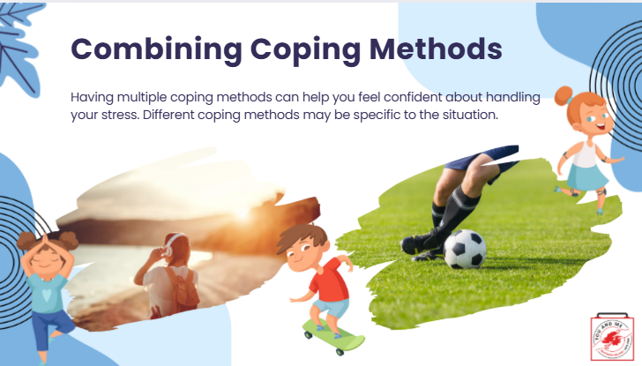 | You may want to try combining several coping methods.  Having multiple coping methods can help you feel more confident about handling your stress.  Different coping methods may be specific to the situation you're encountering.
29 | 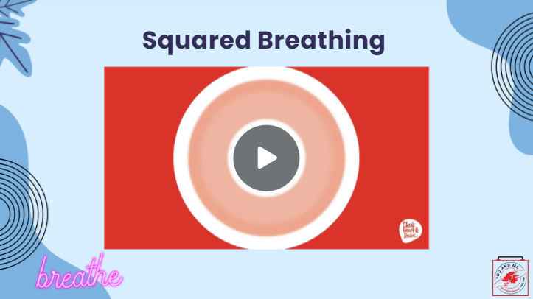 | One technique we are going to try out is a type of breathing called Squared Breathing. You can do it at the moment when you're feeling stressed.  We're going to watch a short video that explains Squared Breathing. After we watch the video, you will all have the opportunity to practice this.  Let's watch the video now.  (After the activity, ask students) How did that go for you? How do you feel?  As with everything new, try this a few times in your day until it becomes a routine.
30 | 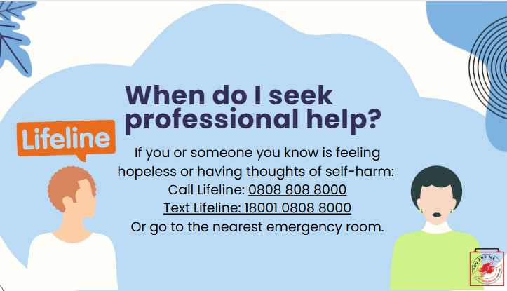 | We've talked a lot about what stress is and what it does to the body.  We also discussed self-medication and mental health.  I'd like to share this resource with you if you or someone you know is feeling hopeless or like you might want to hurt yourself. You can call or text the numbers on the screen to talk to someone on NI's crisis helpline. If you or your friend are at school, please talk to a trusted adult right away, like a school nurse, a teacher, or a coach.  (Educator note): Have students write in their notebook or on a piece of paper a script they could use to convince a friend to seek help from a trusted adult or professional in the community. Be sure to include how that person can help them with their problem  (Examples: Are they a professional? Do they have expertise? Are they understanding? How do they help to solve community health issues?)  Reference:  https://afsp.org/
31 | 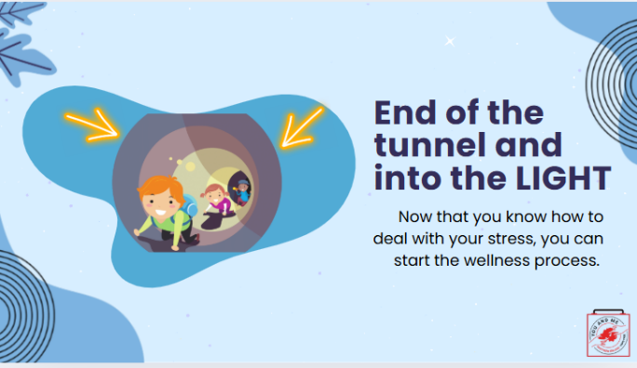 | So we are nearing the end of our lesson.  You have a lot of information from today's lesson on stress and coping to empower you as you start your wellness process.
32 | 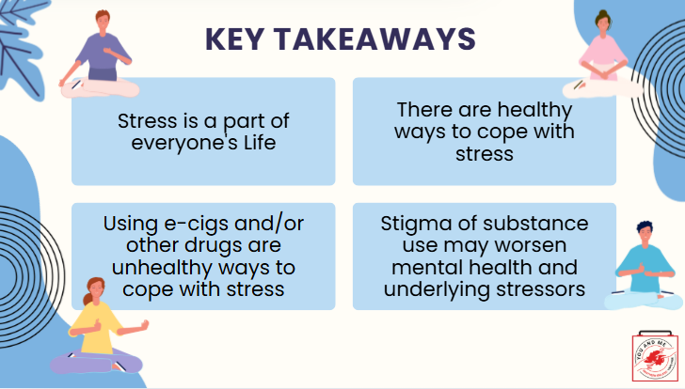 | Let's review our key takeaways.
33 | 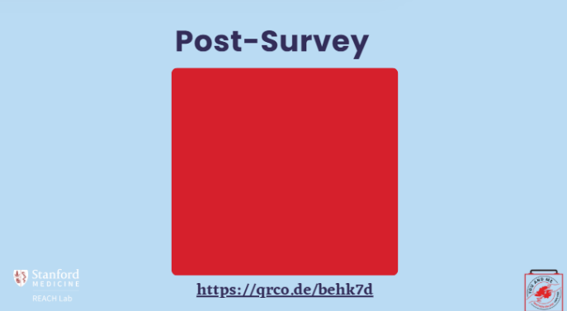 | *If you are teaching the curriculum up to Lesson 5, please complete the survey here. !  Educators - This is the post survey for our dashboard. Please have your students complete this survey after the pre survey and the curriculum has been implemented.  More information can be found at https://med.stanford.edu/halpern-felsher-reach-lab/curriculum-data-dashboard.html  Students can access the post survey at the QR code on this slide, or at https://qrco.de/behk7d

