Year 11-14 Lesson 1:
Full of Potential: Your Brain, Nicotine - Free



Lesson 1
Talking Points and Slide Chart

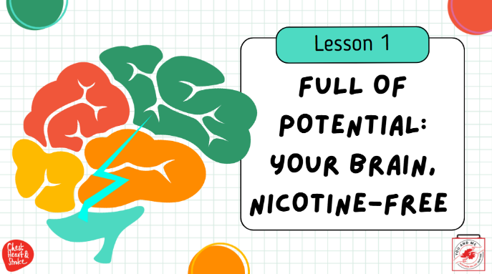

Slide | Image | Talking Points
1
2 | 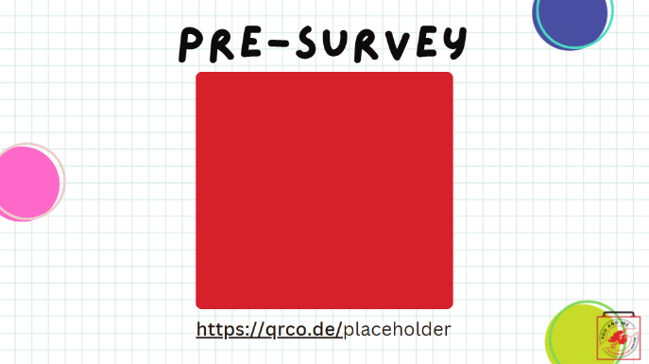 | Educators - as you hopefully saw in the instructions for this lesson 1, we hope you will have registered for our dashboard; instructions and more information can be found at https://med.stanford.edu/halpern-felsher-reach-lab/curriculum-data-dashboard.html  Further, please have your students complete these pre and post surveys. They can access the pre-survey at the QR code on this slide, or at https://qrco.de/behk6D  At the end of the curriculum, please have students take the post survey; links can be found in the slides at the end of the curriculum. Thank you!
3 | 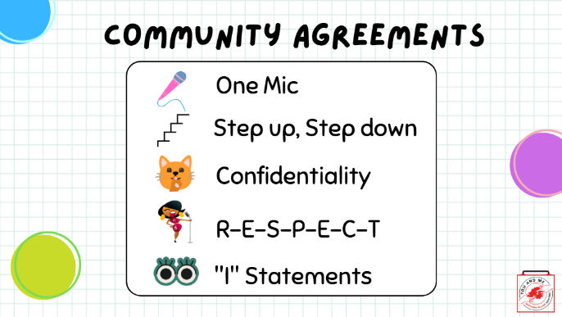 | (Teacher note: this slide is optional; you may use these or use your own established classroom norms)  Here are our community agreements:  One Mic (explain, if needed): one person talking and no interrupting.  Step up, Step down (explain, if needed): if you find yourself speaking a lot, take some time to listen and leave space for others. If you find yourself holding back your thoughts, speak up and share with us.  Confidentiality (explain, if needed): what is said here, stays here, or another way to say it is that our classroom is a confidential space.  (Spell out): R-E-S-P-E-C-T (song by Aretha Franklin)  "I" Statements (explain, if needed): say "I think" or "I feel" instead of "you don't care what I think or feel."  (ask students): Are there others you would like to add to our community agreements?  (Write these on the board or add to the slides)
4 | 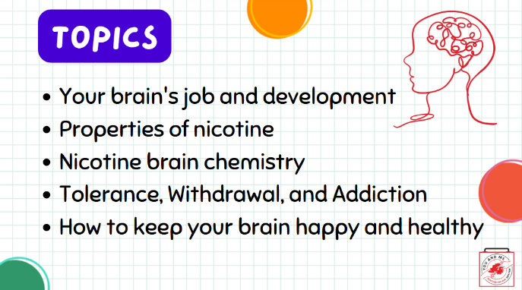
5 | 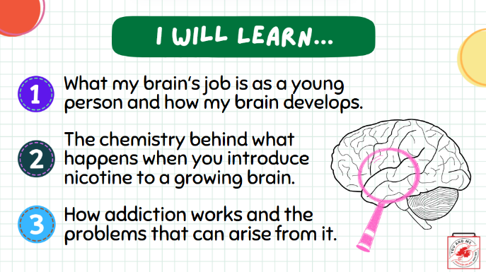
6 | 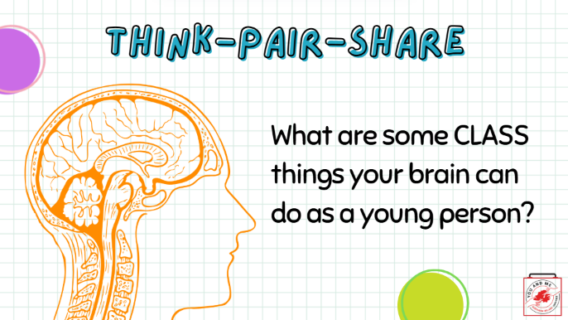 | Let's start off this lesson on the teen brain with a warm-up!  In pairs (think-pair-share), write a list of five things your brain can do as a teen. We will then do a share-out.  (Teacher note: give students about 2-3 minutes, then open to discussion for another 2-3 minutes).
7 | 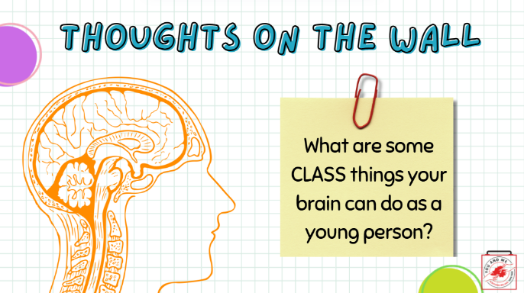 | Let's start off this lesson on the teen brain with a warm-up!  On a post-it note, write a list of five things your brain can do as a teen, and post it on the wall when you're done.  (Teacher note: give students about 2-3 minutes, then open to discussion for another 2-3 minutes).
8 | 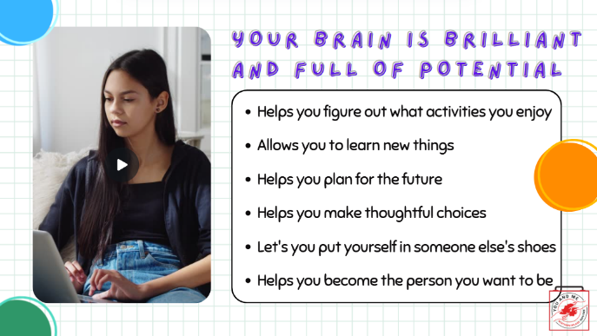 | Indeed, your brain is brilliant and full of potential.  Your brain (Teacher: read off slide):  Helps you figure out what activities you enjoy  Allows you to learn new things  Helps you plan for the future  Helps you make thoughtful choices
9 | 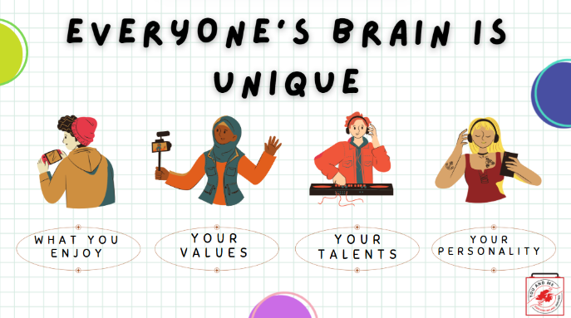 | Everyone's brain is different.  (Teacher Note: read off slide):  It's based on what you enjoy, your talents, your personality, and your values.
10 | 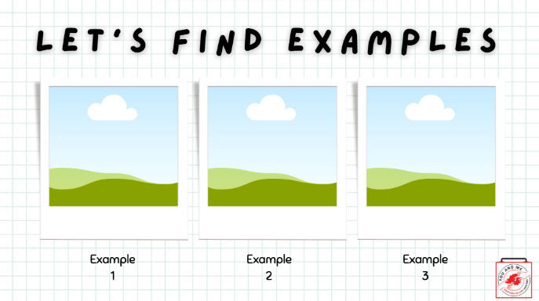 | Let's prove that our brains are different with a quick activity.  I'm going to show some images and you will give a thumbs up if you like the thing in the image and a thumbs down if you don't like it.
11 | 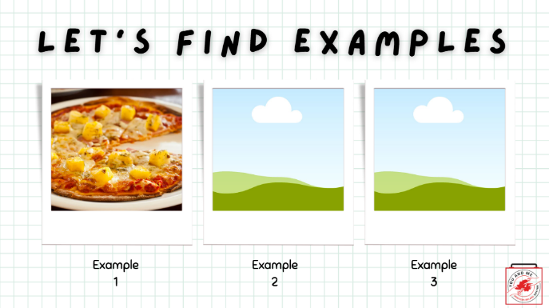 | Let's prove that our brains are different with a quick activity.  I'm going to show some images and you will give a thumbs up if you like the thing in the image and a thumbs down if you don't like it.
12 | 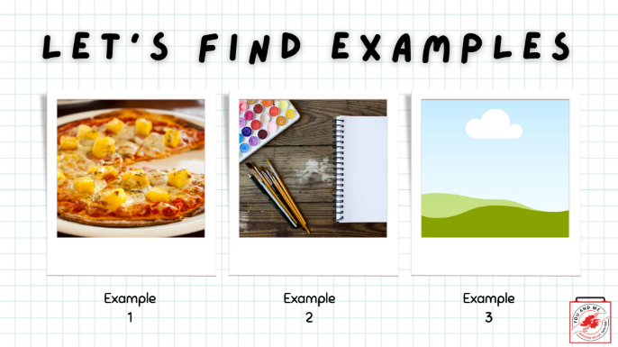 | Let's prove that our brains are different with a quick activity.  I'm going to show some images and you will give a thumbs up if you like the thing in the image and a thumbs down if you don't like it.
13 | 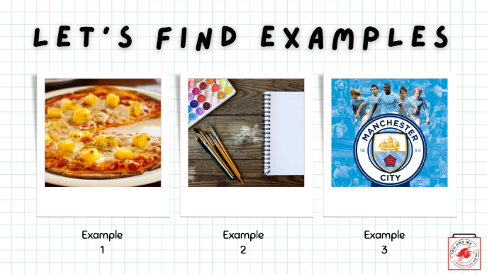 | Let's prove that our brains are different with a quick activity.  I'm going to show some images and you will give a thumbs up if you like the thing in the image and a thumbs down if you don't like it.
14 | 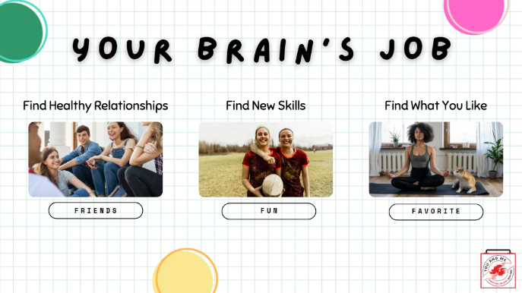 | Right now, your brain's job is to learn:  How to build healthy relationships: This is why you probably care a lot about your friends and relationships.  Find and build new skills: This is why having fun is probably a top priority for you  And figure out what you like: You probably already have favorite music genres, favorite foods, and favorite hobbies.
15 | 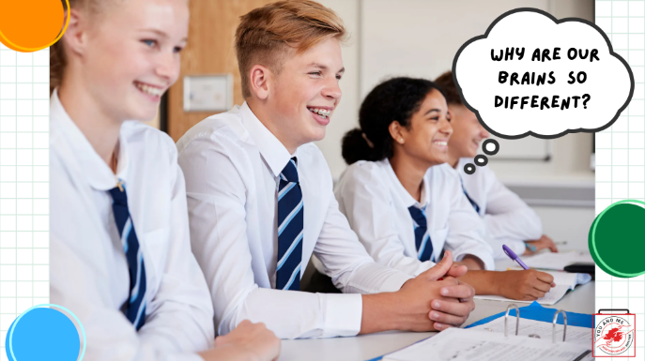 | So why are our brains and, therefore, our likes and dislikes so different? Let’s first start discussing the brain anatomy, and then we will discuss more about brain function.
16 | 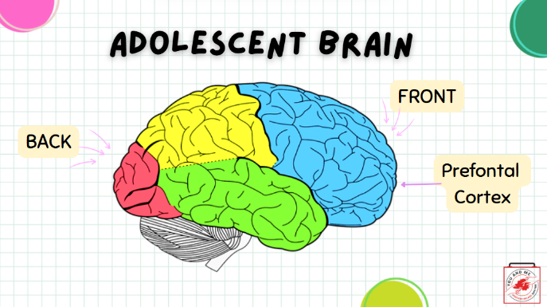 | Multiple areas of the brain are often working at the same time to help us engage in different behaviors.  For example, when we are walking, this involves using multiple areas of the brain, starting from our decision to walk to us standing up and taking our first step.  Our brains develop in a “back to front” fashion over our childhood, teenage years, and even into young adulthood.  Areas near the back of our brain, which control things such as coordination and vision, develop first.  During our teen years, the front part of our brain, called the prefrontal cortex, which we use to help make decisions, continues to develop. In fact, it doesn’t stop developing until we are around 25.  Reference: http://www.drugfree.org/why-do-teens-act-this-way/adolescent-brain-and-behavior/
17 | 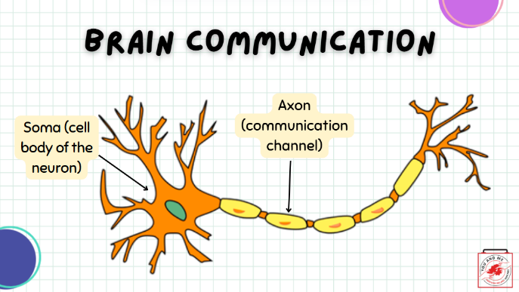 | In order for our bodies to function, the different parts of our brains need to communicate with each other.  The neuron is the primary signalling cell of the nervous system. The interaction between the billions of neurons in the nervous system is what allows our bodies to function and what enables us to think and move.  The neuron is made up of a few parts. The soma is the powerhouse of the neuron, where the nucleus is housed.  The soma gives the rest of the cell instructions on what to do.  The axon is the channel that carries information from the soma to the synapse (the end of the neuron).  The synapse is the part where two neurons communicate by sending chemicals called neurotransmitters.  Reference:  https://psych.athabascau.ca/html/Psych289/Biotutorials/1/soma.shtml
18 | 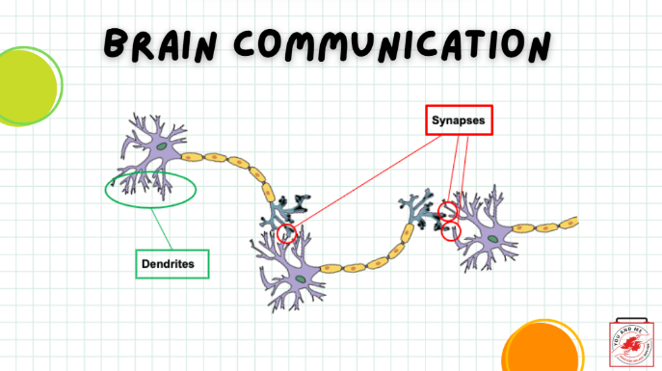 | For neurons to communicate, an electrical signal travels between neurons.  The signal starts from one neuron, travels through a space between neurons called the synapse, and then connects to the next neuron.  The part of the neuron that receives the signal is called a dendrite.  The signal keeps going through connecting neurons.
19 | 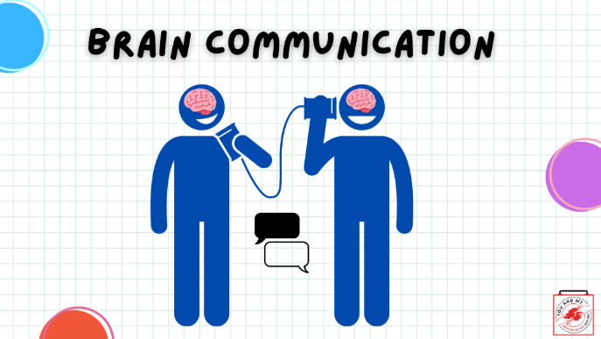 | Another way to think about this is when you play “telephone” by stringing soup cans on a string.  The message travels from one soup can to another through the string that connects them, allowing for communication between separate things.
20 | 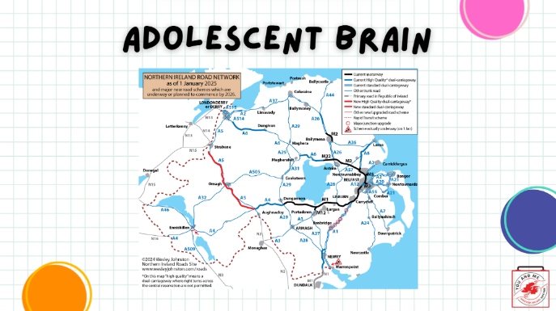 | As a child, your brain is a bit like the western counties - there are not a lot of roads & infrastructure, which means your brain has fewer synapses.  Then, during your adolescent years, your brain experiences a significant increase in these synapses. So, as you get older, it becomes more and more built up, like the eastern side around Belfast, with more connections between neurons in the brain.  In fact, these new connections are overproduced, so your brain looks a little like a crowded motorway system—there are a lot of new connections and roads going everywhere.
21 | 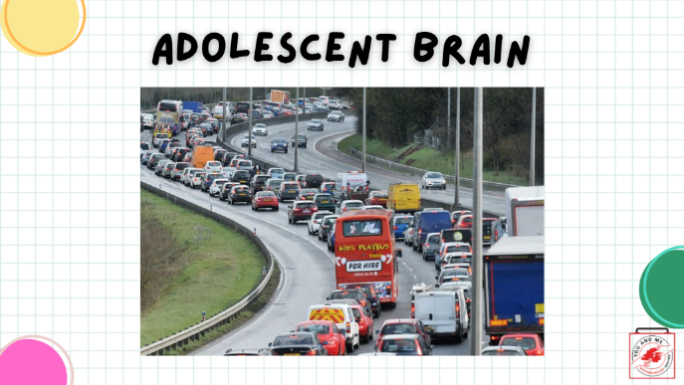 | And there is a lot of traffic. Your brain is experiencing a lot of stimuli right now.  In essence, the chemicals in your brain feel like they are in bumper-to-bumper traffic on the motorway.  As such, while your brain functions well, sometimes there is a lot of traffic slowing down your information processing.  This is totally normal and good!  In fact, that is why adolescents are so creative, great at music, dance, other forms of art, and so on.
22 | 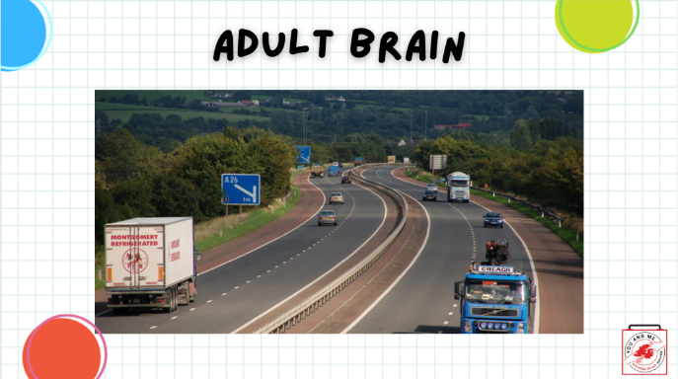 | As you start to get older, your brain begins to “prune” or cut back some of these additional connections to help integrate your learning.  By the time you are in your early to mid-twenties, your brain has reduced the number of synapses or “motorways,” which is good, as it allows for more focused brain communication.  Also during this time, your neurons are undergoing increased “myelination.” This involves forming a type of “sheath” or connecting channels or “roads” between neurons. This allows for the processing of information (or travel between two places) to be smoother and more efficient.  Sometimes we call this "wiring in," and what that means is that the more you do it, the more your brain gets wired to do it.  When we start talking about nicotine and how it impacts the brain, we will reintroduce this concept of pruning.
23 | 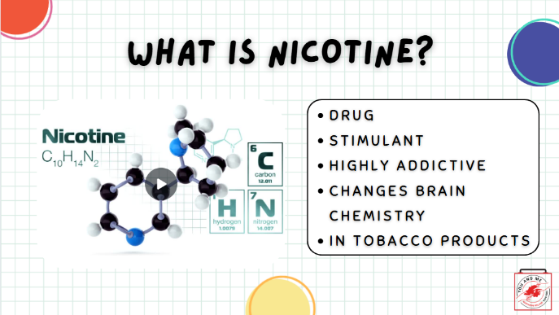 | So let's talk about nicotine now.  Nicotine is a drug that is a stimulant, meaning it raises levels of physical or psychological activity in the body, and it is toxic at high doses (click on the video for animation).  Nicotine is found in tobacco products, and nicotine exposure during fetal development has lasting adverse consequences for brain development, as it can affect maternal and fetal health during pregnancy.  Data from studies of mice suggest that nicotine exposure during adolescence may have lasting adverse effects on brain development.
24 | 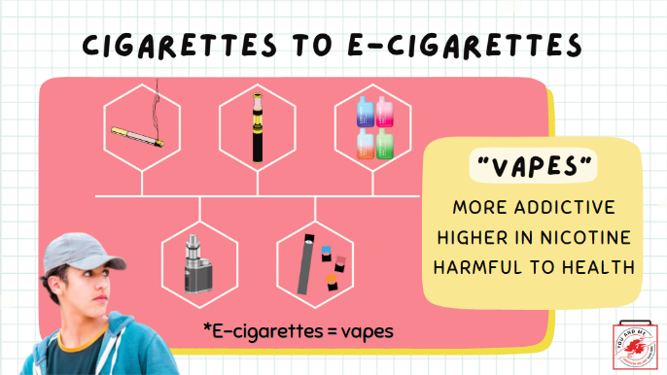 | Over the years, the tobacco industry has created new tobacco products, from cigarettes to e-cigarettes.  E-cigarettes are more addictive, with very high concentrations of nicotine, which are harmful to your health.
25 | 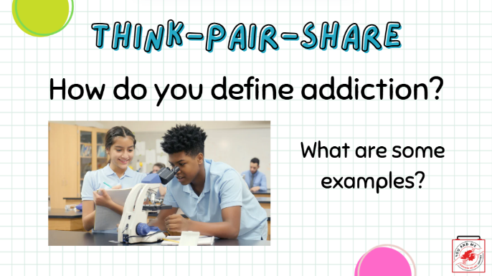 | In pairs (think-pair-share), brainstorm what you think addiction is. Also, provide some examples of addiction.  We will then do a share-out.
26 | 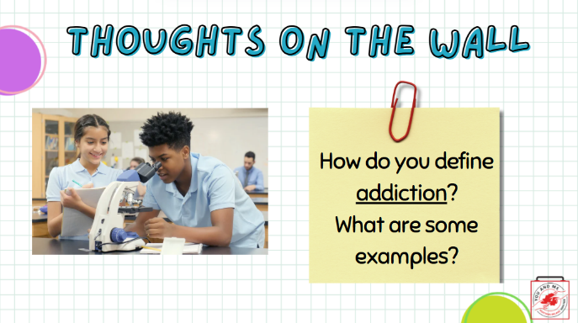 | On a post-it note, brainstorm what you think addiction is. Also, provide some examples of addiction. Post it on the wall when you're done.  We will then do a share-out.
27 | 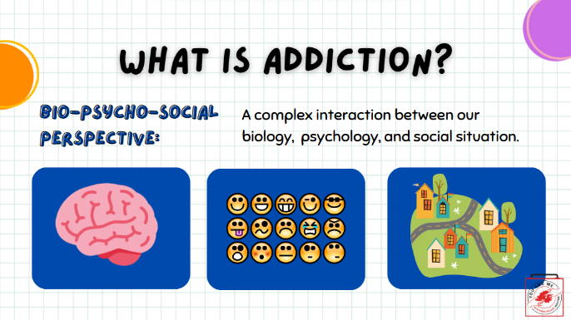 | There are many definitions and theories on what addiction means.  In this lesson, we are going to use a biopsychological perspective, which recognises that addiction is a complex interaction between biology, psychology, and social situations.  When we say biology, we are including the brain.  When we say psychology, we mean thoughts, beliefs, feelings, expectations, and motivations.  What we mean by social situation is where we live and the spaces where people use drugs like nicotine.  References:  Denning & Little (2017). Why do some people get into trouble while others don't?  in Over the Influence (p. 83).  https://www.tobaccofreekids.org/assets/factsheets/0127.pdf- delaying use of nicotine  https://www.verywellmind.com/dsm-5-criteria-for-substance-use-disorders-21926
28 | 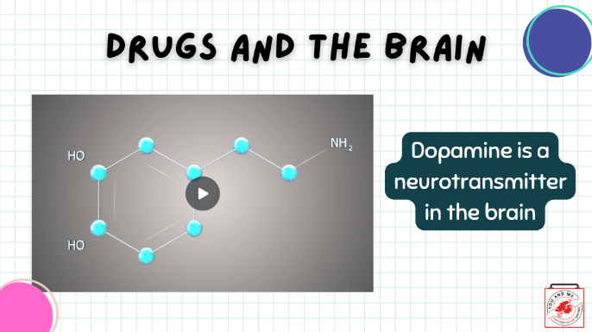 | (Teacher Note: click on the image, which is a video).  There are two neurotransmitters we will focus on—the first is dopamine.  Dopamine is the neurotransmitter involved in the pathway of the brain called the “reward pathway.” We will discuss this pathway more on the next slide.
29 | 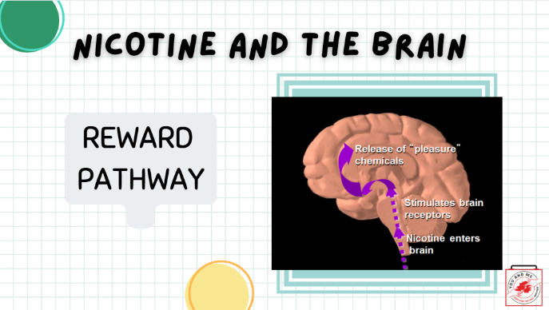 | The reward pathway is activated when you do things that make you feel good.  You first release the neurotransmitter dopamine, which then activates this pathway in your brain.  This pathway was developed evolutionarily to help us pursue activities that would aid our survival.  At normal levels, this release of dopamine rewards the behaviours we need to survive (eat, sleep, etc.), so we keep doing them.  Reference: http://www.addictionsupport.aarogya.com/images/stories/neurochems%20dopamine%20serotonin.jpg
30 | 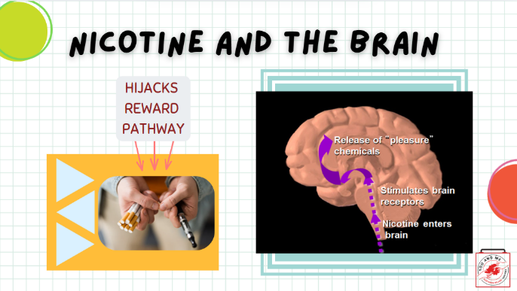 | Drugs like nicotine “hijack” and take control of your reward pathway, so you no longer have control over it.  Drugs cause almost twice to ten times the release of dopamine from this pathway, and this can occur almost immediately and last longer than the dopamine released from “survival activities.”  For example, when you use a cigarette or an e-cigarette, the nicotine in the cigarette or e-cigarette causes dopamine to be released.  This is why people initially feel good after using a cigarette.  However, your brain continues to crave that dopamine release after you are done, and you slowly lose control over your choice to use cigarettes, especially since these drugs artificially release more dopamine than your body naturally does.  This is how people become addicted to cigarettes.  Reference: http://www.addictionsupport.aarogya.com/images/stories/neurochems%20dopamine%20serotonin.jpg
31 | 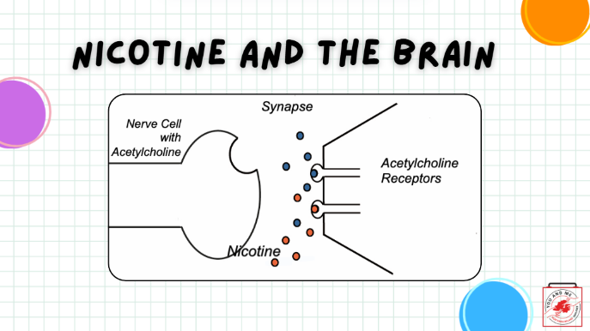 | The other neurotransmitter I want to discuss is acetylcholine.  In order to understand how nicotine works, we must discuss an important neurotransmitter in our body, acetylcholine (blue dots).  Nicotine (red dots) mimics the structure of acetylcholine and readily binds to wherever there are acetylcholine receptors in the brain.  However, nicotine isn’t behaving like acetylcholine in the brain, and as a result, it can disrupt normal signaling processes.  Reference: http://drugabuse.com/visualize
32 | 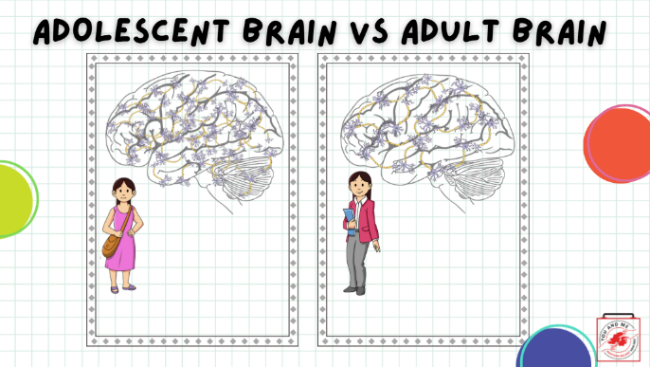 | Having the reward center in your brain hijacked during adolescence is especially concerning.  As we mentioned earlier when we discussed the adolescent brain, your brain has lots of connections based on what you learn and practise.  During late adolescence and into adulthood, the brain begins to cut out connections that are not being used. If you recall from earlier, this is called synaptic pruning.  When you reach adulthood, the necessary and most often used synaptic connections remain and are stronger and more efficient. This allows the brain to be really skilled, but at fewer functions.
33 | 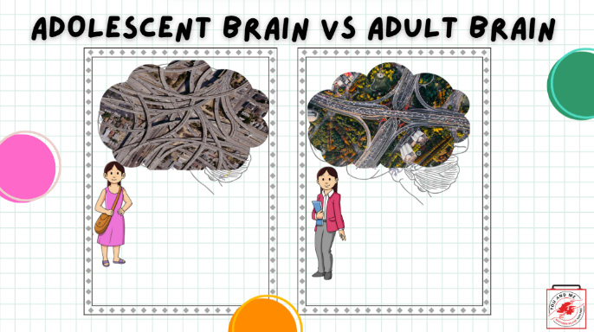 | Remember that slide on the adolescent brain looking like a motorway and the adult brain having less? Here it is superimposed on these brains.  The reason this is important when we talk about nicotine is this: we're born with nicotine receptors. If we don't introduce nicotine into our bodies as youths, we will prune away that receptor and be less likely to use nicotine.  But if we introduce nicotine to our brains, then we are more likely to become addicted to nicotine.  Image: Pixabay.com
34 | 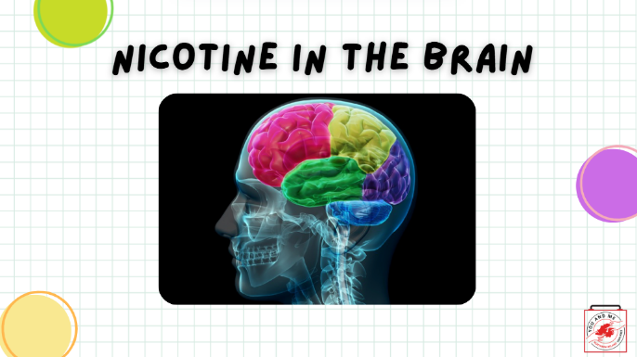 | Remember, earlier we mentioned dopamine, the neurotransmitter?  The reaction that nicotine has in the brain results in the stimulation of pleasure centres in the brain.  When inhaled, nicotine enters the brain after passing through the lungs and binds to pleasure receptors.  That causes a release of pleasure chemicals such as dopamine, providing the user with a temporary feeling of pleasure.
35 | 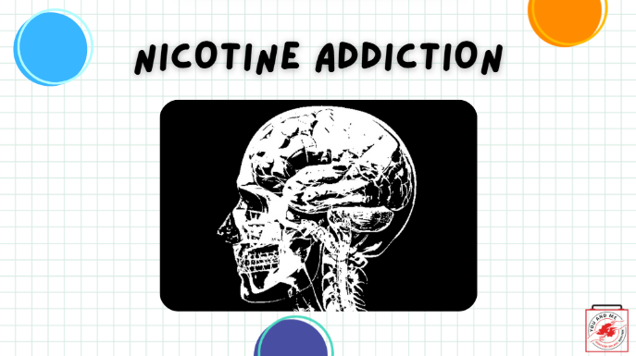 | Nicotine interferes with the body’s natural ability to experience and communicate pleasure.  Nicotine use creates floods of dopamine and intense feelings.  The pleasure centres in the brain adapt to drug use by sensing the extra dopamine and then begin to produce less of it.  This means that the user has a hard time creating natural feelings of pleasure without nicotine.  The user needs nicotine just to feel normal. Additionally, the pleasure centres in the brain create a memory of nicotine and an appetite for it.  That appetite for nicotine, despite its harmful consequences, is what we refer to as nicotine addiction.
36 | 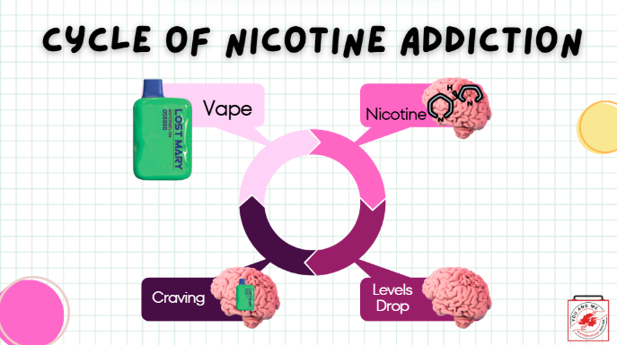 | It's worth repeating that nicotine is a highly addictive drug. The human brain can develop such a strong dependence on the drug that the nicotine user can no longer control their desire or smoking behaviours.  If we start with the brain with the nicotine molecule image (right), the cycle of nicotine addiction begins with bringing nicotine into the body. Nicotine enters the brain and activates the pleasure centres of the brain.  What happens next is that the level of nicotine in the body drops quickly.  This drop in nicotine levels causes the body to have a strong craving for nicotine, which is satisfied by bringing more nicotine into the body.  This cycle is powered by the body’s biological reaction to nicotine and isn’t controlled by the person smoking.
37 | 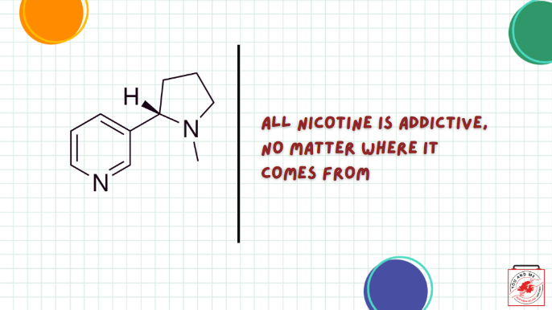 | The body reacts to nicotine in the same way, no matter what product it comes from, be it from cigarettes, hookah, nicotine pouches or gums, e-cigarettes, or any other tobacco product.
38 | 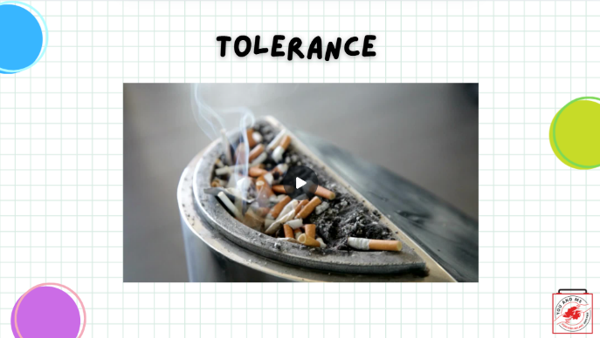 | (Teachers Note: Click on image - video).  Let's talk about two other topics related to nicotine and other drug use.  The first one is tolerance. Tolerance is when someone needs to use higher amounts of the drug to achieve the effect they want. This is because the person's body is used to nicotine.  This can look like someone vaping more often, using higher concentrations of nicotine, or even using more than one type of nicotine product, which is highly toxic (poisonous). You will learn more about nicotine and toxicity in another lesson soon.
39 | 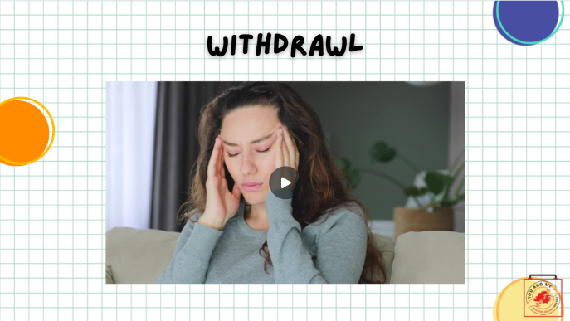 | (Teachers Note: Click on image - video).  The brain and the body feel really bad when they stop using nicotine.  This is called "withdrawal." It can be uncomfortable and distressing for the person.  Withdrawal can produce intense anxiety, a high heart rate, cravings, and irritability.
40 | 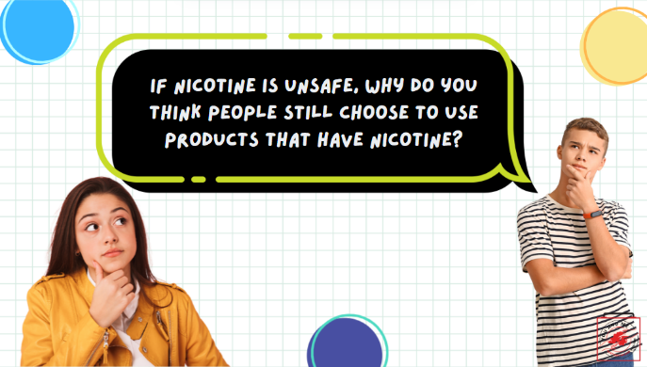 | So, if nicotine is unsafe and addictive, why do some people still choose to use products that contain nicotine? (pause for responses).  These are what we call "perceived" benefits of use, or good things people THINK will happen if they use. But these "perceived" benefits might not match up with reality.
41 | 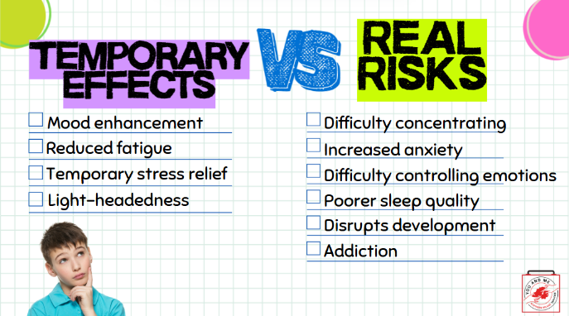 | In reality, there are temporary effects of nicotine, some of which are the "perceived" benefits we talked about.  These can include temporarily feeling like your mood is boosted, feeling more alert for a time, experiencing temporary stress relief, and some potential light-headedness or dizziness when the nicotine first enters your system. But it's important to remember that these effects, and these "perceived" benefits, are all temporary.  Over time, nicotine affects your ability to concentrate properly, increases your anxiety, reduces your ability to control your emotions, affects your sleep quality, disrupts your brain's development at this age, and, as we previously discussed, leads to a long-standing addiction to nicotine.  https://pmc.ncbi.nlm.nih.gov/articles/PMC3543069/  https://pmc.ncbi.nlm.nih.gov/articles/PMC7484459/
42 | 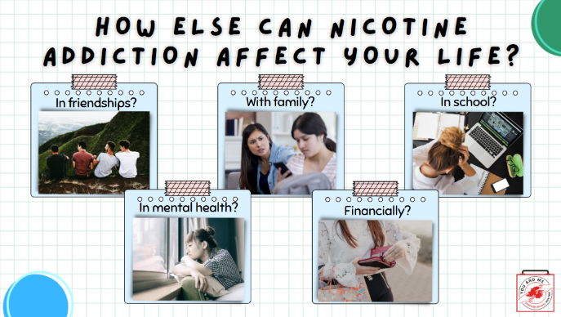 | (Teacher Note: Ask the class: What problems do you think can come from addictions? (pause for responses).  (Some examples may be: difficulty focusing in school; parents and teachers feeling mad and upset; losing friends; dropping grades; feeling lonely, sad, or stressed; letting friends down; and being worse at sports).
43 | 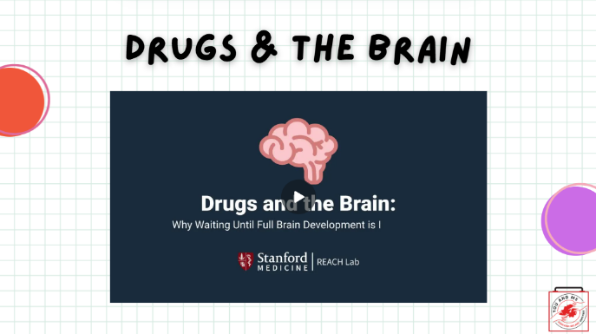 | Now let's watch a video that will show us what happens when someone is using a drug, like nicotine. (click on slide for video).  Reference:  https://www.youtube.com/watch?v=-w8n9UOiBxE
44 | 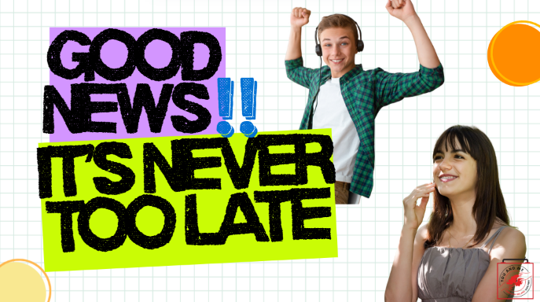 | Despite all the risks and harms of nicotine use we've discussed today, there is still good news!  It's never too late for the brain to heal itself, even if it's struggling with addiction.
45 | 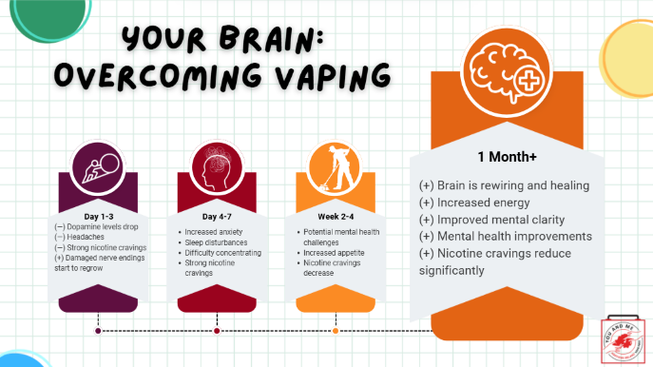 | Now that we know how your brain reacts ON nicotine, let's talk about what happens when it's OFF nicotine.  If you choose to quit vaping nicotine, here is what you can expect.  It won't be easy, and it may take some time. But as you can see, by about a month, things get a lot better for your brain.  (read each time point, with an emphasis on '1 Month+')
46 | 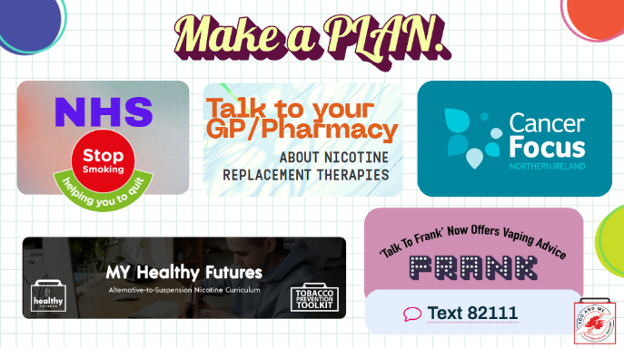 | Now, if you are thinking about quitting vaping - here's my encouragement to you: You've got this! There is loads of support for you out there.  (Optional: LINKED HERE - print out flyers with quit info for students to take home).
47 | 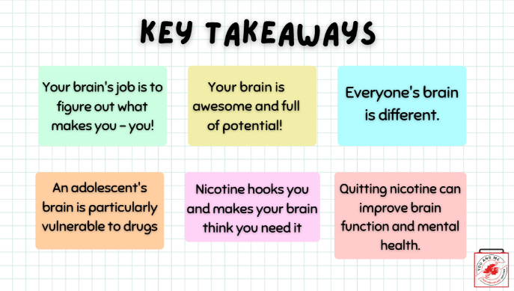 | (Read off slide the Key Takeaways)
48 | 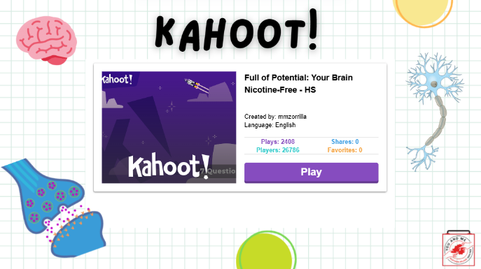 | (Click on the "Play" to start the Kahoot!).

