Year 11-14 Lesson 2:
Healthy Body, Healthy You-th:
Effects of E-cigarettes On The Body



Lesson 2
Talking Points and Slide Chart
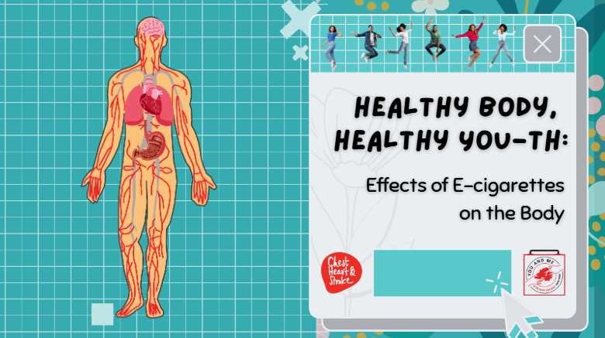

Slide | Image | Talking Points
1 | 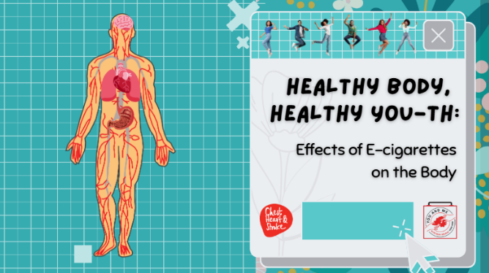 | Welcome back, everyone, and thank you for your amazing participation yesterday!  Today, we will continue discussing why many health professionals (and your teachers) are concerned about e-cigarettes.
2 | 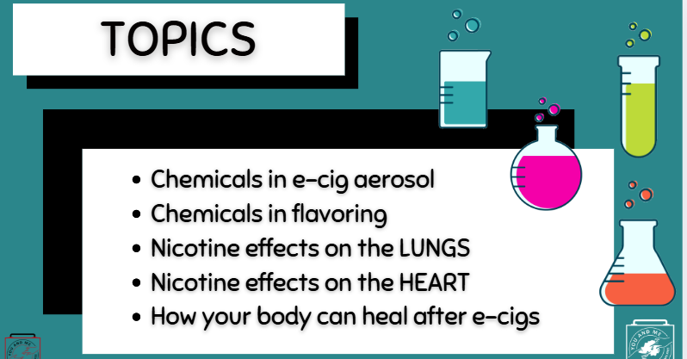
3 | 
4 |  | But first, yesterday we discussed one ingredient in e cigarettes that raises concerns and can affect adolescent brains.  Does anyone remember what that was? (Take answers; then state it is nicotine).  (Ask students):  Why are we concerned about nicotine? (Take responses).  What does nicotine do to your brains? (Take responses).
5 | 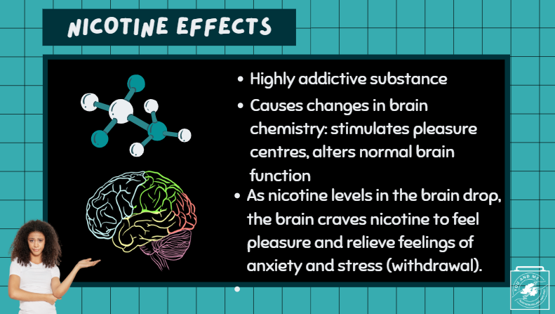 | Great. Thank you. So as a review,  (Teacher Note: Read the bullets on the slide.)
6 |  | So how do e-cigarettes affect the rest of the body?
7 |  | First, let's discuss what else is in an e-cigarette.  (Ask students): So, do you think e-cigarettes are just harmless water vapour?  They are not.  The answer is simply no.
8 |  | E-cigarettes release a harmful aerosol, not harmless water vapour.
9 |  | (Teacher Note):  Play the brief video: (30 seconds)  https://www.youtube.com/watch?v=jWY-As9PTWo&t=4s.
10 |  | Why does it matter that these e-cigarettes produce an aerosol?  What is in that aerosol?
11 |  | Well, all of these chemicals have been found in e-cigarette aerosol.  Simply put, e-cigarettes produce an aerosol that contains propylene glycol, glycerin, flavourings, nicotine, and many other harmful chemicals and toxins. Many of these chemicals are known to cause cancer.
12 |  | And by the way, most of these ingredients are also found in cigarettes, which we all know can cause cancer!  We'll discuss the industry's false claims of e-cigarettes being healthier than cigarettes later in the lesson.
13 |  | Did you know that many of the ingredients found in e-cigarettes are also found in household products—products that I am sure you do not want to put into your mouth or body?  For example...  - Lung exposure to heavy metals such as nickel and lead can significantly increase your cancer risks.  - Acetaldehyde, which is a volatile organic compound, is linked to bronchiolitis obliterans, otherwise known as "vaper's lung."  - Other aldehydes, such as formaldehyde—which is used as a dead tissue preservative—can cause lung disease, as well as cardiovascular (heart) disease.
14 | 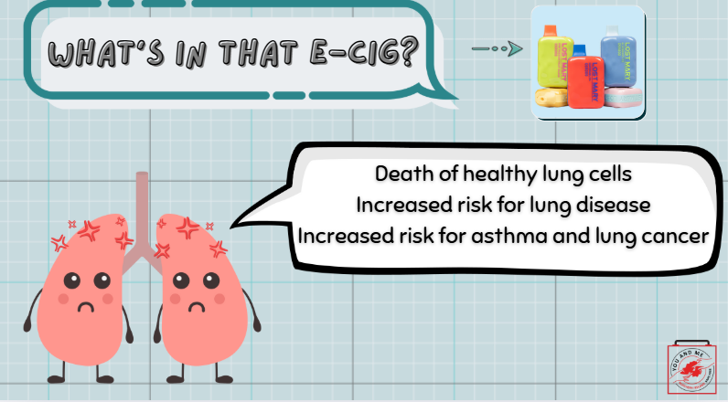 | Those e-cigarette ingredients can cause all sorts of harm to your lungs by killing or damaging otherwise healthy lung cells, increasing the risk for lung diseases like asthma and lung cancer.
15 | 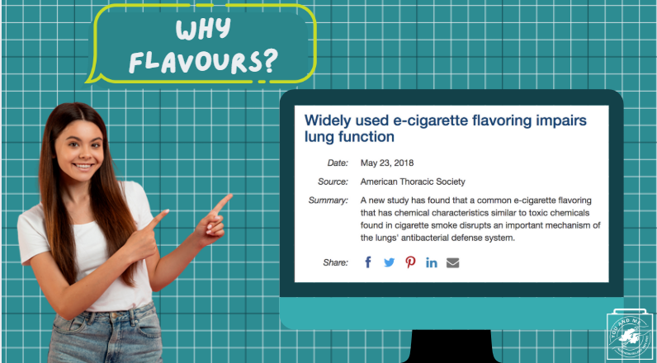 | E-cigarettes also have flavours and flavourants, like cinnamaldehyde (cinnamon), vanillin (vanilla), menthol, and others. When aerosolised through a vape, these flavours themselves are harmful.  You see, you can heat and eat these flavours, but if you heat them and then inhale the aerosol from them, that is where the concern lies!  These flavours can harm your lungs and heart, especially.  So, let's discuss the harms of flavoured e-cigarettes.
16 |  | Let's first discuss menthol.  (Teacher Note): Read slide.
17 |  | E-cigarettes can also include cinnamaldehyde (a cinnamon flavour) that can decrease immune function.  Inhaling aerosol with banana, chocolate, and other flavours can also be harmful.  https://pmc.ncbi.nlm.nih.gov/articles/PMC9590402/
18 |  | Despite the harms from these flavours, e-cigarette companies continue to use them.  (Ask students): Why do you think flavours are still in these products? (Answer: appeal to youth).  (Ask students): How does that make you feel? (Take responses).
19 |  | Despite the harms from these flavours, e-cigarette companies continue to use them.  (Ask students): Why do you think flavours are still in these products? (Answer: appeal to youth).  (Ask students): How does that make you feel? (Take responses).
20 |  | The tobacco and nicotine industry puts flavours in these e-cigarettes to attract young people.  Flavours that smell and taste good mask the harsh taste that tobacco and nicotine have, as well as the harms caused by e-cigarettes.
21 | 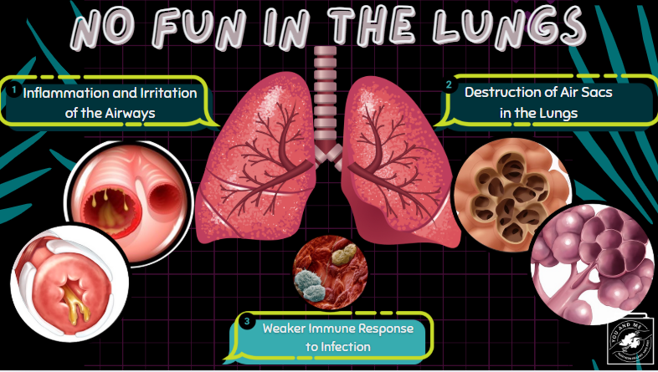 | Let’s now discuss the specific health effects of e-cigarettes.  First, let's discuss how e-cigarettes and their chemicals hurt your lungs.
22 |  | This video explains how e-cigarettes can harm the lungs.  Let's watch and listen.  (Teacher Note): Play embedded video (1:40).
23 |  | As you can see, e-cigarette use can do real damage to your lungs.  Let's hear from Ewan Fisher, who had a life-threatening case of e-cigarette and vaping-associated lung injury (otherwise known as EVALI).  Ewan Fisher switched from cigarettes to vaping, but at just 16, his lungs failed the night before he was due to start his GCSE exams. He spent weeks in intensive care and then needed an artificial lung to survive.  (Play video.)
24 |  | Ewan is not the only young person to nearly die from vaping. More recent cases include 17-year-old Kyla Blight from Cumbria, who had to have part of her lungs removed after one of her lungs collapsed and she went into cardiac arrest.  Here in Northern Ireland, we've had similar cases.  (*Play video.)
25 |  | In addition to harming the lungs, e-cigarettes can hurt your heart.  Nicotine use increases the risk of blood clotting and stiffens blood vessels that direct the flow of blood around your body and heart.  This impact on the heart can seriously increase your risk of cardiovascular disease.  https://pmc.ncbi.nlm.nih.gov/articles/PMC9021536/
26 |  | The evidence that e-cigarettes increase cardiovascular or heart risk is piling up.  The heart is the centre for pumping blood throughout a complex network of blood vessels in the body. These blood vessels are responsible for delivering fresh oxygen to organs and tissues.  Your cells need oxygen to survive and work properly.  Breathing in the aerosol from the e-cigarette, even if you're not the one using it, can lead to blood vessel stiffness and possibly affect your heart’s ability to move fresh oxygen to your brain, muscles, liver, and other parts of your body.  Ultimately, blood vessel stiffness and blood clotting can increase someone’s risk for heart attack or heart disease.
27 |  | There is also evidence that using e-cigarettes can lead to acid reflux or heartburn.
28 | 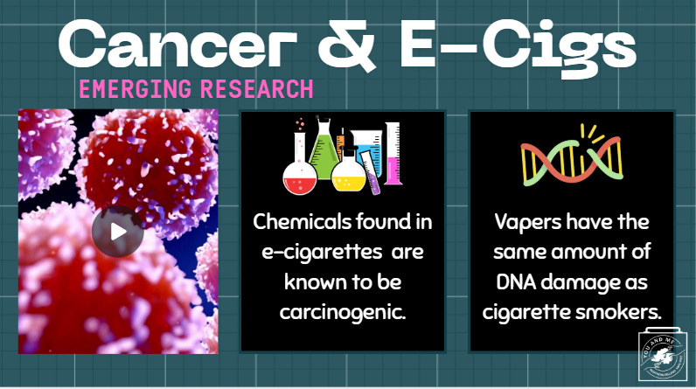 | While the direct link between cancer and e-cigarettes is still being studied, there is emerging research that connects the two.  Here is some emerging research on the topic:  As we discussed earlier in the lesson, there are certain chemicals in e-cigarettes that are known to cause cancer.  Studies in humans found that vapers had the same amount of DNA damage as cigarette smokers, which is concerning since DNA damage is a critical part of cancer development, and cigarettes have long been known to cause cancer.  But, again, more research on this link is needed.  PEER-REVIEWED CITATIONS:  1.https://europepmc.org/article/MED/40278584  2.https://academic.oup.com/ntr/article/25/6/1145/7035481
29 | 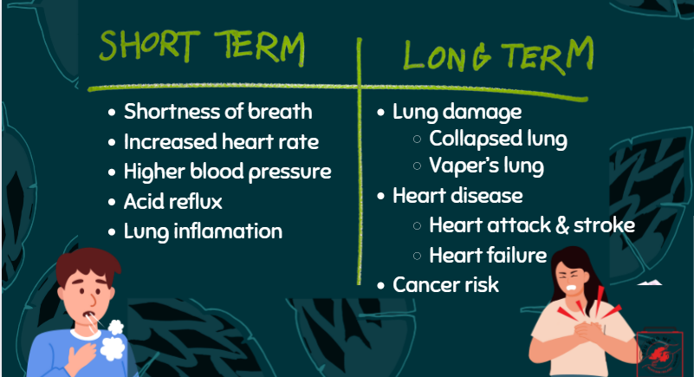 | There are both short- and long-term effects of nicotine on the body. Short-term effects are those that can occur shortly after use, while long-term effects result from repeated use and can develop over the course of months or years.  Here are some short-term effects: (read off the slide)  And here are some long-term effects: (read off the slide)
30 |  | Now that we've discussed how harmful e-cigarettes can be to both your brain AND your body...  Ask yourself: If you wouldn't smoke cigarettes, why would you vape?
31 | 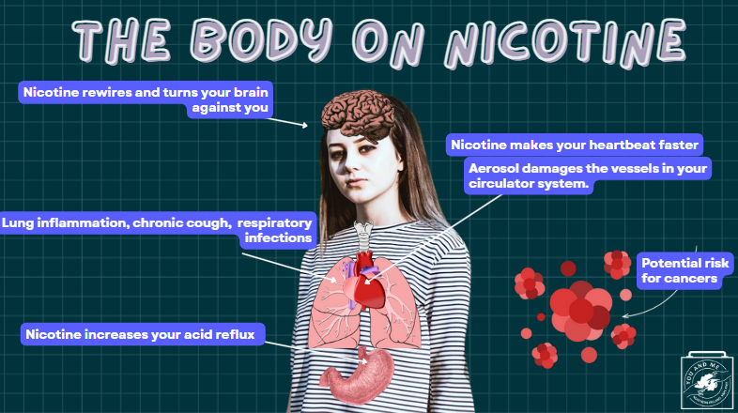 | So, let's recap all the effects of nicotine on the body, shall we?  Sources:  https://www.cdc.gov/tobacco/e-cigarettes/health-effects.html  https://www.ahajournals.org/doi/10.1161/CIR.0000000000001160
32 |  | On the bright side, health risks decrease as soon as you stop using e-cigarettes. For example, the risk of having a heart attack can drop immediately after quitting e-cigarettes.  Someone could take action right away to protect their heart and lungs by stopping any e-cigarette (or cigarette use).
33 |  | In fact, your body begins to heal itself almost immediately after you stop vaping. While it might not be easy, there’s a lot of healing your body could experience in the year or so after you choose to quit.  (Read the different symptoms and healing processes for each time marker.)
34 |  | Now, if you are thinking about quitting vaping - here's my encouragement to you: You've got this! There is loads of support for you out there.  (Optional: LINKED HERE - print out flyers with quit info for students to take home).
35 |  | So, given all you have learned today, what would you say to a friend who wants you to vape with them? (Take responses).  Educator Notes: Have students work in groups of three and come up with three scenarios (have them describe the scene - for example: at a party or after school; with friends or with people they don't know) and role-play through the scenario using the refusal responses listed on the slide.
36 |  | E-cigarettes are NOT just harmless flavoured water vapour. They produce an aerosol full of harmful chemicals and other constituents.  E-cigarette aerosol damages the lungs and heart, which can lead to disease.  The flavours and flavourants in e-cigarettes are also harmful. The risk of having a heart attack decreases right away when going vape-free.  Going smoke or vape-free allows the body to heal right away.
37 |  | (Teacher Note):  Click on embedded link  Administer/play the Kahoot!

