Year 11-14 Lesson 5:
Be Your Strength: Stress, Coping and Wellness



Lesson 5
Talking Points and Slide Chart
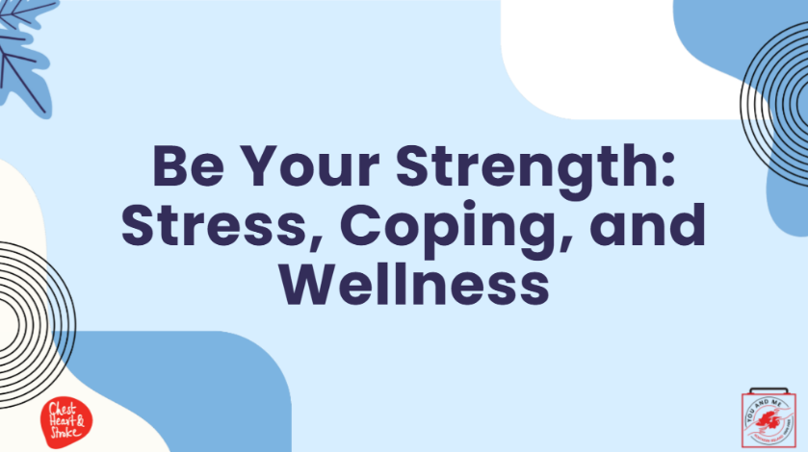

Slide | Image | Talking Points
1 | 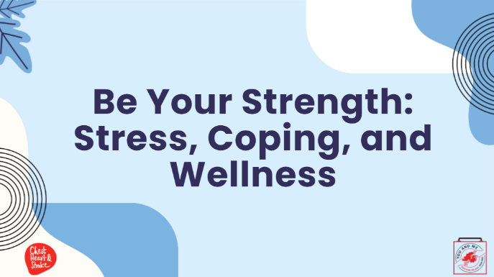 | Today’s lesson is on wellness.  We will discuss what stress is, identity triggers, and causes of stress, plus practice some strategies to manage stress and discover what works for you.  We will also discuss mental health and substance use and provide resources on where and when to seek help.
2 | 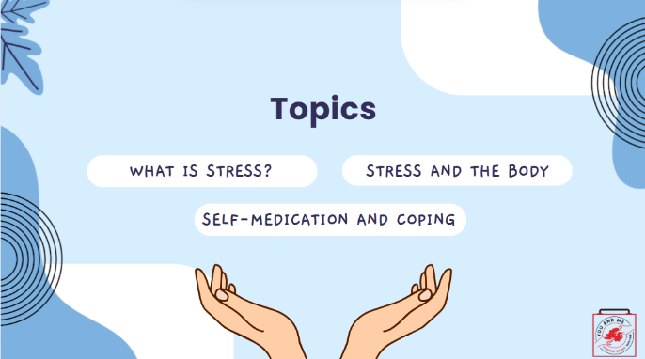 | (Teacher note): Read slide
3 | 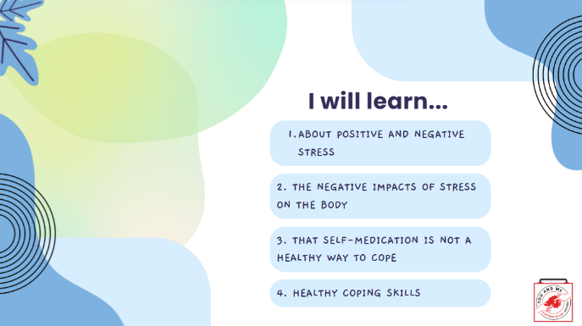 | (Teacher note): Read slide
4 | 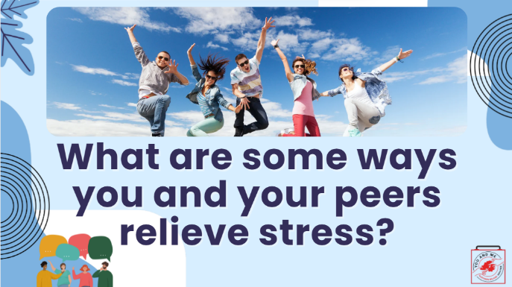 | (For teachers only: the graphic image of the four youth in a group is a cue to engage students in discussion.)  Today’s topic is on ways to relieve stress.  (Ask students): Let's brainstorm some ways you and your peers relieve stress. (Write down answers on the board.)  Possible responses: sleep, ride my bike, play with my dog, listen to music.
5 | 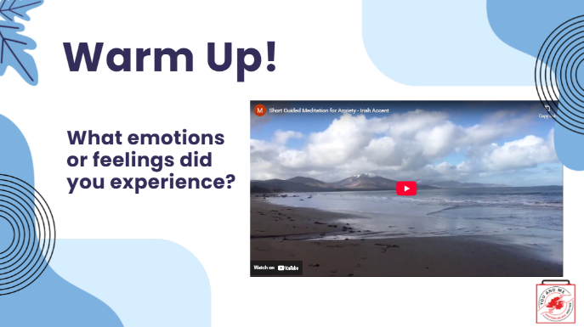 | We will start off our lesson on stress, coping, and wellness by listening to and participating in a guided meditation activity together as a class.  We will then have a share-out.  You are in a safe space. Please close your eyes. (Teachers: If you notice students with their eyes open, repeat the message one more time.)  (After the meditation is over, ask students): What emotions or feelings did you experience during or after the meditation?  (Some possible responses: relaxed; sleepy; didn’t like it.)  Consider this mindful meditation as one of many techniques in your wellness toolkit. We will do another technique later in our lesson.  Reference:  https://www.youtube.com/watch?v=LrFswk2uvvM
6 | 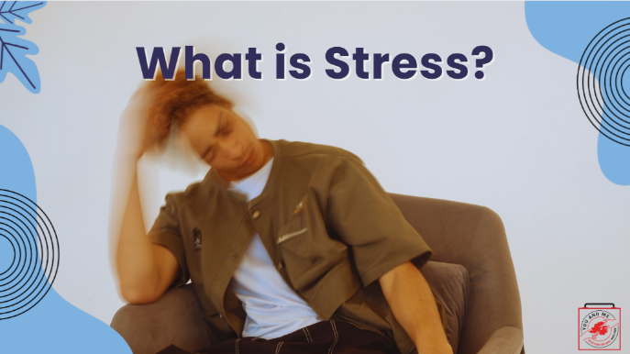 | How do you define stress?  (Pause and wait for students to respond.)  Possible responses:  not feeling good; under pressure; lack of time management.
7 | 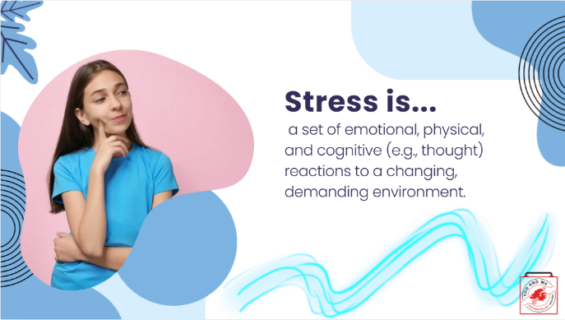 | A way to think of stress is as a set of emotional, physical, and cognitive reactions to a changing, demanding environment.  Stress is really more about our capacity to handle change than it is about whether that change makes us feel good or bad.  Change happens all the time, and stress is, in large part, what we feel when we are reacting to it.  Reference:  https://www.mentalhelp.net/stress/
8 | 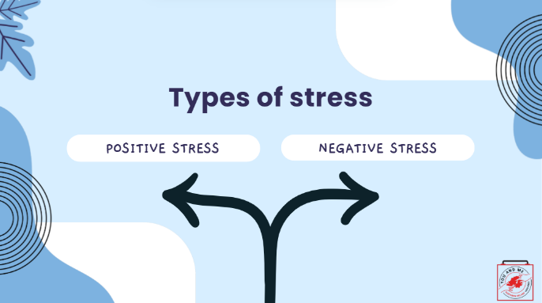 | There are two types of stress, both positive and negative.
9 | 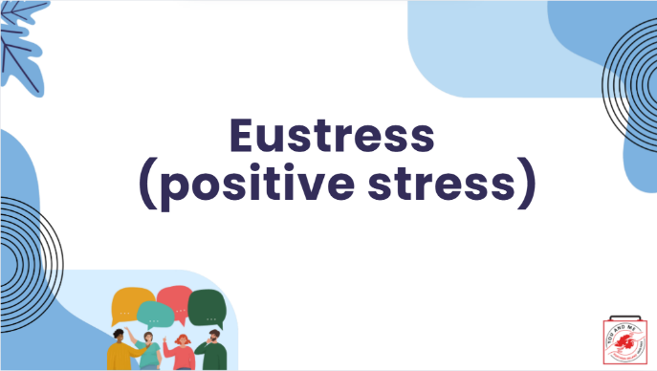 | Eustress is positive stress.  (Ask students) What do you think are some examples?  (Teacher note: some examples are provided in the next slide).
10 | 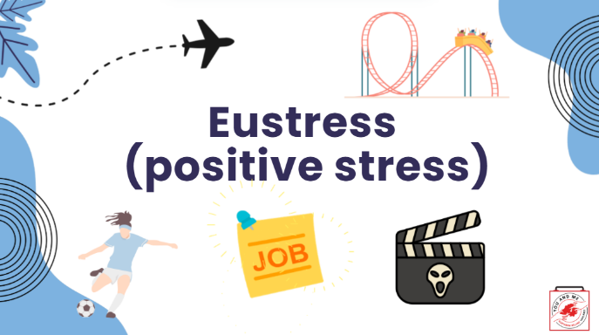 | Eustress is positive stress.  It's short-term.  It motivates you.  It can be exciting and can improve performance.  Here are some examples on the slide: planning a trip; playing sports; getting your first summer job; going on a rollercoaster; and watching a scary movie.
11 | 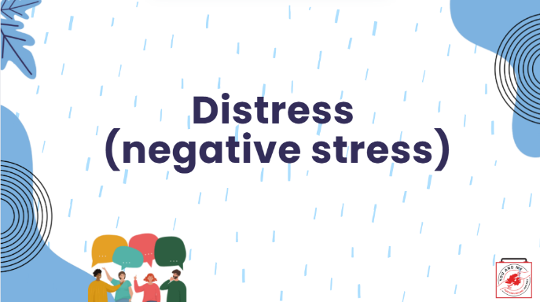 | Distress is negative stress.  (Ask students) What do you think are some examples?  (Teacher note: some examples are provided in the next slide.)
12 | 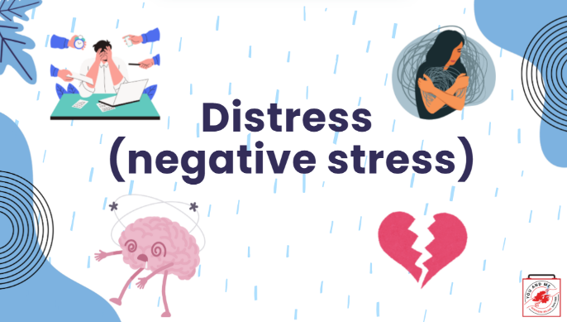 | Distress is negative stress.  It can be short or long-term.  Feels unpleasant.  Decreases performance.  It may cause anxiety or concern.  It can lead to mental and physical problems.  Here are some examples on the slide.  Grief and loss, especially of a loved one, can be very distressing for anyone.
13 | 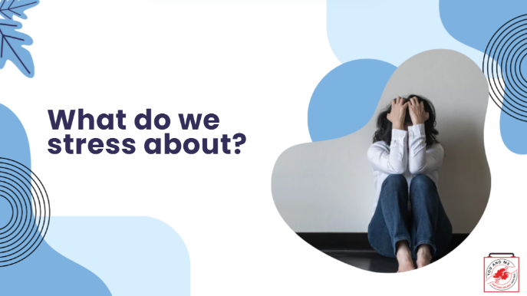 | So what do young people stress about?  Let's take a look.
14 | 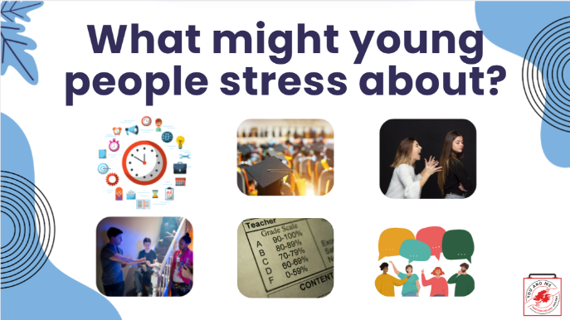 | Young people may stress about many things.  For example, some may stress out about how to manage their time.  Some may stress about being offered e-cigs and other drugs by their peers.  Others may wonder what life will be like after secondary school or worry about their grades.  Some may be in an unhealthy relationship with either their romantic partners or friends.  (Ask students): What are some other things that young people might stress about?
15 | 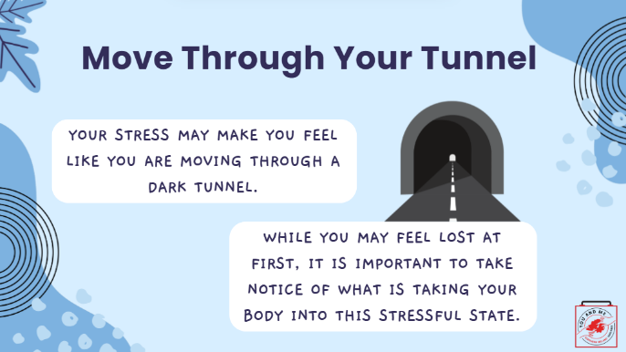 | When someone is under a lot of stress, they may feel like they're in a dark tunnel.  While you may feel lost at first, take notice of the kind of stress or rather, your reaction to that stress, and how your body is responding.
16 | 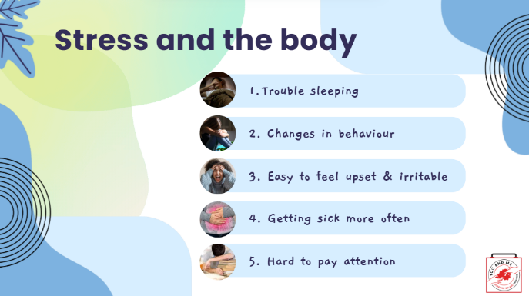 | When you are stressed, the body responds.  You might notice feeling tired all the time because of sleep issues. You might sleep more than usual or have trouble falling asleep.  Your behaviour changes. Others may notice that you are not as outgoing as you used to be, or you want to be left alone. Sudden changes like these can be a sign of high stress levels.  You might be argumentative and irritable, more than usual.  Stress often shows up as physical symptoms. You may experience more headaches or stomach-aches. Additionally, your eating habits may change from eating too little to too much.  If a person suddenly forgets obligations like homework and other activities, or starts to procrastinate, stress could be a factor.  References:  https://www.apa.org/topics/child-development/stress#:~:text=Prolonged%20stress%20can%20cause%20high,becoming%20more%20common%20in%20youth.
17 | 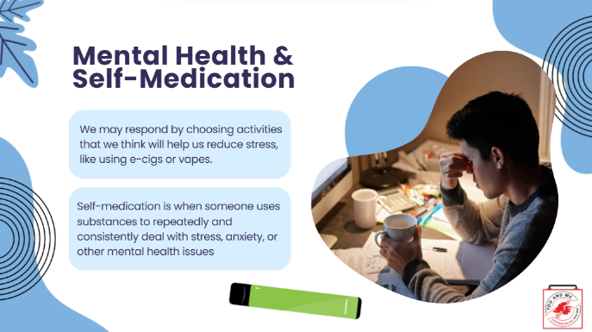 | It’s no surprise that some people use e-cigarettes, cannabis vapes, and other drugs to deal with stress and other mental health issues.  As we’ve discussed, drugs can change the chemistry in your brain. They can increase neurotransmitters that make us feel good. They can slow our brain activity and help decrease anxiety. For a short while, they can seem like great problem-solvers.  However, when someone starts using drugs repeatedly and consistently to deal with stress, anxiety, or other mental health issues, this is called self-medication.  For example, a person may use e-cigarettes and/or cannabis vapes to try and make themselves feel better.  (Ask students): Who can tell me some of the risks involved for teens who are self-medicating with alcohol or other drugs? (Pause for responses.)  Because it is illegal for teens to use many drugs, even those that are legal for adults, like e-cigarettes with nicotine (which are illegal for youth under 18), youth who use drugs to self-medicate may be suspended or expelled from school if used on campus.  While self-medication may temporarily mask the symptoms of an issue, it doesn’t solve it. People, including youth who self-medicate, may not get help addressing the root of their problems, and the problems could get worse.  If self-medication goes on long enough, physical dependence becomes a concern, and new problems may arise, such as tension with family or friends. That's why it's very important to learn how to identify stress and other mental health issues when they come up, and to learn healthy ways to handle them.  Reference:  Safety First, Lesson 11, Mental Health and Coping
18 | 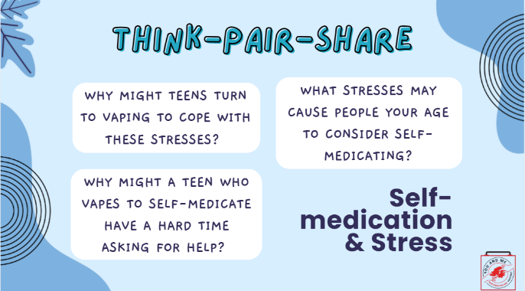 | In groups of two (think-pair-share), let's discuss this topic a little deeper using the following questions. After 10 minutes, we will share what some of you said in your groups.  (After 10 minutes, ask 1-2 students per question what they came up with. You can ask others to chime in if others had different responses in their groups.)  What stresses may cause people your age to consider self-medicating?  (Possible answers: struggling with gender, sexuality, helping to take care of siblings; getting good grades; succeeding on a sports team; problems at home; living in a dangerous neighbourhood; money troubles; fitting in socially).  Why might teens turn to vapes to help cope with these stresses?  (Possible answers: Because they are easy to access; because a friend suggested it; because it’s how their friends/families cope; because they don’t have access to other help.  Why might a teen who vapes to self-medicate have a hard time asking for help?  (Possible answers: They may be afraid of getting in trouble; they could be worried about what people think; they may think nothing else would help; etc.)
19 | 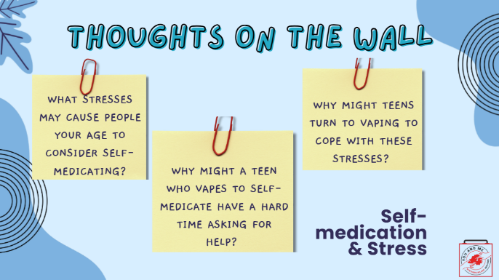 | In groups of two (think-pair-share), let's discuss this topic a little deeper using the following questions. After 10 minutes, we will share what some of you said in your groups.  (After 10 minutes, ask 1-2 students per question what they came up with. You can ask others to chime in if others had different responses in their groups.)  What stresses may cause people your age to consider self-medicating?  (Possible answers: struggling with gender, sexuality, helping to take care of siblings; getting good grades; succeeding on a sports team; problems at home; living in a dangerous neighbourhood; money troubles; fitting in socially).  Why might teens turn to vapes to help cope with these stresses?  (Possible answers: Because they are easy to access; because a friend suggested it; because it’s how their friends/families cope; because they don’t have access to other help.  Why might a teen who vapes to self-medicate have a hard time asking for help?  (Possible answers: They may be afraid of getting in trouble; they could be worried about what people think; they may think nothing else would help; etc.)
20 | 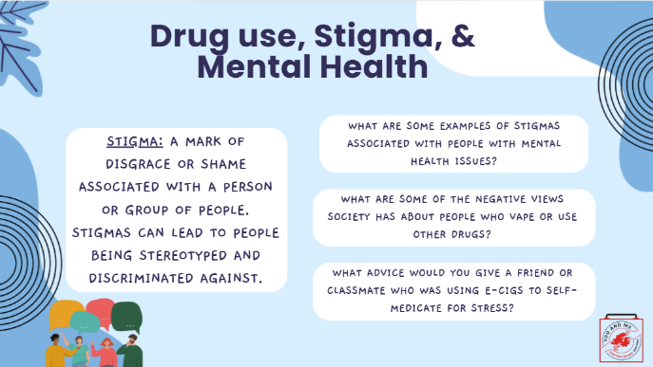 | Youth may use e-cigs or other drugs to cope with stress because they don’t have access to other resources or don’t know how to access other resources.  Because of the stigma related to mental health issues, some teens may see using drugs like tobacco to cope with their problems as less shameful. Some teens may use drugs to fit in and be accepted.  A stigma is a mark of disgrace or shame associated with a person or group of people. Stigmas can lead to people being stereotyped and discriminated against.  When people who use drugs are stigmatized, they may try to hide their drug use. This makes it difficult for them to ask for help and puts them more at risk for harm. It’s important to remember that using tobacco and other drugs doesn’t make someone a bad person. If people who use drugs are treated like bad and undesirable people, they may be too ashamed to get help even if they want it.  (Ask students): What are some examples of stigmas associated with people with mental health issues?  (Possible answers: They are crazy; dangerous; they are hard or uninteresting to talk to; they are stupid; they are lazy, weak; they are bad people; etc.)  (Have students discuss with a partner): What are some of the negative views society has about people who use e-cigs and/or cannabis vapes?  (Possible answers: They are lazy; they are weak; they are bad people; they are stupid; they are dangerous; etc).  What advice would you give a friend or classmate who was using e-cigs or other drugs to self-medicate for stress?  If comfortable, ask a few groups to share their discussion responses with the class.
21 | 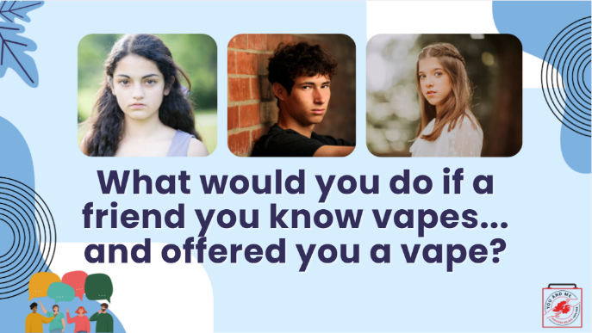 | So let's talk about what you would do if a friend you know vapes. What would you say or do if they offered you a vape?  (pause for responses)  We're going to discuss how we can respond to a friend's e-cig use in a compassionate and destigmatizing way.
22 | 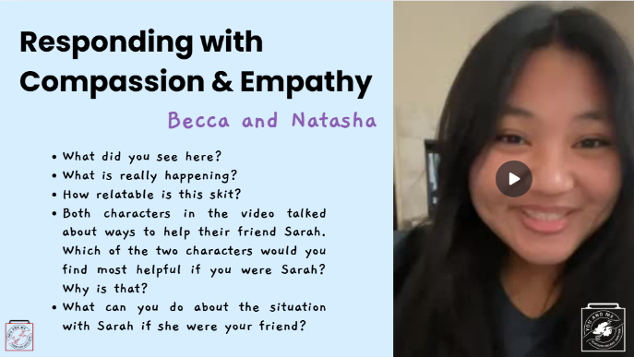 | Let's first discuss the difference between compassion and empathy.  Empathy is the ability to feel for someone: "I understand what you're going through. I've been there."  Compassion is feeling for someone with a desire to help: "I can understand your distress, and I want to help."  We want to let the other person (for example, the person who is using e-cigarettes and/or cannabis vapes) know that they are not alone. Essentially, you're creating a connection with the other person.  We are going to watch a short roleplay (video) that shows one of the characters, Natasha, responding with compassion and empathy. (Click on video.)  We will then break into small groups. (Teacher note: once they are in groups): Each group will write up the answers to the questions you see on the slide. We will then do a large group share-out for each question.  Please have one representative be the group spokesperson, one take notes, and everyone share in the discussion.  (After watching the video and completing the assignment, the teacher will ask each question, and everyone will share their findings.)  References:  https://www.betterup.com/blog/compassion-vs-empathy  https://www.psychologytoday.com/us/basics/empathy  https://www.drstevesilvestro.com/teaching-kids-empathy-and-compassion
23 | 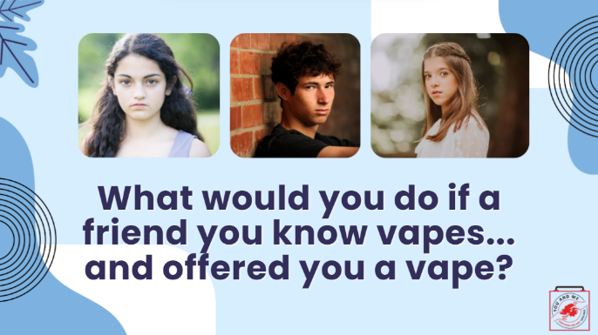 | Knowing what you know now, how you refuse with compassion and empathy if a friend offered you a vape?
24 | 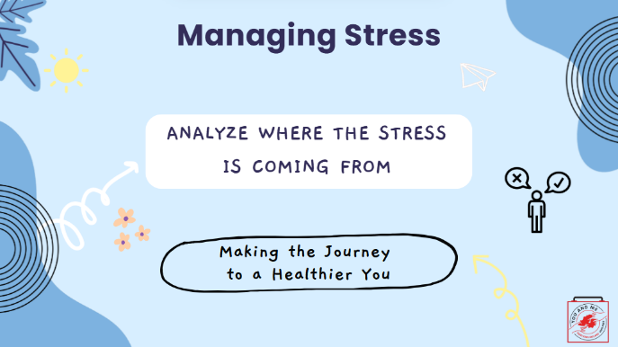 | In summary, when managing stress, analyse where the stress is coming from.  Pick the coping technique that works for you.
25 | 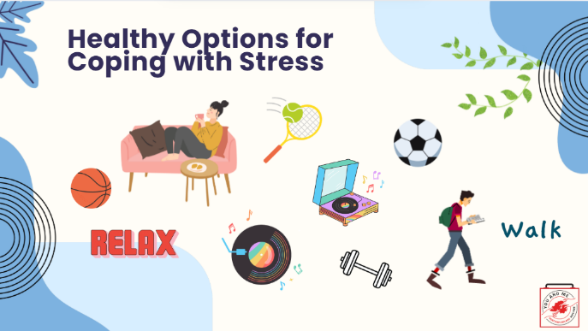 | Here are some healthy options for coping with stress.  What are your healthy options for coping with stress? Write down a list of five techniques you can use.
26 | 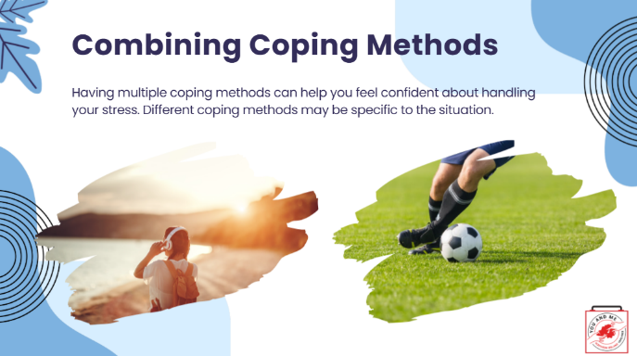 | You may want to try combining several coping methods.  Having multiple coping methods can help you feel more confident about handling your stress.  Different coping methods may be specific to the situation you're encountering.
27 | 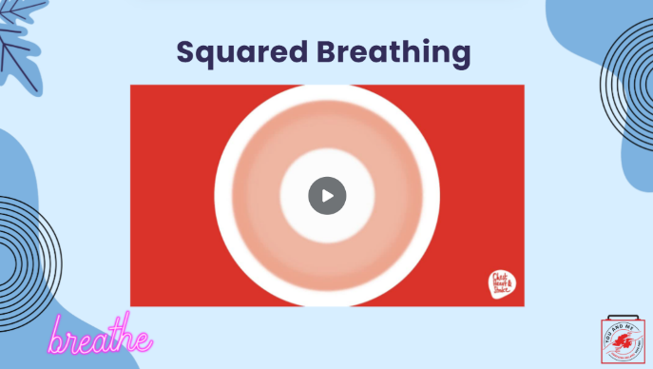 | One technique we are going to try out is a type of breathing called Squared Breathing. You can do it at the moment when you're feeling stressed.  We're going to watch a short video that explains Squared Breathing. After we watch the video, you will all have the opportunity to practice this.  Let's watch the video now.  (After the activity, ask students): how did that go for you? How do you feel?  As with everything new, try this a few times in your day until it becomes a routine.
28 | 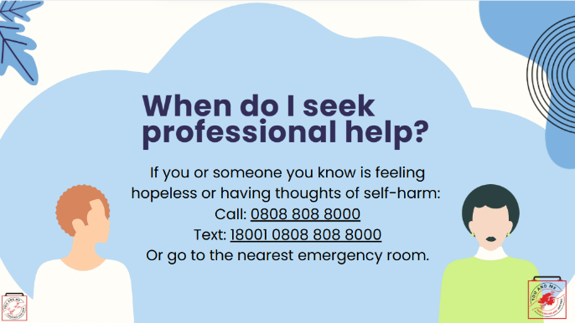 | We've talked a lot about what stress is and what it does to the body.  We also discussed self-medication and mental health.  I'd like to share this resource with you if you or someone you know is feeling hopeless or like you might want to hurt yourself. You can call or text the numbers on the screen to talk to someone on NI's crisis helpline. If you or your friend are at school, please talk to a trusted adult right away, like a school nurse, a teacher, or a coach.  (Educator note): Have students write in their notebook or on a piece of paper a script they could use to convince a friend to seek help from a trusted adult or professional in the community. Be sure to include how that person can help them with their problem  (Examples: Are they a professional? Do they have expertise? Are they understanding? How do they help to solve community health issues?)  Reference:  https://afsp.org/
29 | 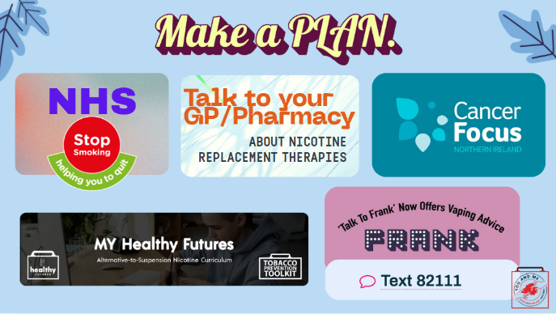 | If you or someone you know smokes cigarettes or uses vapes, consider quitting.  Here are some quitting resources.  (Optional: LINKED HERE - print out flyers with quit info for students to take home).
30 | 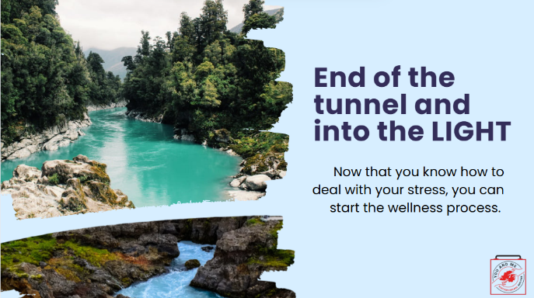 | So we are nearing the end of our lesson.  You have a lot of information from today's lesson on stress and coping to empower you as you start your wellness process.
31 | 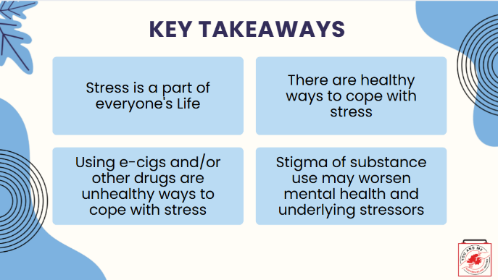 | Let's review our key takeaways.
32 | 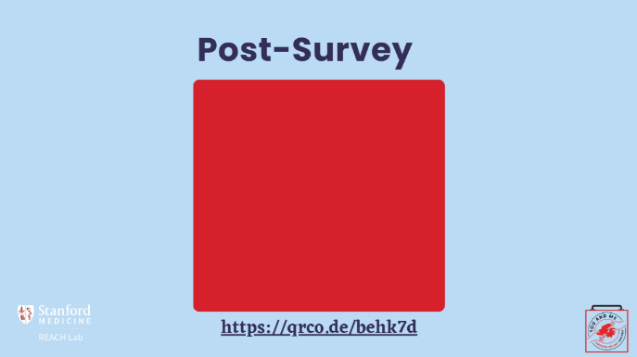 | *If you are teaching the curriculum up to Lesson 5, please complete the survey here. However, if you are including Lesson 6, please use the survey in the slides at the end of Lesson 6. Thank you!  Educators - This is the post survey for our dashboard. Please have your students complete this survey after the pre survey and the curriculum has been implemented.  More information can be found at https://med.stanford.edu/halpern-felsher-reach-lab/curriculum-data-dashboard.html  Students can access the post survey at the QR code on this slide, or at https://qrco.de/behk7d
33 | 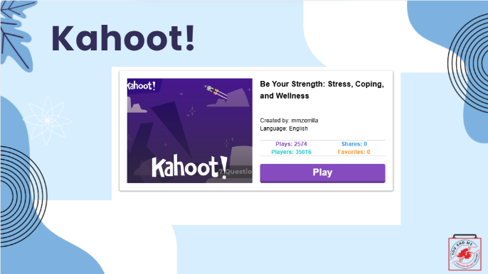 | Now, we will play a quick game of Kahoot!

