Year 11-14 Lesson 6:
Can’t Be Missed: Cannabis & You-th



Lesson 5
Talking Points and Slide Chart

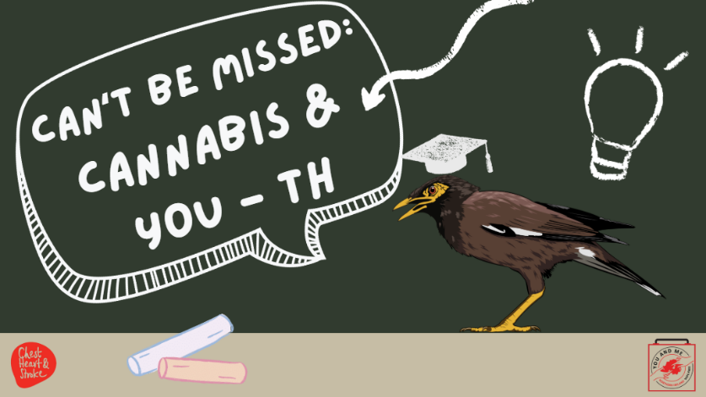

Slide | Image | Talking Points
1 | 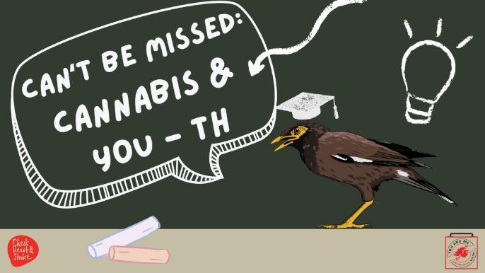 | Welcome back, class. This lesson is about cannabis and YOU-th.
2 | 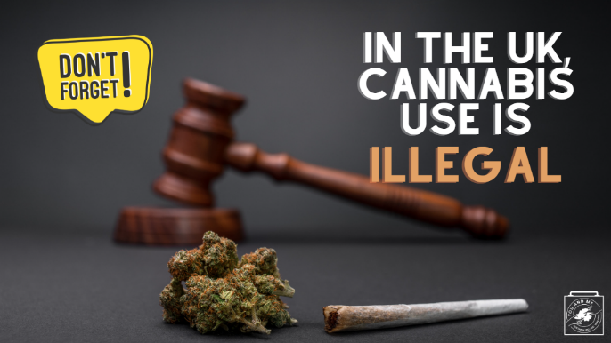 | As we continue with this discussion about cannabis, keep in mind that cannabis use is illegal in the UK, unless it is for a medical purpose.  Engaging in any of the kinds of recreational cannabis use we will discuss is ILLEGAL.  However, we are aware that some young people do use cannabis, so it is important to be educated on what it is, how it affects you, and what the potential repercussions of using are.
3 | 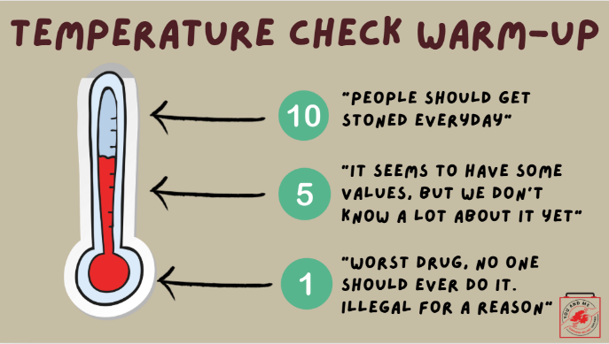 | Let’s start off with a temperature check!  (Ask students): On a scale of 1 to 10, with 1 being the worst ever, and 10 being something people should use every day: what do you think about cannabis?  Hold up the number on your fingers for me to see.  As we can see, there are differing opinions on cannabis, but in this presentation, we will talk about cannabis in a non-judgmental and fact-based way. We hope that through this lesson, you can learn the real facts and dispel any myths about cannabis.
4 | 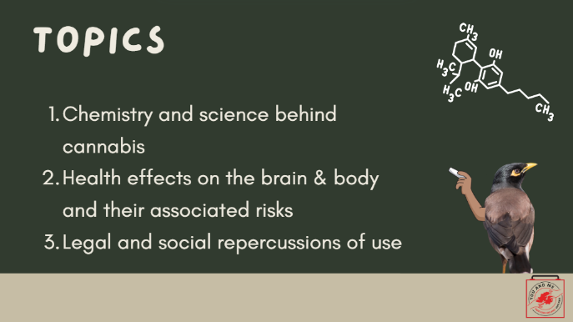 | We're going to talk about the basics of cannabis, including its chemistry, what it does to a brain that is still developing, and the legal and social repercussions of use.
5 | 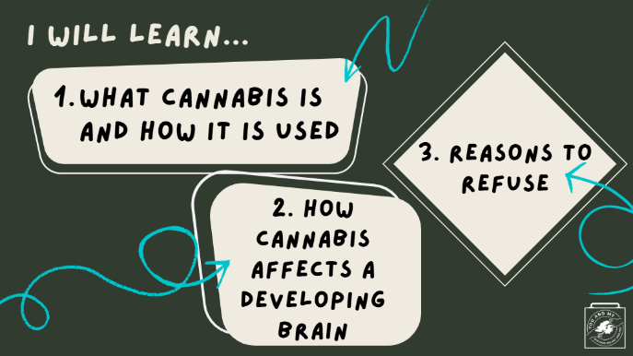 | (Teacher note): Read from slide
6 | 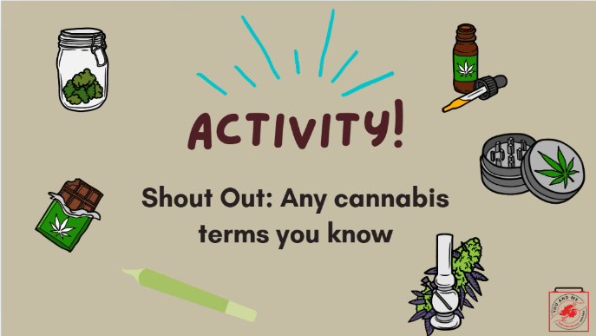 | What are some cannabis terms you know? What have you ever heard cannabis called or referred to?  (Teacher note): Record the students’ answers on a whiteboard, chalkboard, or large piece of paper. Refer back to the students' responses throughout the presentation.
7 | 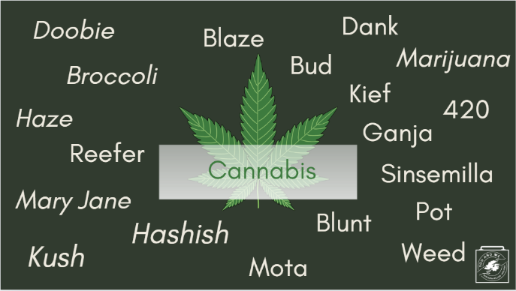 | Here are some of the different names used for cannabis; a lot of the ones you all mentioned are on here.  There are at least 1,200 slang terms. This reflects the cultural phenomenon and the stigma it may carry as it takes on different names with different connotations. Different names can have positive or negative associations.  Remember these terms, as they may be used interchangeably in life. However, in keeping with a non-judgmental and fact-based environment, we will use the term "cannabis" throughout this lesson.
8 | 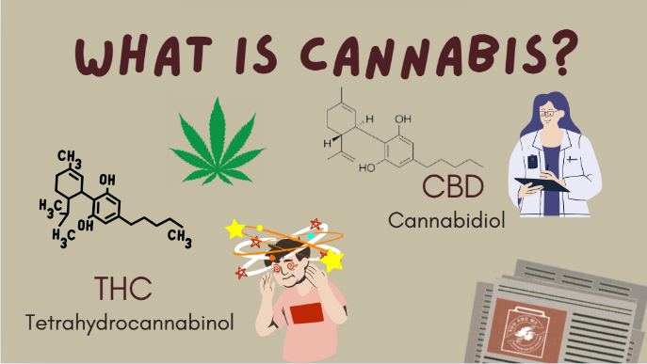 | So what is cannabis? Well, there are two chemicals in cannabis that are responsible for causing direct effects on the body and are the most talked about when cannabis is mentioned.  THC, or Tetrahydrocannabinol, is what gives cannabis its psychoactive property, meaning it makes the user feel “high.”  CBD, or Cannabidiol, doesn’t make you high and is the compound that can be used for clinical or medical purposes when used under the supervision of a medical professional.  While medical use of cannabis is legal here in NI, recreational use, or use for the general public, is not. And the cannabis industry has made many unsupported health claims about the benefits of using this drug. The concern is that the short- and long-term positive and negative health effects of using cannabis are still unknown.  Cannabis can look different, depending on the form it comes in. These different forms fall into two major categories: inhalation and ingestion.
9 | 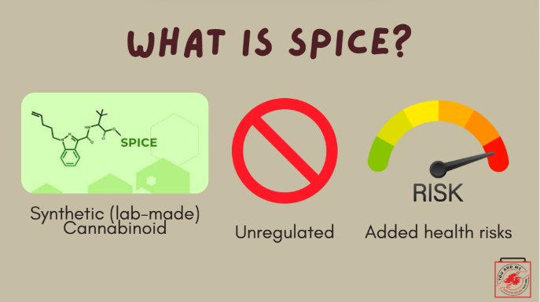 | You may have also heard of 'Spice' before. Spice is a nickname for substances containing one or more synthetic cannabinoids.  Synthetic cannabinoids are not naturally occurring and are man-made. They mimic the effects of THC but are more harmful, more potent, and more unpredictable than cannabis.  Unlike medical cannabis, which a GP or pharmacy can prescribe, spice is unregulated by the government and is sold illegally. Because of this, you can never be too sure of what's inside.  We'll discuss the added health risks associated with spice later in the lesson.
10 | 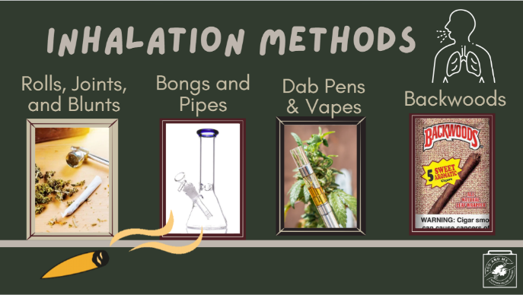 | Now, let's discuss the various ways cannabis, including spice, is typically inhaled:  - Rolls, pipes, joints, and blunts are all methods to burn and inhale cannabis.  - A joint is made from cannabis flowers and a thin paper made for rolling cigarettes.  - Blunts are made from the tobacco leaf of a cigar and cannabis flower.  This means that smoking a blunt exposes the user to harmful tobacco substances from the cigar paper, which is made from tobacco leaves, as well as the substances from the cannabis flower.  Why might this pose an even greater health risk?  - The answer is NICOTINE! Which is a highly addictive substance.  - The user is exposed to both tobacco and cannabis substances.  Backwoods, which also come in different flavours, also contain nicotine! And you may not even know it!  Bongs and pipes are also methods of burning the cannabis flower.  Dab pens and vapes aerosolise a THC wax concentration that is then inhaled. These pens and vapes contain all the same harmful aerosolised chemicals that we discussed in lesson 2.
11 | 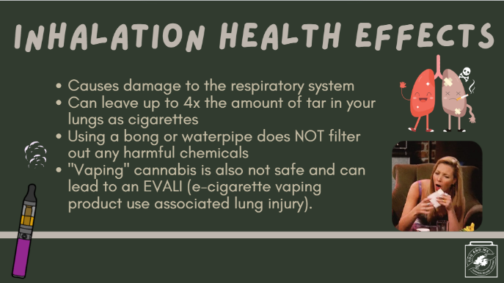 | In inhaling cannabis, the smoke is inhaled deep into the lungs and held there, which can cause damage to the respiratory system (including the lungs, cilia, and airways).  Researchers have found that since cannabis smoke is typically held in the lungs for a longer period of time, it can leave up to four times the amount of tar as cigarettes do in your lungs.  Some believe that using a bong or water pipe may filter out some of the chemicals, but this is not true.  "Vaping" cannabis in a dab pen is also not a safe alternative. As a matter of fact, a study done in 2021 says that young people who vape cannabis are twice as likely to develop a wheeze in the lungs or a new disease called EVALI (e-cigarette vaping product use-associated lung injury).  References:  https://pubmed.ncbi.nlm.nih.gov/3340105/#:~:text=We%20measured%20each%20subject's%20blood,a%20similar%20quantity%20of%20tobacco.  https://www.lung.org/quit-smoking/smoking-facts/health-effects/marijuana-and-lung-health
12 | 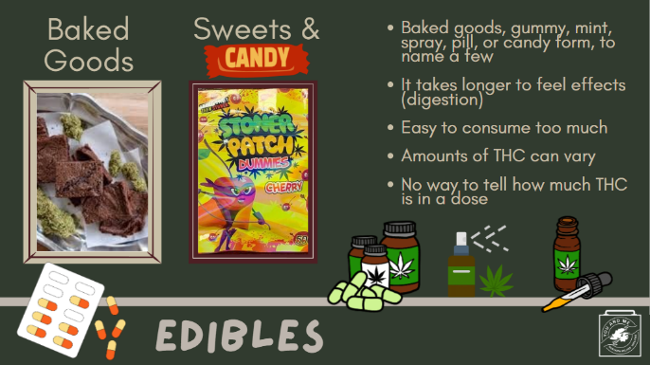 | Now, let's talk about edibles. Edibles are the way cannabis enters the body through the digestive system. Because of this, it takes longer to feel the effects of cannabis when ingesting it. One may think they need more because they don’t feel the effects and ultimately consume too much, making them sick.  Cannabis can be infused into baked goods through butters and oils. They can also be taken in gummy, mint, spray, pill, or candy form, to name a few.  Edibles may have varying amounts of THC in one serving. A single edible often has several serving sizes and a large amount of THC.  Whether homemade or bought pre-packaged, eating an entire cookie or brownie with THC can result in accidentally eating too much THC, leading to cannabis intoxication.  Edibles also cause a different and more intense experience than inhaled cannabis.
13 | 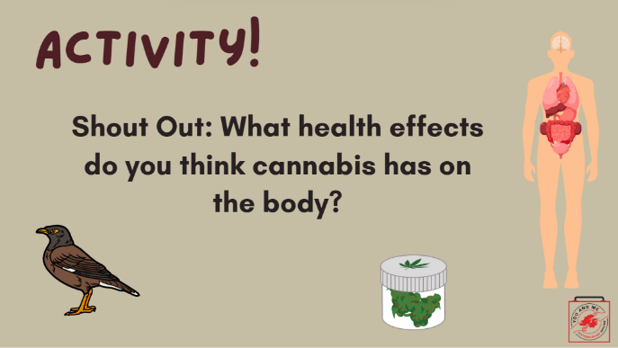 | (Ask Students): Shout out what health affects you think cannabis has on the body?  (Teacher Note): Take 3 or 4 example answers. Record the students’ answers on a whiteboard, chalkboard, or large piece of paper. Refer back to the students' responses throughout the presentation.  (Teacher Note): Note that students most likely will share some comments such as “makes you feel good or relaxed.”  So, as you can see, from what we have on the board, there are both positive and negative ideas. As we mentioned in the beginning, we are going to look at all of this, not in a good or bad way, but from the facts. Let’s start with the facts about short-term effects.
14 | 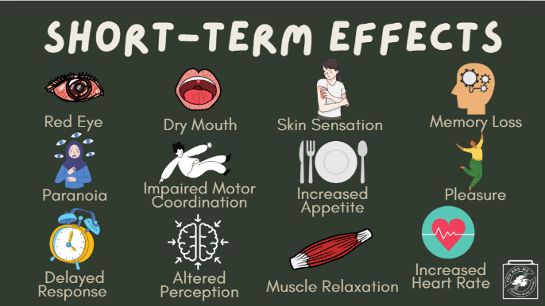 | Some of the obvious short-term physical changes include: red eyes, dry mouth, impaired motor coordination, increased heart rate, delayed response to people and the environment, increased appetite, aka “munchies,” and muscle relaxation.  Now, for someone experiencing the “high” or intoxication from cannabis, they may feel the following: skin sensations of hot or cold, memory loss or inability to recall certain memories, pleasure or bliss, paranoia or fright, and an altered perception of time and space.  These effects are the result of THC and CBD acting on different parts of the body.
15 | 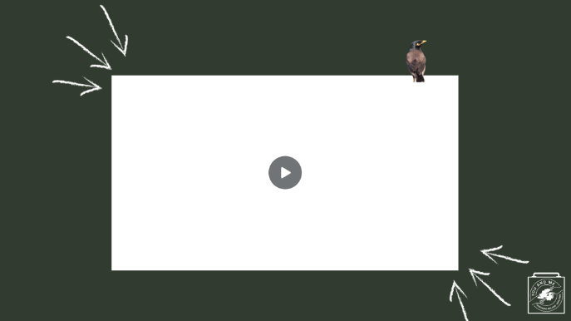 | Here is a short video on some effects of cannabis on the body (2:52).  (Teacher Note): Play embedded video.
16 | 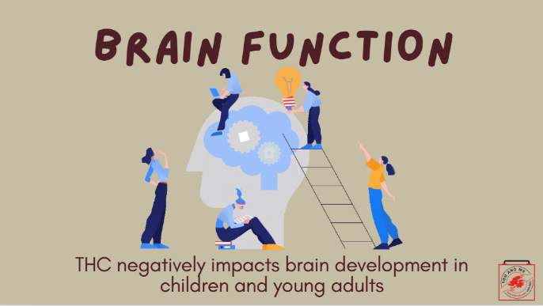 | Now we will move on to brain function. We learned about this in lesson 1, but we will go over a quick review to refresh our memory.  THC negatively impacts brain development in children, adolescents, and young adults.
17 | 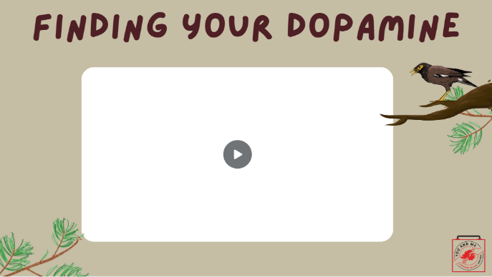 | Let’s watch this video (4:54) explaining the effects of dopamine on a young brain.  (Teacher Note): Show video.  Isn't Ralph fun?  Similar to what you learned earlier, as this video shows, as part of your adolescence, you are supposed to figure out what you like and don’t like.  Everyone’s brains are different, and now it's focused on your identity and what you're supposed to be doing now.
18 | 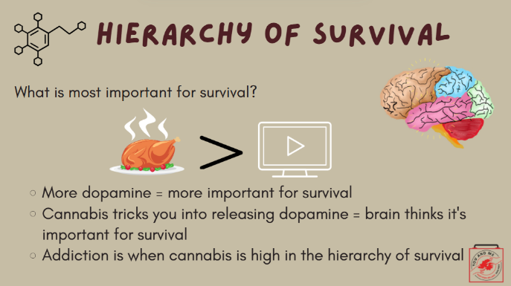 | Your hierarchy of survival is your brain’s way of prioritising what is most important for survival. The more dopamine something releases, the higher it ranks on your hierarchy of survival.  For example, while you may enjoy watching a YouTube video, your brain recognises that eating a good meal is more important.  Drugs hijack the part of your brain that releases dopamine. Cannabis tricks the brain into releasing dopamine, often in greater amounts than the body has experienced before. This excessive release of dopamine can lead your brain to associate that feeling with survival. It’s like buying happiness, but only for the moment.  Addiction occurs when cannabis ranks high on the hierarchy of survival.
19 | 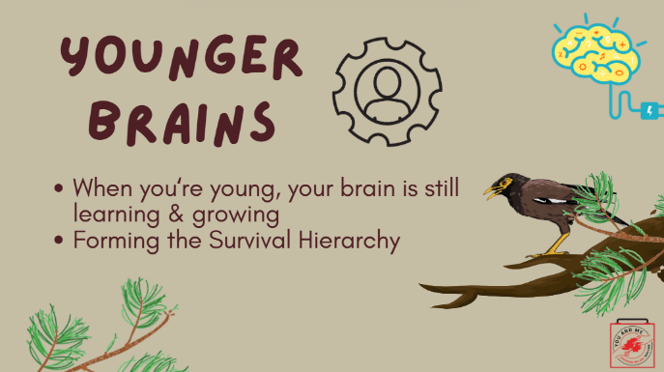 | Research shows that young people are at the highest risk of having their hierarchy of survival hijacked. Young brains are hypersensitive to the false shocks of dopamine that drugs produce; your brain is still learning and growing.
20 | 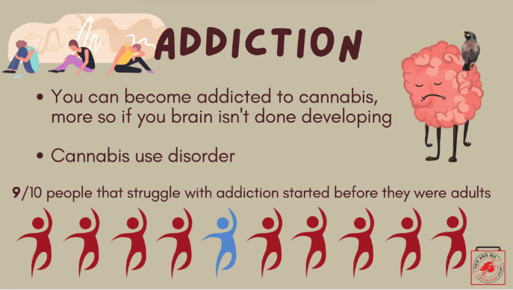 | Given what we talked about regarding the survival hierarchy, you can become addicted to cannabis, much more so if you are an adolescent than an adult.  A cannabis use disorder is when someone is unable to stop using cannabis, even if it causes them health or social problems.  Nine out of ten people who struggle with drug addiction started using before they were adults.
21 | 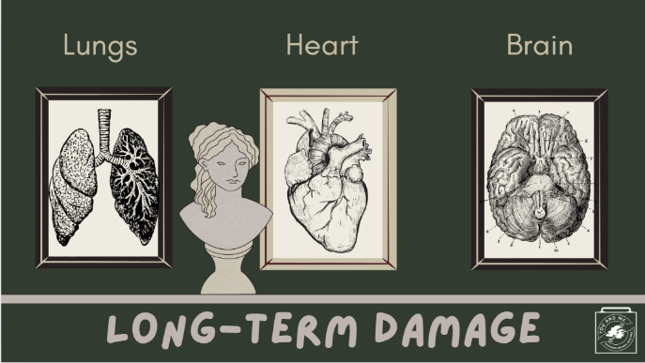 | The lungs, heart, and brain can suffer due to long-term use of cannabis.  LUNGS:  - Those who smoke it run the risk of damaging their lungs over time. A lot of the harmful and cancerous chemicals released from cigarettes are also released from cannabis.  - It is also important to note that smoke is smoke. Second-hand smoke from cannabis is released just like cigarettes, and the second-hand aerosol in e-cigarettes/vapes.  HEART:  - The heart is also negatively affected.  - Smoking cannabis is associated with increased risk of heart attacks and stroke.  BRAIN: As we’ve been reviewing, there is strong evidence that cannabis negatively impacts the brain long-term, especially a young person’s brain, and can lead to addiction.  References:  https://www.nih.gov/news-events/news-releases/smoking-cannabis-associated-increased-risk-heart-attack-stroke  In addition to the health risks we just discussed, using synthetic cannabis like spice presents even more risk.  Spice can lead to neurological issues, such as psychosis (which is a mental health condition that entails losing touch with reality and having hallucinations), seizures, paranoia, and extreme anxiety.  Effects on the heart and lungs are also worse, and spice overdose can even lead to paralysis, a comatose state, and even death.
22 | 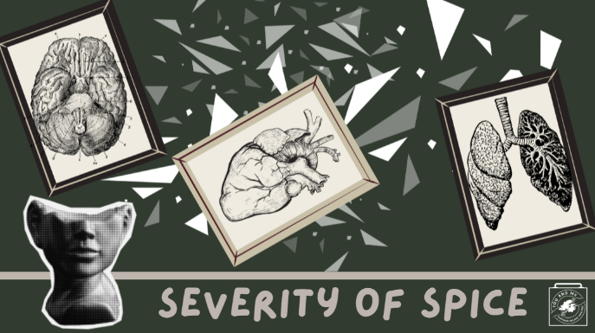 | In addition to the health risks we just discussed, using synthetic cannabis like spice presents even more risk.  Spice can lead to neurological issues, such as psychosis (which is a mental health condition that entails losing touch with reality and having hallucinations), seizures, paranoia, and extreme anxiety.  Effects on the heart and lungs are also worse, and spice overdose can even lead to paralysis, a comatose state, and even death.
23 | 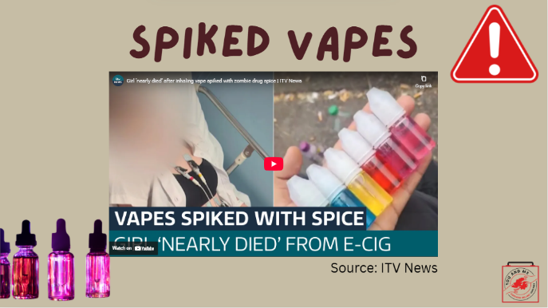 | Recently in NI and across the UK, we have had an increasing number of instances where young people are injured or hospitalized after using vapes spiked with spice or other drugs.  (Play video.)  (After the video, ask students:) What are some ways you can protect yourself from these kinds of dangers?  (Potential answers: don't vape, make sure you know where your vape is from, avoid cannabis of any kind unless prescribed.)  Video: https://www.youtube.com/watch?v=8l160TY2bnA
24 | 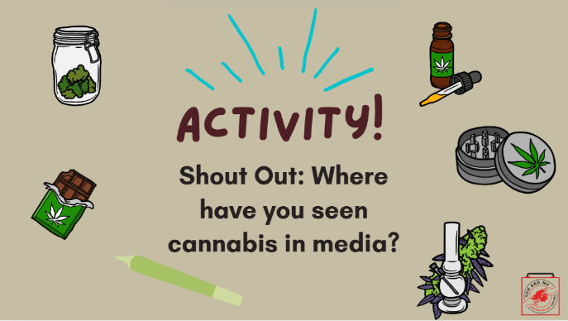 | We've talked about the brain and long-term effects; now, let’s go into why one may use cannabis, starting with targeted marketing. I know we learned about tobacco marketing in lesson 4, and now let’s focus on cannabis.  (Ask students): Shout out: Where do you see cannabis in the media?  (Teacher Note): Same activity as before; write down students' answers and use them as examples throughout the next few slides.
25 | 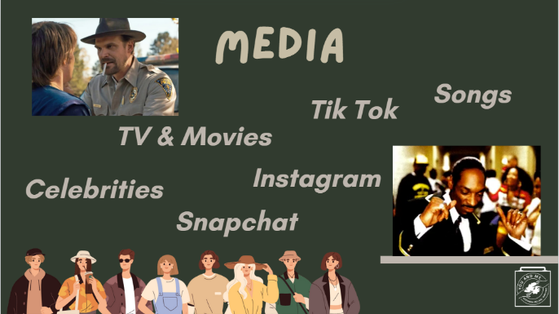 | Yes, you’re all correct!  You see cannabis portrayals in movies, songs (rap, pop, country, rock, and reggae), and celebrities, like Snoop Dogg there. You can also come across portrayals on social media sites like Instagram and TikTok, particularly from people in places where cannabis is legalized.  How many of you have seen cannabis use on social media, anywhere? Right, in pictures or videos on social media, we don’t really get to see the negative effects it has on people here.  It's important to know where this information is coming from and how it impacts our perception of cannabis, whether positive or negative. It is also important to remember that just because cannabis is legal in other countries, it doesn't mean it is harmless and without risk, as we've discussed throughout the lesson. And again, this is especially true for spice.
26 | 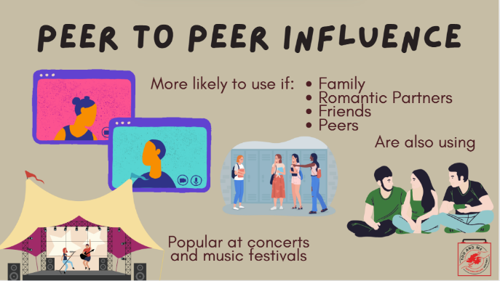 | Peer-to-peer influence is the main way youth begin to use cannabis. Young people are more likely to start using and buying if their family (parents, siblings, cousins), romantic partners, friends, and peers are also using.  Taking cannabis before raves or music festivals is also popular and can be seen as a social activity.  Know the risks and don’t take anything from anyone you don’t completely trust. You don’t know what else could be in it!
27 | 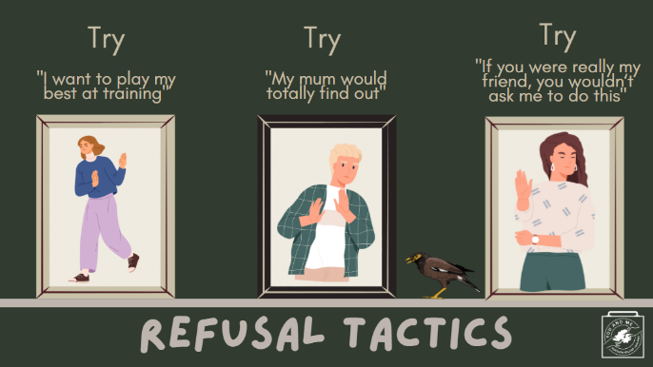 | Peer-to-peer influence is the main way youth begin to use cannabis. Young people are more likely to start using and buying if their family (parents, siblings, cousins), romantic partners, friends, and peers are also using.  Taking cannabis before raves or music festivals is also popular and can be seen as a social activity.  Know the risks and don’t take anything from anyone you don’t completely trust. You don’t know what else could be in it!
28 | 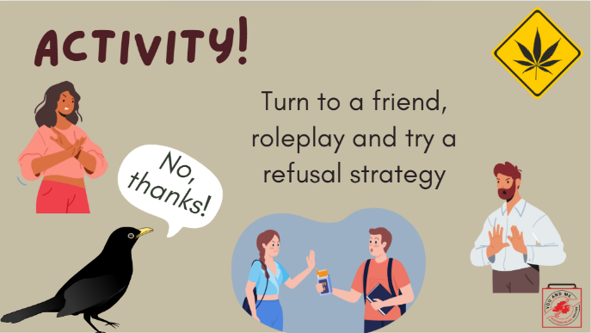 | Roleplay Activity!  (Teacher Note): Have the students turn to a friend and try out a refusal strategy. One student can offer cannabis, and the other can try out a refusal tactic (or come up with their own!). Then, have them switch roles!
29 | 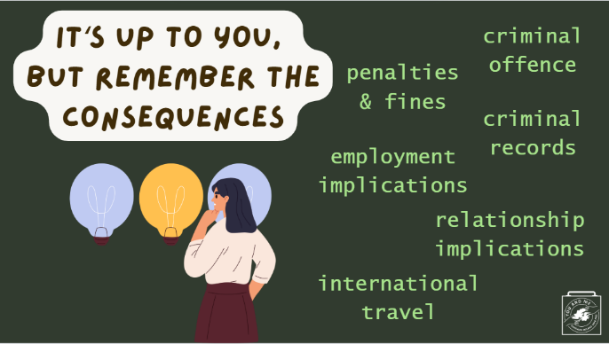 | In summary, cannabis can be risky, and there are a couple of behaviours, such as using spice, that can make it even more risky.  In addition to everything we've discussed today, there are also legal and social repercussions to consider.  Since using cannabis recreationally is a criminal offence, you may be subject to penalties, fines, and marks on your criminal record. All of this could impact future employment, your chances of getting into university, your relationships with your friends and family, and even your ability to travel internationally if you have a criminal record.  What I hope you take away from today’s discussion is that you are more in control of your brain development than you might realise.  As teachers, parents, and mentors, we are here to help and guide you, but you must make the right decisions for yourself.  You are in charge, but do remember the consequences of your actions!
30 | 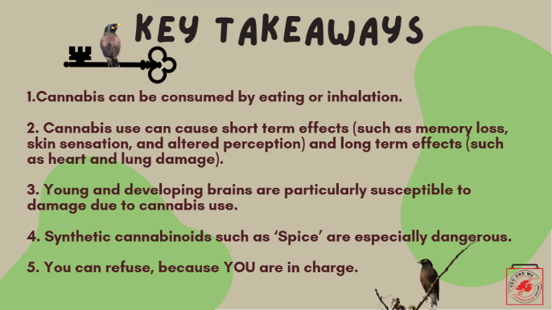 | Our Key Takeaways for today:  Cannabis can be consumed by eating or inhalation.  Cannabis use can cause short-term effects (such as memory loss, skin sensations, and altered perception) and long-term effects (such as heart and lung damage).  Young and developing brains are particularly susceptible to damage due to cannabis use.  Synthetic cannabinoids such as ‘Spice’ are especially dangerous.  You can refuse, because YOU are in charge.
31 | 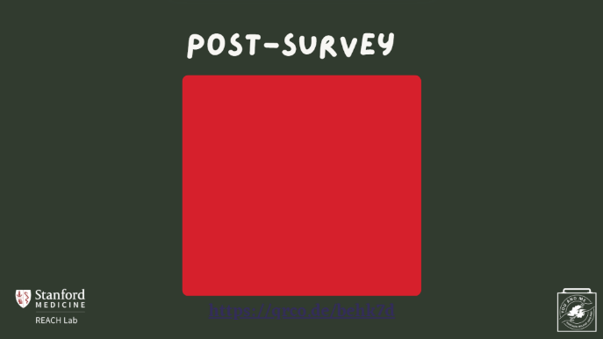 | Educators - This is the post survey for our dashboard. Please have your students complete this survey after the pre survey and the curriculum has been implemented.  More information can be found at https://med.stanford.edu/halpern-felsher-reach-lab/curriculum-data-dashboard.html  Students can access the post survey at the QR code on this slide, or at https://qrco.de/behk7d
32 | 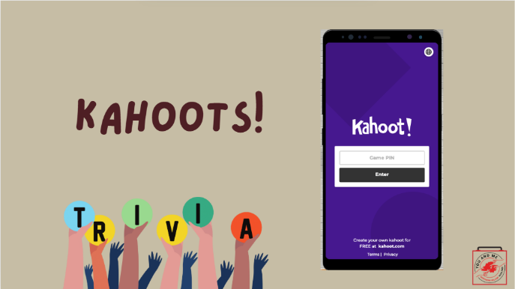 | Now, we will play a quick game of Kahoots!  Please use your phones or computers to play!  (Teacher note): Kahoot link embedded in slide and also here: https://create.kahoot.it/share/cannabis-lesson/43498760-c180-4efd-bc55-991e986d91d4  Kahoot will give you a unique game PIN when you start the game!

