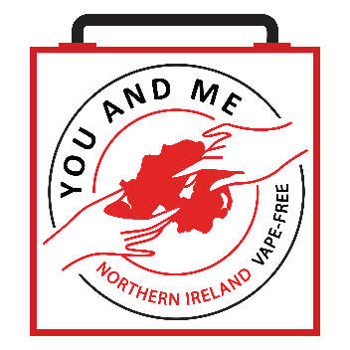
<<EDUCATORS: FEEL FREE TO ADD YOUR LETTERHEAD>>
<<Today’s Date>>
Dear Parent/Guardian,
As you may be aware, the use of e-cigarettes (also known as vaping) among young people has become a growing concern. Students are increasingly exposed to e-cigarettes containing nicotine, cannabis/THC, and other substances.
Starting <<next week or on [insert dates]>>, students will begin a new learning programme called You and Me N.I. Vape-Free, developed by Stanford University in collaboration with Northern Ireland Chest Heart and Stroke (NICHS).
This curriculum is part of the internationally recognised Stanford Tobacco Prevention Toolkit and has been carefully adapted for Northern Ireland through consultation with local young people, teachers, parents, scientists, and healthcare professionals.

The goals of the programme are to help students:
- Increase their knowledge about e-cigarettes and the harms they can cause.
- Understand how e-cigarette companies use marketing strategies to target young people.
- Build confidence and skills to resist peer pressure and avoid vaping.
- Signposting to support if they are already vaping and wish to quit.
- Ultimately, reduce and prevent the use of all types of e-cigarettes, including those with nicotine, cannabis/THC, and non-nicotine products.
The You and Me N.I. Vape-Free curriculum includes six engaging lessons with interactive activities, online quizzes, worksheets, and presentations. It addresses key factors influencing youth vaping, such as:
- Misconceptions about e-cigarettes
- The appeal of flavours and social media
- Stress, anxiety, and coping strategies
- Building refusal skills and resilience
This age-appropriate programme supports all students—those who choose not to vape, those who may be curious, and those who are already experimenting and want to reduce or quit.
<School name> is committed to using the most effective approaches to prevent e-cigarette use in our schools and communities. We believe that prevention works best when schools, families, and communities work together.
Research shows that teens who learn about the risks of substance use at home are significantly less likely to use them. That’s why this curriculum also includes optional discussion guides to help parents and guardians have open, supportive conversations with their children. These guides are designed to encourage listening, understanding, and connection—not judgment.
You can learn more about the curriculum at: www.nichs.org.uk/parents-vape-free.
If you have any questions, please feel free to contact me at the email address below.
Warm regards,
<<Educator’s Name>>

